Erasmus + Smart schools for smart age
 | Sports school G. S. Rakovski  Dobrich, Bulgaria  Lesson 10:  Literature – Yordan Yovkov | 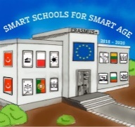

Lesson 10 Yordan Yovkov
Class 7
Topic: Yordan Yovkov.
Objectives:
- Introduction to Bulgarian writer Yordan Yovkov
- Introduction to the work of Yordan Yovkov
- Showing some of Yordan Yovkov's works

Resources:
- computer with internet access
- multimedia projector

Lesson source:
https://docs.google.com/presentation/d/1qAfF_o6vrJQUSvZQyE8hjRC2onGTwsTn/edit?usp=sharing&ouid=108790201128611252560&rtpof=true&sd=true

