Smart School for Smart Age

Lesson plan - Erasmus +
Subject: Math
Number of lessons: 7
Teachers: Murat Avanoğlu, Deniz Ayata
Topic: Measures
Key words: measures
Lessons objectives:
- describe units of measure
- use measuring tools
- explain purpose of measuring
- describe methods of measuring

Resources
- Computers with internet access;
- Multimedia projects;
- Tablets with internet access;
- Mobile Phones with internet access
Lessons sequence/activity
- Lessons with different web tools(7 lesson)
Web Tools
https://quizizz.com/

1. | Learn – Calculating Perimeter  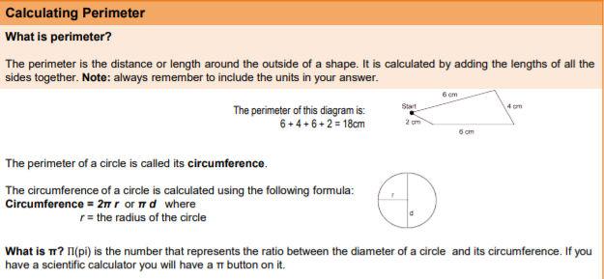
2.  3. | Pratice –  https://images.app.goo.gl/G7dpeP98yNQLURMu8  Quiz:https://quizizz.com/admin/quiz/56f0c1df7cba8aed164624b6/perimeter-area-and-volume

Smart School for Smart Age

Lesson 2- Calculating Areas

Sentences to Inequalities

1. | Learn - Calculating Areas  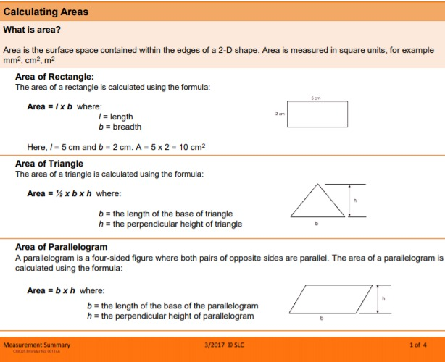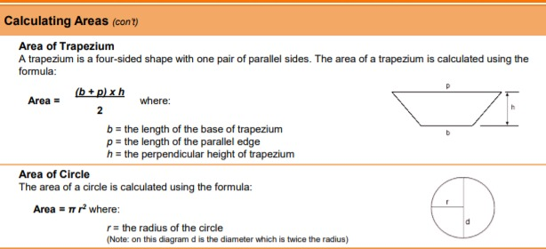
2. | Pratice – https://images.app.goo.gl/cdKvX7bBLAFTYiC47  3 Quiz:https://quizizz.com/admin/quiz/56f0c1df7cba8aed164624b6/perimeter-area-and-volume

Smart School for Smart Age

Lesson 3- Calculating Volumes

Sentences to InequalitiesSmart School for Smart Age

Lesson 1- Calculating Perimeter

Sentences to Inequalities

1. | Learn - Calculating Volumes  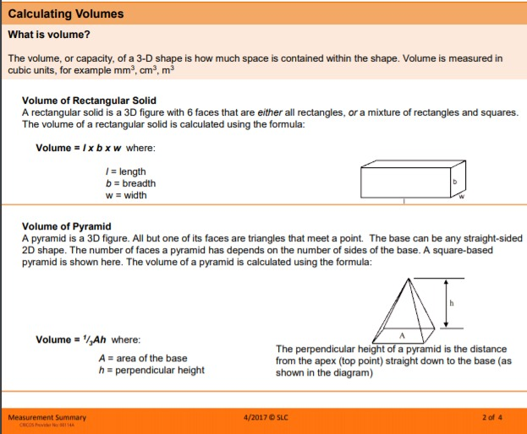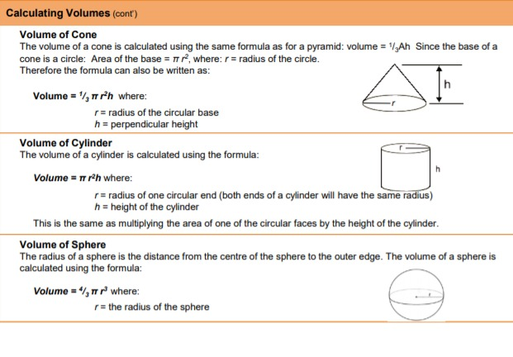
2.  3. | Pratice –  https://images.app.goo.gl/Xuk3jxcgddDdLfsj9  Quiz-https://quizizz.com/admin/quiz/56f0c1df7cba8aed164624b6/perimeter-area-and-volume

Smart School for Smart Age

Lesson 4- The Metric Prefix System

Sentences to Inequalities

1. | Learn - The Metric Prefix System  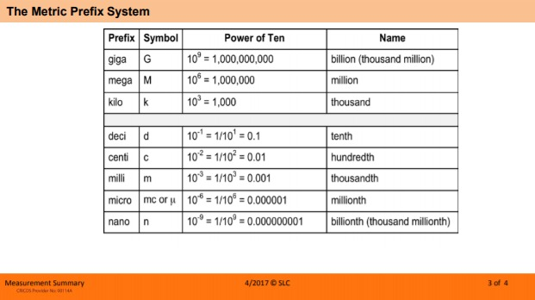
2.  3. | Pratice https://www.proprofs.com/quiz-school/story.php?title=metric-system_4  Quiz-https://www.proprofs.com/quiz-school/story.php?title=metric-system_4

Smart School for Smart Age

Lesson 5- Metric Conversions

Sentences to Inequalities

1. | Learn – Metric Conversions  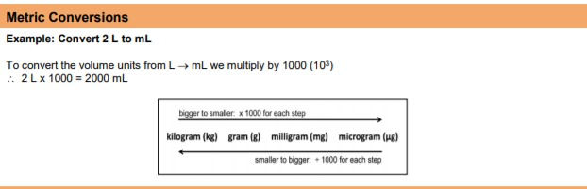
2.  3. | Pratice –  https://images.app.goo.gl/TuM5k7J86ZZFZ7e146  Quiz- https://www.thoughtco.com/metric-to-metric-conversions-quiz-4052360

Smart School for Smart Age

Lesson 6- SI Units

Sentences to Inequalities

1. | Learn - SI Units  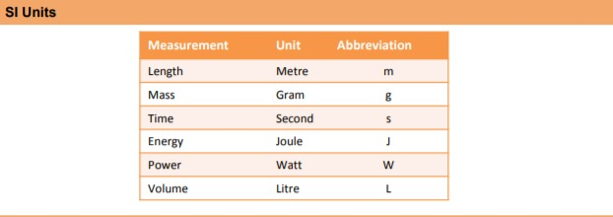
2.  3. | Pratice – https://images.app.goo.gl/QyRSEbCe3HNB3pug9  Quiz- https://quizizz.com/admin/quiz/589a356681b37dfa554b7f54/si-units

Smart School for Smart Age

Lesson 7- Speed Calculations

Sentences to Inequalities

1. | Learn - Speed Calculations  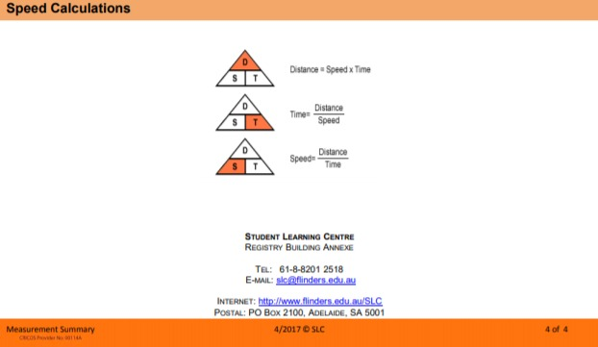
2  3. | Pratice – https://www.proprofs.com/quiz-school/story.php?title=calculating-speed  Quiz-https://quizizz.com/admin/quiz/587f80f0030439325e99467c/calculating-speed

