Smart School for Smart Age

Lesson plan - Erasmus +
Subject: literature
Number of lessons: 2
Teachers: Fatma Özet
Topic: Biographical Essay
Key words: biography
Lessons objectives:
In a biographical essay, you write about the life and personality of a person who actually lived. A biographical essay should have the following characteristics:
- a thesis statement that states a specific idea about that person’s life and achievements
- an account of one or more major events in the subject’s life
- a description of the subject’s key character traits
- a real-life subject

Resources
- Computers with internet access;
- Multimedia projetos;
- Tablets with internet access;
- Mobile Phones with internet access.
Lessons sequence/activity
- Chooses the subject
- Gathers information
- Writes a thesis statement

Smart School for Smart Age

Lesson1 - YOUTUBE RESOURCES

Sentences to Inequalities

1. | Learn - here’s a link below  https://www.youtube.com/watch?v=48D09oEgZjU&ab_channel=TutorPhil
2. | Pratice – here’s a link below  https://www.youtube.com/watch?v=q7abluGwup8&ab_channel=TalaPasley
3. | Quiz – here’s a link below  https://www.youtube.com/watch?v=akmCwhsL6jU&ab_channel=EnglishWithMedChannel

Narrative Essay
Northwest Territory, European wars

Biographical Essay

€ Introduction
For a review of the steps in the writing process, see the Historian’s Toolkit, Write Like a Historian.
In a biographical essay, you write about the life and personality of a person who actually lived. A biographical essay should have the following characteristics:
• a real-life subject
- a thesis statement that states a specific idea about that person’s life and achievements
- an account of one or more major events in the subject’s life
- a description of the subject’s key character traits
Assignment On the following pages, you will learn how to write a biographical essay. You will get step-by-step instructions. Each step will include an example from a sample essay discussing the life of George Washington.
Read the instructions and the examples. Then, follow each step to plan and write a 500–700 word essay.
Discuss one of the historical people from Unit 3. Review his or her most important contribution to
the nation, giving reasons for your choice.
Sample notes about George Washington

€ Prewriting
father of his country
first in war, first in peace, first in the hearts of his
Choose your subject. Choose a person whose life seems especially appealing to you. Once you have decided on a subject, make notes about what you already know about his or her life and personality.
ountryme
Washingto s father was a wealthy Virginia planter.
Washington fought in the French and Indian War
ed disorganized, poorly funded Continental army in
the Revolution against better-trained, better-funded
professional British soldiers
struggled with Continental Congress for money
encountered many tough situations as President and
knew each decision would have impact on the future
the nation faced financial problems: debt crisis,
s plan
faced other crises: Whiskey Rebellion, conflict in

Sample questions about George Washington
What was Washingto s family background like?
What about his education?
What qualities made him a good general? Were they
the same things that made him a good President?
ow did his soldiers feel about him? How did other
eaders feel about him

have learned more about your subject and reflected on his or her life and personality. You are ready to write a thesis statement.

Gather information. Once you have reviewed what you know, think about what areas of this person’s life you would like to focus on. Then, write down some questions to help you direct your research.
Draw conclusions. Based on your research, make some decisions about your subject’s personality. What did he or she value most? Is there a connection between your subject’s character traits and his or her role in history?
Write a thesis statement. You
Sample thesis statement: George Washington was not a very imaginative man, but he had a practical, steady mind—a quality that was necessary to give stability to our new nation.
ow effective was he as a President
What was Washington like as a person?
What were his personality strengths and weaknesses?
t? What did he not do as well?

€ Drafting
Decide how to organize your writing. The simplest way to organize a biographical essay is to cover the main events of the subject’s life chronologically.
Another type of organization focuses on a few important events in the person’s life, building up to the one that you think is most important.
Write an introduction. The first paragraph of your essay introduces your subject. The introduction leads up to the thesis statement, which expresses the idea you will develop in your essay.
Support your thesis with examples and details. Use the information you have gathered to support and develop your idea about your subject.
Use an informative, lively tone. As you write your draft, enliven your writing with vivid language and colorful details that appeal to the senses.
Write a strong conclusion. In your final paragraph, restate your view of the person about whom you are writing. Tell the reader what this individual has contributed to the country.

Read the following model of a biographical essay about George Washington. Notice how it includes the characteristics you have learned about.

€ Model Essay

The opening paragraph is an introduction to the subject. It can
include an anecdote.

Is this essay organized chronologically; by focusing on a few events; or by contrasting the public’s opinion with the real man?
George Washington: A Quiet American Hero

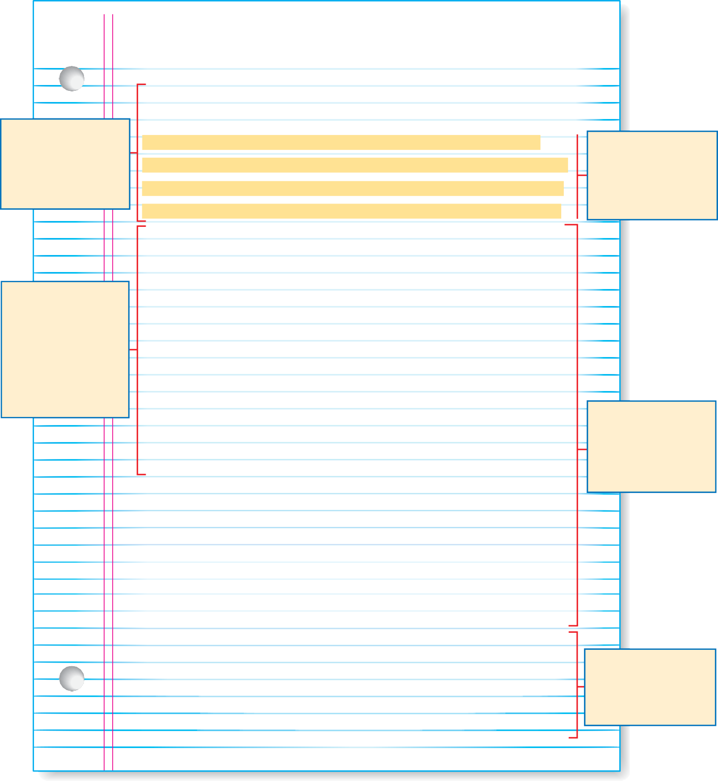
When George Washington was a boy, he liked to make up his own sayings. “Lean not on anyone” was one of them. As he grew older, a strong sense of self-reliance and responsibility—to his family, his soldiers, and his country
—shaped Washington’s character. It gave him a quiet strength that helped him direct the course of our nation.
Washington grew up on his family’s Virginia plantation.
As a young man, he decided to learn a trade as a land surveyor. George Washington was only sixteen years old when he set out on his first surveying expedition. Sleeping outdoors and hunting for his food made the teenager more mature. This maturity and sense of responsibility were the perfect qualities for a military leader.
Seven years later, Washington was already a colonel commanding Virginia’s colonial troops. At six feet two inches tall, he was a forceful leader who inspired his men to defend the colony’s 350-mile western frontier.
In 1775, Washington’s leadership was called upon one more time. The Second Continental Congress named him commander in chief of the army. From 1775 to 1783 his strength helped his soldiers overcome many problems.
Washington’s troops didn’t have enough supplies, and many soldiers deserted. The men suffered horribly during the bitterly cold winter at Valley Forge.
After Washington’s death, Thomas Jefferson said about the leader, “His integrity was most pure, his justice
the most inflexible I have ever known.” Without this quiet
American hero, with his strong sense of responsibility, our
nation’s early history would have been very different.

The thesis statement introduces the idea that will be developed in the essay.

Each paragraph includes examples and details to develop ideas about the subject.

The conclusion restates the thesis statement in a new way.

€ Revising

After completing your draft, read it again carefully to find ways to make your writing better. Here are some of the things you should look for.

Revise to strengthen your thesis
  - Do the introduction and thesis statements create a clear, unified impression of the person about whom you are writing?
  - Do the body paragraphs develop this impression?

Revise to meet written English-language conventions
  - Are all sentences complete, with a subject and a verb?
  - Are all the words spelled correctly?
  - Are all proper nouns capitalized, including names of people and places?
  - Did you use proper punctuation?

€ Rubric for Self-Assessment
Evaluate your biographical essay using the following rating scale:

 | Score 4 | Score 3 | Score 2 | Score 1
Organization | Supports the thesis with a series of logically | Uses a reasonably clear organization, but | Chooses an organi- zation not suited to | Shows lack of organi- zational strategy
 | ordered paragraphs | occasionally includes | the topic (for example,
 | creating a clear | less relevant informa- | presents personality
 | impression of a real-life | tion (for example, | traits without tying
 | person, organized | anecdotes or facts that | them to an overall
 | chronologically, by | wander from the thesis) | impression or to the
 | order or importance, |  | subject’s actions)
 | or by character trait
Presentation | Discusses the life and personality of the | Discusses the life and personality adequately | Does not discuss the life and personality | Does not provide any facts, details, or
 | subject in a way that | with several facts, | adequately in any | examples about the
 | develops a clear | details, or examples; | detail; does not link | subject’s life and
 | impression of the | links most supporting | supporting informa- | personality
 | person with facts, | information to the | tion to the thesis
 | details, and anecdotes | thesis
 | from the subject’s life;
 | links all information
 | to the thesis
Use of Language | Varies sentence structure and voca- | Uses some variety in sentence structure and | Uses the same types of sentences without | Writes incomplete sentences; uses
 | bulary successfully; | vocabulary; includes | varying them; repeats | language poorly;
 | includes no or very | few mechanical errors | words; includes many | sounds confused;
 | few mechanical errors |  | mechanical errors | includes many
 |  |  |  | mechanical errors

