Trip to Poland

In the 22-28th days of September, we had a visit to Poland, Sulmierzyce – there we lived with host families. All I can say is that this trip gave me so many emotions, experience and many other feelings, and now I will tell you how and why...
1st day. On Monday we visited the school of Sulmierzyce and met all project students from other countries. Then we visited important places of this city community and learned some history. Also, we had sweet gifts from Sulmierzyce community and lunch. In the evening we drove to teachers hotel and watched a presentation and concert from Poland students.
2nd day. On Tuesday we had a trip to Wroclaw. We visited an incredible big zoo, oceanarium. We walked the streets of Wroclaw and listened to the history of this city. We got home very tired (in a good way) and happy.
3rd day. At the start of Wednesday, we were kinda nervous, because we presented our homework- presentations. After this, we had work in groups – workshops. When we got home, everyone had individual free time with host families. I with my host family had fun in a trampoline park.
4th day. Poznan. In Thursday we visited this beautiful city and interesting places of the city. Also listened to the history and watched fighting goats on the clock tower. After this, we had a chance not only to watch how croissants were cooked, but some of us had a chance help to cook them! The day was full of fun and good emotions.
5th day. On Friday morning we had a trip to Krotoszyn and also we visited the market. After this, we had lunch in a pizzeria and got home. At the evening we drove to the hotel and participated in official, a project in Poland. closing part - we got certificates. After this, we had a party. And when we realized it was the last evening with our friends…
Saying goodbye is always hard… I never realized that people in such little time can make such strong bonds! It was really hard to stop the tears and let go of our new friends. This trip to me gave so many cultural experiences, new English and Polish language skills, cooperation experience and new emotions. Expanded my worldview and perception. Thank you ERASMUS+!

Ieva Gaidytė

This trip to Poland gave me a lot of new experiences! I found new friends that will help me learn English even better. And my communication skills will increase as well. It will help me in future plans. New places I visited was very beautiful. We have a few places like that in our own country so its really wonderful to visit. The cities we visited were not much different from ours but it had so many unspeakably beautiful places. For example, Poznań had really big central market place there was a lot of souvenir shops and food shops too. And croissants in Poznan was very tasty I still can remember that pleasant taste. Also, Wroclaw had huge zoo park where I saw some animals that we didn’t have in Lithuania. Also, I bought a toy monkey and gave it to my Portugal friend so she can remember me. Some memories will stay in my head entire life. I’m glad that I joined this project.
Donatas Verbickas
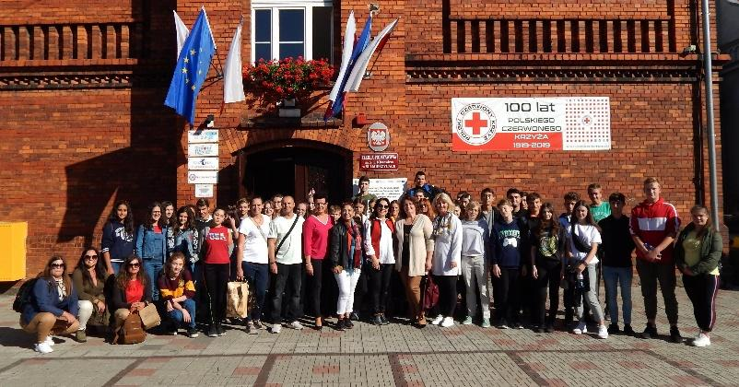
In this trip, we meet a lot of new students from other countries. We got really close and didn’t want to split up. In this trip to Poland we travelled a lot around Poland we went to Wroclaw and Poznan city. And also, we had some time in Krotoszyn market. We were living in town Sulmierzyce.
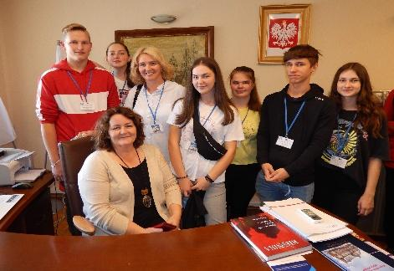
In this town, people are very close and know each other. The host families were really nice and welcoming. In Wrocław we went to a zoo and saw a lot of animals I really liked it and we were counting little gnomes around the tow.
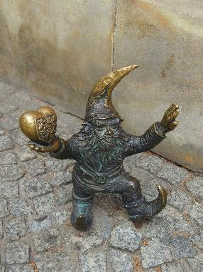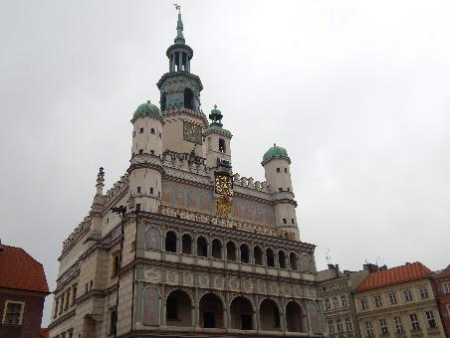
And in Poznan, we saw the famous Poznan Town Hall and after that we made croissants.
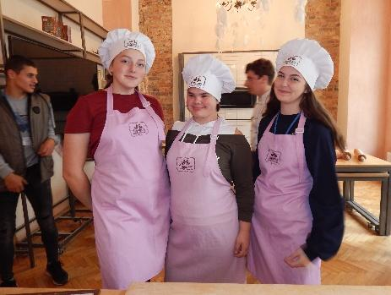
All around our trips we saw a lot of churches and cathedrals.
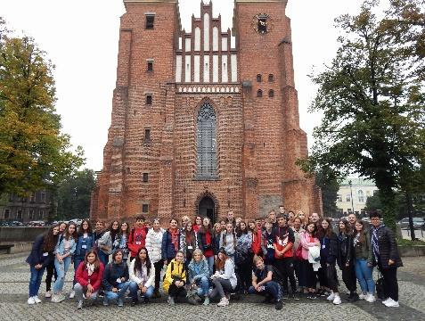
In school, we were participating in different workshops that were linked to the Catholicism. For the summary of this trip, I would say that we got to know Poland’s culture and history also got to know the people that live in Poland and made some friends.
Saulė Peseckaitė
In this trip we had so much fun because we made new friends, we got to know their culture and how they live also got to know their history and how they welcome people, they meet us very friendly.
On the first day we came to the school, in the school we got information about how they are learning, and how much students they have, we had a chance to see some lessons.
On the second day we had a trip to Wroclaw there we went to a zoo and we had a good time, we meet new kinds of animals, some of them were wild. In Wroclaw we had a chance to stroll around the city and count all dwarfs, also we had a chance to go to the mall.
In the third day we came to Sulmiezyca museum there we saw what kind of clothes Polish people had, how they message each other, how they sleep and what kind of job they had to do. We were invited to the kindergarten to listen to the song that children learned, and a little bit of history how they are learning.
In the fourth day we had a trip to Poznan there we saw the nice show of how two goats are biting with horns in this towns hall, it‘s like Polish tradition ‘If you didn’t see that so what you did in Poland’.
In the fifth day we went to bazaar there we spent not to much time but we liked it, later we had a party where we got certificates, had dances, and then we had time to say goodbye to everyone, and do some photos.
From this trip, I got not just knowledge about Poland’s culture, people and history, but also some good friends.
Arnoldas Vasiliauskas
On our first day, Sunday, in Sulmierzyce, we had a lot of time to get to know each other and have a look around the town with our host families.
On the second day, we had a tour around the school and Sulmierzyce. Also, we have visited Town Hall in Sulmierzyce. Later, on the same day, we saw a presentation from Polish students about their country, town, school, and etc.
Tuesday was very fun because we had a trip to Wroclaw. We've been to Zoo park, shopping mall had a tour around the city with a guide. The day was full of impressions, it was wonderful.
On Wednesday we presented our homework. It was really interesting because we heard and found out so much about foreign poets and their works. It took longer than it was planned so we missed the first workshop (as written in agenda). But that's okay because the second workshop was very great. We divided into groups and had different tasks. I've had a task to paint an icon.
On Thursday we had a trip again, to Poznan. We had a tour with a guide around the old town, we saw Poznan Goats, which appear at noon from the central towers and for a minute they butt horns. Then we've been to Poznan Croissant Museum. We heard a story about St. Martin and the croissant. Volunteers even tried to make St. Martin's croissant. After that, we ate croissants made by the previous group. Later we went to the shopping mall and had a few hours to spend there.250.
On Friday we went to Krotoszyn's market and spent there some time. Also, we had some free time in Krotoszyn. Our group together with Portugal group went to eat ice cream. In the evening we had our last dinner/party at the hotel. We received our certificates there.
In summary, the project was very very cool. We found out so much about Poland, especially the cities we've been to, learned about foreign poets, found so many new friends from all countries and didn't want to split up, go home. Until this day we talk to each other on the internet.
Karina Butrimaitė

