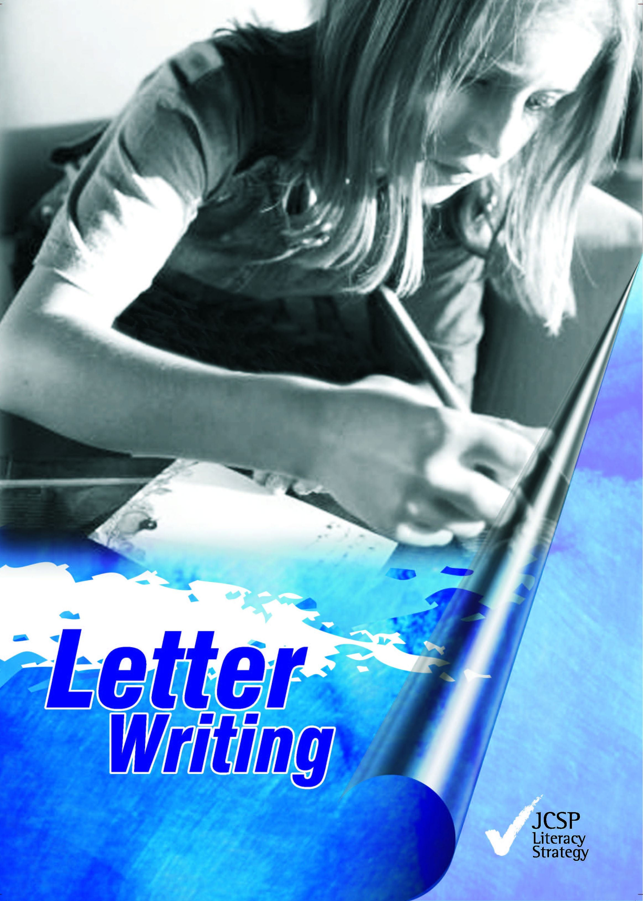

Letter Writing

Published in 2006 by
Junior Certificate School Programme Support Service Curriculum Development Unit
Sundrive Road Crumlin Dublin 12

Phone: 01 453 5487
Fax: 01 402 0435
Email: jcsp@iol.ie

First written and published by teachers involved in the School Certificate Project, CDVEC Curriculum Development Unit 1989.

Revised and edited by Fiona Richardson, Junior Certificate School Programme 2006. Designed by Melt Design Ltd – www.melt.ie.
The Junior Certificate School Programme Support Service is funded by the In-Career Development Unit, Department of Education and Science and the European Social Fund.

The Junior Certificate School Programme Support Service is a national Programme sponsored by the Department of Education and Science and the National Council for Curriculum and Assessment.

Contents

Introduction 4

Section | 1: | Informal Letters & Postcards
 |  | - Informal letters | 7
 |  | - Addressing envelopes | 12
 |  | - Postcards | 14

Section | 2: | Formal Letters
 |  | - Letters of complaint | 26
 |  | - Letters asking for information | 31
 |  | - Letters making a booking | 34
 |  | - Letters of application | 37
 |  | - Curriculum Vitae | 42

Section | 3: | Keywords
 |  | - Abbreviations | 47
 |  | - Quiz | 48
 |  | - Wordsearch | 49
 |  | - Word Grid | 49

Introduction

This booklet is about writing letters. People can tell a lot from the way you write letters, so you will need to practice writing many kinds of letters.

Most of the letters you will need to write will be:

- Informal or personal letters
- Formal Letters for example:
  - Business letters
  - Job application letters

This workbook will give you a chance to write all of these.

How to use this book

- There are three sections. Each section shows you how to write a different kind of letter.

- There is a sample letter, followed by exercises for you to do.

- Write each letter in your copy first. When you and your teacher have corrected it, you can copy it carefully into the blank page provided in this book.

- When you finish the workbook you will have your own collection of letters to look back on when you need to revise.

Introduction

Rules for all letters

  - It is important that your handwriting be neat and clear.
  - The writer's address is written in the top right-hand corner.
  - Leave a space between the address and date.
  - Spell out the month in full, e.g. 15th February 2006
  - Begin the letter Dear , on the left-hand side.
  - The first paragraph of the letter begins under the person's name.
  - A formal letter usually ends with either: Yours sincerely, or
Yours faithfully,

  - Followed by your signature. (Note: 'Yours', always begins with a capital letter, but 'sincerely' and 'faithfully' begin with a small letter.

  - Always use plain unlined paper and the same colour envelopes. A large size writing pad is best for most letters.

  - Write your letter in blue or black pen only.
  - Revise the rules for using capital letters.
  - Always use paragraphs when writing a letter.
  - All of these rules are shown on the sample layout on the next page.
  - After you write out your letter in the workbook or in your copy check back here to see you have followed all the rules for letter writing.

Section 1
Informal Letters & Postcards

  - Informal or personal letters are those you write to people you know – friends, cousins, aunts, uncles, etc.

  - Informal letters should be friendly, chatty and relaxed as though you're talking to the person.

  - You sign an informal or personal letter using phrases like – Best Wishes, Love, Yours truly, Lots of love etc.

  - You must, however, obey the rules for all letters. Look back at page 2 and check these out.

  - Look at the example of an informal letter below and do the exercises that follow.

Informal letters exercises
- In your copy write your own address and today's date as you would write it on a letter.

- Write the following addresses and dates as they would be written on a letter: Remember capital letters, commas and fullstops.

Address: Date:
  - 65 shamrock court mounthill limerick 6-4-06
  - valeview shadowlands mallow co. cork 28-9-06
  - 125 st. patricks crescent doddermount dublin 22 17-2-06

- Write your own signature as you would write it at the end of a letter.

- Write out these endings as they would be written at the end of a letter. Use capital letters and commas.

  - best wishes tom
  - lots of love margaret

- Look at the following letter and rewrite correctly using capital letters, commas,
and full stops. There are 14 mistakes you need to correct! (9 capital letter, 4 commas and 1 fullstop).

- Pretend that you are Sally. Reply to Joe's letter above telling him all about life in your new school in Cork.
- Pretend you are Phil Martin. Write to Sally telling her all about your break-up with Sandra Byrne.

Letter of invitation
1 Read Sally’s letter below and write a letter back, letting her know if you can make the party or not. Use the blank paper on the opposite page to write your reply.

- Write your reply here using Joe’s address from page 8.

- You have been asked to your cousin Paul's 21st birthday party on Friday 15th April at 9pm. In your copy write your reply letting him know if you are going or not.

- You have just spent the weekend with your friend in the country. Write a letter thanking him/her, in your copy.

- You have just received a very expensive birthday present from your godmother. In your copy write and thank her.

- Your class tutor is sick in hospital. Write a letter to her/him on behalf of the class. Don’t forget to give the news and gossip.

Addressing an envelope

Look at the following envelope and note where the address goes and the use of capital letters, commas and full stops.

1 This letter is addressed incorrectly. Using the blank envelope on the next page rewrite the address correctly. There are 8 capital letters missing, 3 commas and 1 fullstop.

- Remember to put the address and the stamp in the correct place on the envelope.

- Address the envelope below to yourself.

Postcards

There are two types of postcards:
- plain postcards
- picture postcards

Plain postcard can be used for short messages. For example:
- to send for an application form. You would include your name and address on the postcard.
- to enter a competition. You would include your contact details – phone number or address.
- to remind somebody of an appointment or a meeting.

Picture postcards are often used to send greetings when you are on holidays. The message is usually fairly short and friendly.

Leave out:
- your own address
- the date

Plain Postcards
This is the back of a plain card, asking for an application form.

You address the front of the plain postcard the same way as an envelope, leaving room for the stamp.

Exercise

- Send for a job application form for a summer job in a local clothes shop on the postcard below.

- Send for information on photography courses this college runs.

Information Officer
Marion College of Further Education Fairview
Dublin 3

Write out the front and the back of the postcard in your copy.

- Write a postcard to the members of your youth club, reminding them of a meeting on Friday 21st June, in St Joseph’s School at 7pm.

Picture Postcards
Picture postcards are usually sent to friends and relatives letting them know how your holiday or trip is going.

Exercise

1 Write the postcard you would send home to your family from a school trip to a hostel in Wicklow.

- Write the postcard you would send to your friend from a camping holiday with your family.

- Write the postcard you would send to your brother or sister from a holiday with your friend’s family in Spain.

Section 2

Formal Letters

Formal letters

Formal letters are business like and get quickly to the point. Formal letters are different to personal letters. You do not write in a chatty manner or use slang. For example, you would write a different letter to your Principal inviting him to your class JCSP graduation as you would to your friend.

Formal letters are usually written for some of the following:

- To apply for a job.
- To make a complaint.
- To order goods.
- To the editor of a newspaper.
- To ask for something – a form, an appointment.
- To ask for information.
- To make a booking for a holiday etc.
- To invite someone to an event or to visit such as a school open day or a JCSP celebration.

Points to note:

- The sender's address (your address), is on the top right hand corner.
- The address of the company/person to whom the letter is being sent is written on the left-hand side.

- When you do not know the name of the person to whom you are writing, you may start with 'Dear Sir/Madam'.

- If you begin with 'Dear Sir/Madam', you end the letter with 'Yours faithfully', and your full name.

- If you know the name of the person you are sending the letter to e.g. Dear Ms Smith, you end the letter with ‘Yours sincerely’ and your full name.

- Remember to use capital letters, full stops and commas.
- Use paragraphs in your letter – at least 3.
- Look at the following example and try the exercises that follow.

Exercise

- Rewrite the letter below on the opposite page, using paragraphs (3) and the capital letters that are missing (11).

Write out the the letter from page 19 here.

- Look at the advert below. On the opposite page write a letter to the Mail Order Department asking for a tracksuit to be sent to you. Remember to include the colour and size you are looking for.

Write your letter here using your own address.

- On the envelope below address the envelope for the letter you have written ordering a tracksuit. Look back at the advert for the address.

- Pick out an advertisement for goods in a newspaper or magazine like Buy and Sell and write a letter ordering something you like.

- Write a letter to your local shop asking them to order a magazine you would like to be able to buy there.

Letters of complaint

Another type of formal letter which you may have to write is a letter of complaint.

You will need this kind of letter if you have bought faulty goods, or you have a complaint over a certain issue or topic.

Remember always to include all the important details of your complaint.

Letter of complaint – faulty goods

Exercise

- You have bought a pair of trainers which are faulty – the sole of the trainer has become unglued after one day. In your copy, write a letter of complaint to the company/shop from which you bought it, giving all the details and asking them to replace or refund your money.

- You have recently bought a 3-in-1 stereo set from Murphy Electrical Stores, Talbot Street, Dublin 1. It has broken down and Murphy's have repaired it once. Now the CD part of it is broken and you would like a new one but Murphy's have refused to give you one. You have decided to write to the manufacturers/makers of the stereo to complain.

  - Write out your final version of one of these letters on the following blank page. Remember to use capital letters, full stops and commas. Also use at least 3 paragraphs in your letter.

  - Write to the manufacturer: Sonny Electronics Ltd., Newtown Road, Finglas, Dublin 11, and include these details:

    - Name of shop where you bought it
    - Date you bought it
    - Model number (WVF 200GB/34)
    - What is wrong with it
    - What you want them to do

Another type of letter of complaint could be about an issue or topic that you are concerned about.

Letter of complaint – Issue or Topic

- Address the envelope for the letter written on the previous page.

- Write a letter to your Principal telling him/her of a bullying situation in the school that you know about. Tell him/her what has happened, how long it is going on for and what you think is needed to improve the situation.

- Write a letter to your local politician asking for more bins to be put in your area to improve the litter problem.

- Write a letter to your favourite radio station asking them to have less stories of teenagers behaving badly and more about the good things teenagers do in their communities.

Other formal letters that you can write are to organisations or companies looking for information.

Letter asking for information

- Write a letter to Redrock Adventure Centre, Castletown, Co. Galway, asking for information about summer courses for young people. Explain what kind of course you are interested in (football, basketball, canoeing, sailing, rock climbing etc.) and the cost. Also look for information on places to stay near the Adventure Centre.
- You are the secretary of your local youth club. They have asked you to find out about taking a group of ten people on a cycling tour of Co. Wicklow, staying at three different hostels. Write to the Information Office, An Óige, 39 Mountjoy Square, Dublin 1, asking for information about hostels in Wicklow, and about group rates.

Use the blank page to write our your final version of one of these letters.

Sometimes you might need to write a letter to make a booking for a trip or a concert.

Letter making a booking

Exercise

  - You have received a brochure from the Oaktree Hotel, Marigold Street, London EX12. Write a letter booking accommodation for your family of two adults and three children. You will be staying for one week and would like bed and breakfast only. Send a deposit to confirm your booking.

  - An Óige have sent you the information you asked for. Write to them, booking accommodation for your group. You will be staying for one night in each of the following hostels:

    - Glencree Hostel
    - Aughavannagh Hostel
    - Glendalough Hostel.
Copy out one of these letters neatly on the blank page opposite.

Letters of application

- It is very important to be able to write a good letter when you are applying for a job. This kind of letter is called a letter of application.

- Sometimes you will have to fill in an application form, but at other times you will be asked to write a letter.

- Many people send a Curriculum Vitae, or CV for short, with a letter of application.
- A CV gives all the basic details about you and means your letter of application can be quite short.

- If you have not prepared a Curriculum Vitae/CV, you will need to give all the important details about yourself in your letter.

- These are important things which an employer needs to know about you.
  - age.
  - school attended.
  - educational record.
  - work experience.
  - any special skills.
  - hobbies or interests.
  - have you got references?
  - are you available for interview?

Letter of application (1) – Sample (without CV)

38 Letter Writing

Exercise

1 Look at the following job application letter. Rewrite this letter on the following page. Divide the letter into 6 paragraphs and put in the 9 capital letters that are missing.

- In the space below address the envelope that the job application letter from question 1 would be posted in.

- Write a letter applying for one of the following jobs that appeared in the Evening Herald on May 23rd:

Part-Time help required by fast food restaurant would suit student.

Apply to: The Manager
Pizza World Main Street Rathcoole Co. Wexford

Friendly, Honest young person needed for part-time work in busy sports shop

Apply to: Sam Brown
Manager Sports Scene
O'Connell Street Limerick

The following is an example of a letter that you would send along with your CV when applying for a job.

Letter of application (2) – Sample (with CV)

Exercise

- Write a letter of application that you would put with your CV, in reply to the advertisement below. The advert appeared in the Evening Herald on July 2nd.

Friendly, responsible young person needed part-time for busy petrol station and shop.

Apply with CV to: The Manager
Max Petrol Station Summerhill Road Naas
Kildare

- Use the headings that follow and complete this CV. (Use your own details for this CV.)
CURRICULUM VITAE

Personal Details

Name:

Address:

Date of Birth:

Educational Record

Secondary School:

Dates Attended:

Work Experience Name and Address of Employer:

Dates of Employment:

Part-time:

Duties:

Interests and Hobbies:

Referees:

1.

2. .

Section 3

Keywords

Some important keywords and phrases

Abbreviations
These are short forms of words which are sometimes used in letters or addresses. When you shorten a word, you must put a full stop after it to show that you have left out some letters.

Quiz – abbreviations in names

Match the following abbreviations to their meaning drawing a line. The first one is done for you.

Mr. Street

Ms. Grove

Dr. Road

Fr. for a priest

Ave. Gardens

Cres. Park

Dr. Avenue

Gdns. Drive

Gr. for a woman

Pk. for a man

Rd. for a doctor

St. Crescent

SCORE: out of 12

Letter Writing Quiz. Put a tick in the box beside the correct answer.

- When you write an informal or formal letter you always put your address on:

The top left hand corner
The bottom left hand corner
The top right hand corner

- The date of a letter always goes:

Under your address
Under your signature
Under the greeting

- When you do not know the name of the person you are writing to you begin your letter with:

Dear Sir Hi Dear Sir/Madam

- In a formal letter when you know the name of the person you are writing to the sign off you use is:

Yours faithfully
Yours sincerely
Lots of Love

- You are writing to a person called Ronan Quinn, who is the Manager at Sports World. You want to complain about a tracksuit you bought. The colour has faded after one wash How would you begin the letter?

Dear Ronan
Dear Mr Quinn
Dear Quinn

- You are writing to the Principal of a school. Which sign-off would you use?

Yours faithfully
Your friend
Love

- You are writing to the manager of Max Petrol Station to ask about vacancies for part-time work. It's on Summerhill Road, Castletown, Dublin 4. You don't know the name of the manager. How would you address your envelope?

Max Petrol Station Summerhill Road Castletown Dublin 4
The Manager
Max Petrol Station Summerhill Road Castletown Dublin 4
The Manager Summerhill Road Castletown Dublin 4

SCORE: out of 7

Letter writing word search

C | Y | L | L | U | F | H | T | I | A | F | W | A | Y | S | ADDRESS
Z | U | A | V | A | I | L | A | B | L | E | C | P | L | I | APPLICATION
T | B | R | I | L | N | S | E | W | I | M | Q | P | E | G | APPOINTMENT
S | N | A | R | A | A | T | U | V | I | A | B | O | R | N | AVAILABLE
R | X | E | U | I | A | M | R | Q | P | J | I | I | E | A | CURRICULUM VITAE
Q | E | D | M | D | C | E | R | P | Y | N | L | N | C | T | DATE
R | X | F | B | T | T | U | L | O | F | P | U | T | N | U | DEAR
F | I | I | E | N | R | I | L | O | F | F | F | M | I | R | DEPARTMENT
T | C | Z | I | R | C | A | R | U | U | J | K | E | S | E | FAITHFULLY
W | V | K | D | A | E | M | P | R | M | Y | V | N | U | Y | FORMAL
O | E | N | T | U | A | N | G | E | M | V | S | T | E | J | INFORMAL
N | M | I | D | L | U | N | C | A | D | N | I | C | P | F | INTERVIEW
W | O | S | C | S | M | T | S | E | D | X | P | T | X | L | REFERENCE
N | S | S | E | R | D | D | A | O | E | W | S | N | A | D | SIGNATURE
K | A | M | I | S | X | L | S | V | T | N | A | V | L | E | SINCERELY
1.

Letter writing word grid
2.

3
.
4.

5.
6.

7.

8.

9.

Across
2 Short for avenue
4 Another way to write this is Rd.
- This goes at the bottom of you letter
- Short for a woman
- Short for a doctor
- If you don't know who you are writing to sign off with this

Down
- Most letters start this way- it's a greeting
- You put this in the top right hand corner of a letter
- Short for a man
- It's on a calendar
- If you know the name of the person you are writing to, you finish the letter with this

More abbreviations

You may see these short forms of words used in letters:

Bros. – Brothers (in a company name, e.g., Smith Bros).

Co. – Company

C/o – Care of (if you are writing to somebody at an address which is not their own).

C.O.D. – Cash on Delivery (means goods will be paid for when they are delivered).

Dept. – Department

Etc. – "and so on" (et cetera).

N. B. – "note well" (nota bene).

P. S. – post script (a message added on at the end of a letter, after the signature. Usually only used in personal letters).

R. S. V. P. – please reply (French – respondez s'il, vous plait).

s.a.e. – stamped addressed envelop (an envelope with a stamp, addressed to yourself).

