Erasmus + Smart schools for smart age
 | Sports school G. S. Rakovski  Dobrich, Bulgaria  Lesson 7:  Mathematics - Prism | 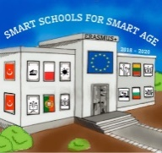

Lesson 7 Introduction to geometry
Class 7
Topic: Basic concepts in geometry.
Objectives:
- Introduction to geometry
- Learning the basic concepts in geometry
- Applying knowledge to solve problems

Resources:
- computer with internet access
- multimedia projector

Lesson source:
https://drive.google.com/file/d/13N45rjOa3xcUuoBUqdkqR1cecJoublQI/view?usp=sharing

