OUR GYMNASIUM PARTICIPATES IN THE INTERNATIONAL ERASMUS + PROJECT "SMART SCHOOL FOR SMART AGE" AND OUR STUDENTS ARE SHARING THEIR IMPRESSIONS ABOUT THE FIRST MEETING IN TURKEY
During this school year, our gymnasium started to participate in the Erasmus + Smart School for Smart Age project.
The aim of the project is to develop intercultural, linguistic, information technology, mathematics, literature, literacy and religion competencies of pupils involved in the project, they are also supposed to use the good learning experience of different cultures, to improve communication and cooperation skills in a multicultural environment.
The Project Coordinators are the Agrupamento de Escolas Antonio Correia Oliveira School in Esposende, Portugal. Project partners are Ozel Canik Ugur Anadolu Licay of Samsun in Turkey, Rakowski Sports School in Dobrich, Bulgaria, and Skola Padstawowa in Poland.
In September, a project coordinating committee was established at our gymnasium. Members of the Committee are the School Director Lolita Mikalauskienė, Deputy Regina Barsuliene, English Language teacher Ingrida Lisinskiene, Mathematics Teacher Regina Ratkeviciene, Lithuanian Language Teacher Vilma Kisielytė - Hancharyk and Dana Bruzgiene, Teacher of Religion. Participants of the project are 14-18 year-old school students.
By the end of October, students enrolled into project activities. Five pupils from the gymnasium were selected to participate in the first meeting of countries in the city of Samsun in Turkey. These students are Ieva Gaidytė (2nd gymnasium form), Virmantas Miloleika (IVg), Saulė Peseckaitė (IIIg), Beata Subočiūtė (IIIg), Eva Gordynec ​​(IIIg. form).
The pupils had to do a homework assigned by the coordinators : to create project logos and submit them to the logo competition, film and create a movie about Lithuania, the Dieveniskes region and our gymnasium. The Pawtoon program was used to create the movie. Students also had to answer a questionnaire sent by the partners about the countries and traditions of the project.
After doing homework, on January 6th the mentioned pupils accompanied by director Lolita Mikalauskienė and English teacher Ingrida Lisinskienė went to the city of Samsun in Turkey. The first visit in Turkey lasted from 2019 January 6 to January 12 The pupils and their teachers participated in Turkish language lessons, attended maths, literature, and religion lessons in Anadol Ugur High School, participated in creative workshops where the Turkish school's good experience in mathematics and literature teaching was presented, and pupils were actively involved in creative workshops.
Pupils from Portugal gave lessons on how to work with the new Edmodo lesson creation and learning platform. Teachers, who were supposed to introduce Edmodo platform to their school community, were trained. One of the requirements of the project is that the lessons of mathematics, religion and literature should be created and posted on the virtual platform Edmodo, students should join this system and do homework, tests and surveys created by teachers.
During the visit, the pupils and teachers were acknowledged not only with the Turkish education system, the work in their High school, but we also visited the most famous monuments and art galleries of the city of Samsun. The central museum of the city, the Toy and Ceramics Workshop, the City University, the Ship Museum, and the Amazon Park left a huge impression on us. In 2019 Turkey will be celebrating its 100th Independence anniversary, and the whole city is decorated with advertisements dedicated to celebrating its 100th anniversary. Thanks to the tour guide we got to know the rich history of Samsun, the most important historical personalities, we tasted delicious Turkish dishes, sharp soups and sweets that are unusual for our culture.
According to the pupils, such projects not only provide an opportunity to meet new people, but also allow to compare their national and other cultural customs, teaching and learning content, teaching methods, discover new possibilities to expand the use of information technologies in our gymnasium, students also have the opportunity to communicate live in English, which is very important in the current global society.
At the moment we are starting to use the virtual Edmodo platform in mathematics, literature lessons and preparing for the second visit to Bulgaria on May 5 – 11of 2019. The visit to Lithuania is scheduled for the first week of June.

The students who participated in the first meeting in Turkey wrote their impressions and gave feedback about their trip.

Ieva Gaidyte wrote

|The trip to Turkey personally to me was interesting and very useful. The Week in Turkey gave to me useful experience with the English language. Also we had a marvellous possibility to try some Turkish food and desserts.The host family to me was very good and friendly, they gave me everything what I needed and that was very nice.
During that week we alsohad classes in Samsun Uğur Okulları school and tours to museums and Turkish memorials. I liked every place we visited in this tours and maybe if it had been more tours to Turkish places it would have been even more perfect! During events and meetings with families or school students we had so much fun and nice moments!
Also all school students were very friendly and helpful. Leaving Turkey was very hard because of new friends, host family and amazing beautiful city Samsun... I think this week was amazing to me, thank you for this possibility Erasmus+! I really liked attending Turkish lessons and learnt many new things.

Beata Subočiūtė said

The first time I saw the school building I was really impressed. I can say that it is very modern and the view from windows was incredible.
The city itself is also a place to love and enjoy – architectures, museums, nice restaurants and much more. I lived in the host family apartment. I will miss them, because they were very nice and hospitable to me.
Turkish food was perfect, I liked it just after trying it. We had an amazing experience to see how another country students are studying and we were tring to study together with them.
It was nice to be in that school, because every person you met there had become your friend. People were very glad when we said that we are from Lithuania, they know where this country is and some of them were asking to tell more about our country and culture.

Saulė Pesckaitė gave such a feedback

The first day of school was interesting because we had a tour around the school and saw all the classes and met everyone from different schools and saw presentions of other schools and learned a Turkish dance.
On the second day of our trip students presented Web tools and we visited a different museums
like Canik toy museum, Panorama 1919. On other day we went to a ship there we heard that story about Turkish hero Ataturk. We went to a beautiful Park and saw a beautiful memorial for Ataturk.
On Thursday we were joining the lessons, it was very different from our lessons, but it was interesting to participate in lessons.
I joined English, Math, German, Literature lessons. Sometimes we were together with all the students and played games, sang songs or just chatted on different topics. In conclusion, I want to say that I liked how the project was presented to us.

. In conclusion, I want to say that I liked how the project was presented to us.

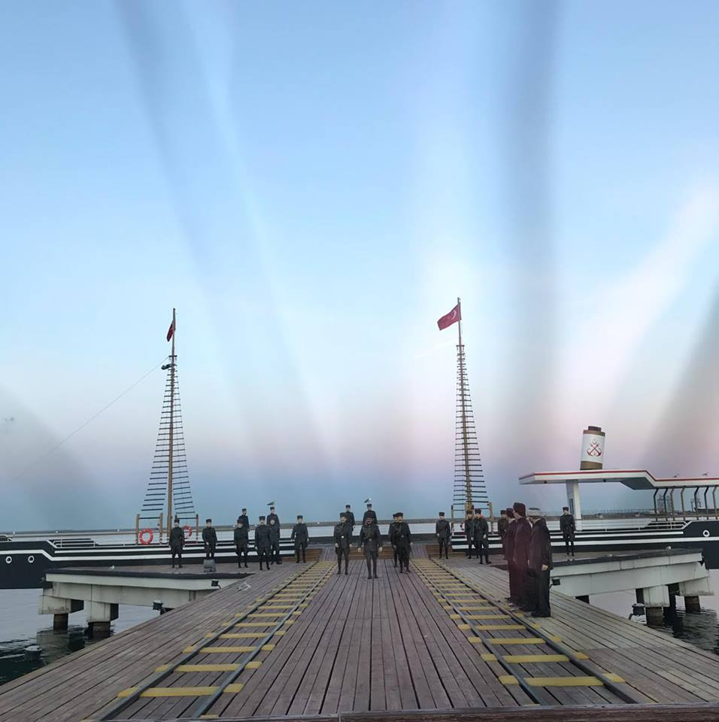

Virmantas Mikoleika wrote in his diary

My trip to Turkey went wonderfully. On the first day, there were presentations of each Eramus+ partisipating school, we were learning what activities they are doing in the school.
The Other days we were attending classes with our Turkish friends, all teachers tried to interact with me and we were playing games so it would improve our English language at the same having some fun. We had presentations of Turkish student and teachers who were dancing and played music, we even learned some dances.
In the school we met a lot of new friends with whom we were improving even more our English language skills. After couple classes two days in a row we were going to museums, learning about Turkey culture, we were going around a lot of places of Samsun.
On the fourth day evening we had party were we had just good time dancing, talking with people, we were covering everything what we were doing during those four days. At last day we had couple lessons and then we were taken to a lot of places where we could buy souvenirs and other things we liked.

A lot of teachers said that the Lithuanian students and teachers spoke a very fluent English and were very active during all project activities.

Eva Gordynec had shared her impressions

Turkey is a beautiful country, full of interesting history, culture, and the Turkish people were very welcoming and friendly to visitors. I am so grateful to have had the opportunity to see this part of the world for myself.
Spending 7 days in Turkey with Erasmus+ project friends is a travelling adventure I will never forget. What a great time I had! I am really happy about my host family, they had shown me many beautiful places I fell in love with that. Time in school was really good, I enjoyed all the lessons in which I was, and also school activities were well planned.

