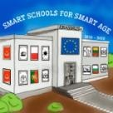
Smart School for Smart Age

Lesson plan - Erasmus +
Subject: Math
Number of lessons: 2
Teachers: Murat Avanoğlu, Deniz Ayata
Topic: BASIC GEOMETRIC FORMULAS AND PROPERTIES
Key words: Geometry, Formula, Properties
Lessons objectives:
- Identify and define points lines, line segments, rays, and planes.
- Classify angles as acute, right, obtuse, or straight.
Resources
- Computers with internet access;
- Multimedia projects;
- Tablets with internet access;
- Mobile Phones with internet access
Lessons sequence/activity
- Basic geometric formulas and properties with student learning assistance center (SLAC) (2 Lessons)
Web Tools
https://study.com/

https://www.txstate.edu/slac/
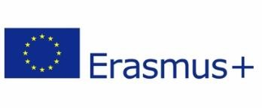

Smart School for Smart Age

Lesson 1- BASIC GEOMETRIC FORMULAS AND PROPERTIES

Sentences to Inequalities

1. | Learn -BASIC GEOMETRIC FORMULAS AND PROPERTIES- First 2 Pages  https://gato-docs.its.txstate.edu/slac/Subject/Math/Pre-Algebra/Basic-Geometiric-Formulas-and-Properties/Basic%20Geometiric%20Formulas%20and%20Properties.pdf
2. | Learn– BASIC PROBLEMS OF GEOMETRY- Last 3 Pages  https://gato-docs.its.txstate.edu/slac/Subject/Math/Pre-Algebra/Basic-Geometiric-Formulas-and-Properties/Basic%20Geometiric%20Formulas%20and%20Properties.pdf
3. | Quiz – BASIC GEOMETRIC FORMULAS AND PROPERTIES Quiz  https://study.com/academy/practice/quiz-worksheet-basic-geometry-formulas-rules.html

