Erasmus + Smart schools for smart age
 | Sports school G. S. Rakovski  Dobrich, Bulgaria  Lesson 9:  Mathematics – DEGREE | 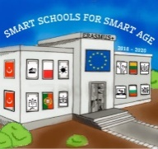

Lesson 9 DEGREE
Class 6
Topic: DEGREE. GRADING OF RATIONAL NUMBERS.
Objectives:
- Introduction to degree
- Learning the grading of rational numbers
- Applying knowledge to solve problems

Resources:
- computer with internet access
- multimedia projector

Lesson source:
https://drive.google.com/file/d/1vWH3qvwb90ut0Ch_GOwZkzUeDOGzOxs5/view?usp=sharing

