Erasmus + Smart schools for smart age
 | Sports school G. S. Rakovski  Dobrich, Bulgaria  Lesson 8:  Literature – Tavanski spomen | 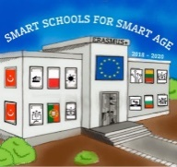

Lesson 8 Tavanski spomen
Class 10
Topic: Tavanski spomen.
Objectives:
- Presentation of the work Tavanski spomen
- Interpretation of the meaning of the work
- Excerpts from the work

Resources:
- computer with internet access
- multimedia projector

Lesson source:
https://prezi.com/view/TgLqwmgf5O0TmzEyQvNF/

