Erasmus + Smart schools for smart age
 | Sports school G. S. Rakovski  Dobrich, Bulgaria  Lesson 3:  Religion -Ivanov-day | 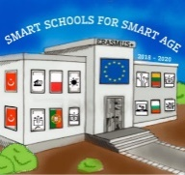

Lesson 3 Christian holidays - Ivanov-day
Class 7
Topic: Тhe Christian holiday Ivanov-day.
Objectives:
- Introduction to the Christian holiday Ivanov-day
- Show Ivanov-day customs
- Presenting how Ivanov-day is celebrated in every home

Resources:
- computer with internet access
- multimedia projector

Lesson source:
https://docs.google.com/presentation/d/1d5hJqaNbXbfOpOXhLf90-XcpN8cvQI_4mRHj5BMmMpE/edit?usp=sharing

