Smart School for Smart Age 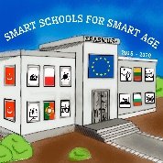

Subject: The Lithuanian language and literature
Number of the lessons: 3
Teacher: Inga Salavei
Topic: GREEK MYTHS‘ HEROES AND THEIR TRIPS‘ MEANINGS
1st lesson aim: to discuss the point of view of the concious individual‘s choice and his destiny in Greek myths.
Goals: after reading and analysing the myth about Prometheus followed by the given promts and tasks, students will be able:
- To describe consistently the main characters‘ activities and explain their behaviour motives;
- To explain the meaning of Prometheus feats;
- To indicate the reasons why Zeus punished Prometheus so cruelly;
- To formulate the main idea and message of the myth about Prometheus;
- To create a short opinion paragraph using the given scheme.

2nd lesson aim: to find out what does Sisyphus symbolize in Greek mythology.
Goals: after reading and analysing the myth about Sisyphus followed by the given promts and tasks, students will be able:
- To describe the main character of the myth;
- To evaluate Sisyphus behaviour, explain the choices and opinion providing some arguments;
- To formulate the main idea and message of the myth;
- To compare two Greek myths‘ heroes Sisyphus and Prometheus – showing their similarities and differences;
- To recognize the rising ideas in Sisyphus and Prometheus myths

3rd lesson aim: to find out the variety of the ideas hidden in the myth about Dedal and Icarus.
Goals: after reading and analysing the myth about Dedal and Icarus followed by the given promts and tasks, students will be able:
- To describe the main characters of the myth;
- To evaluate Dedal‘s character features and Icarus‘ risky behaviour your opinion supporting by some arguments;
- To identify the resons of the characters‘ choices;
- To formulate the main idea and the message of the myth;
- To recognize the stylistic devices used in the myth;
- To compare fire symbol‘s meaning in the myth to the myth about Prometheus;
- To connect the quotations from the text with the main idea‘s formulations.
Resources:
- a computer with the internet access
- multimedia
- mobile phones with the internet access
Digital resources:
- XMind,
- Google Forms,
- H5P,
- Storyboard Creator,
- Blendspace.
Lesson progress:
1. Greek myth’s hero Prometheus and his feats’ meanings.
2. Greek myth’s hero Sisyphus and his feats’ meanings.
3. Greek myth’s heroes Dedal and Icarus and their feats’ meanings.

Smart School for Smart Age 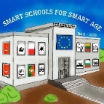
1 lesson
Greek myth’s hero Prometheus and his feats’ meanings.

1. | Learning content:  https://www.blendspace.com/lessons/nQv5HEBi4m9AWg/graiku-mitu-herojai-ir-ju-zygiu-prasme-prometejas  http://ebiblioteka.mkp.emokykla.lt/kuriniai/graiku_mitai/  file:///C:/Users/t22/Downloads/Graiku_mitai%20(1).pdf
2. | Practice:  Myth‘s analysis. Fullfill the mind map.  http://www.xmind.net/m/6bkbQh  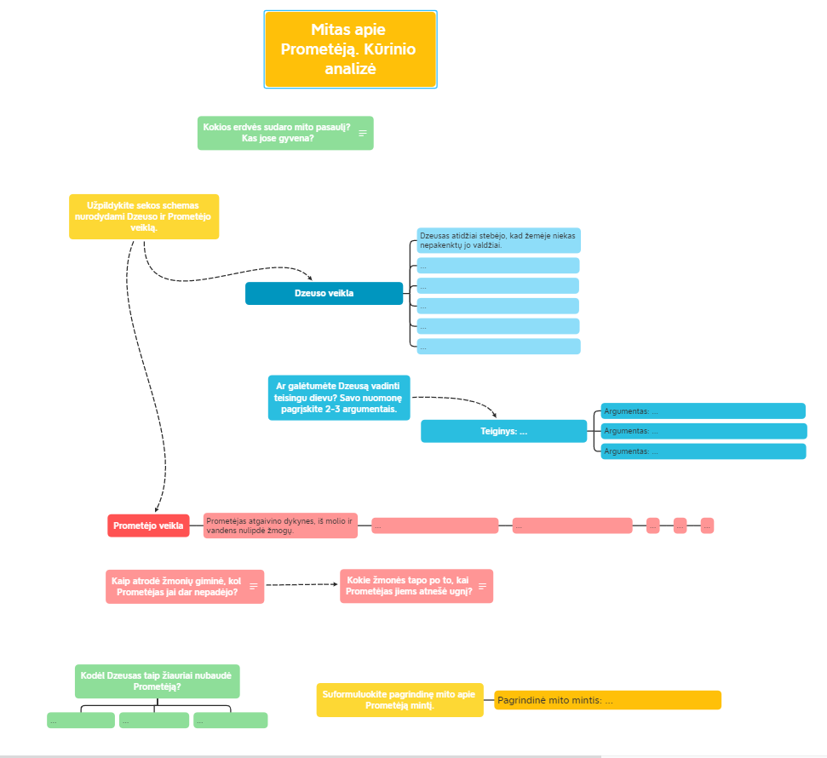
3. | Practice:  Do the task of creating a paragraph.  https://docs.google.com/forms/d/e/1FAIpQLSeEshUobfDqX4MRONTB8gXVszOVW9ucPZ1X1slnNWUzPta2Mw/viewform?usp=sf_link  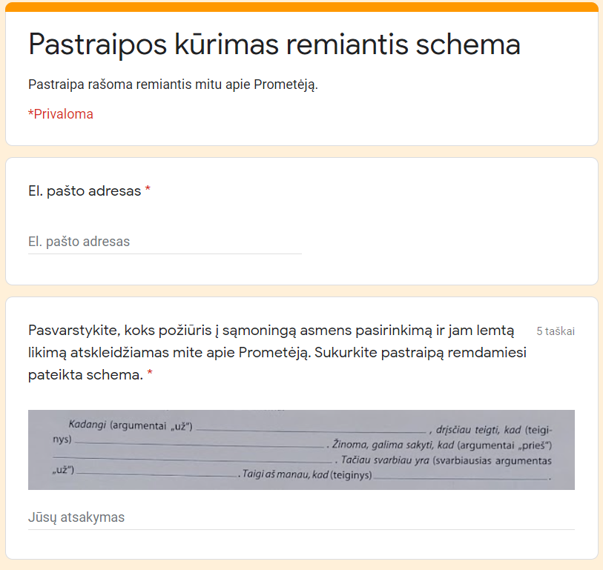

Smart School for Smart Age 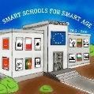
2 lesson
Greek myth’s hero Sisyphus and his feats’ meanings.

1. | Learning content:  https://www.blendspace.com/lessons/viN8HyRrHrCnGg/  http://ebiblioteka.mkp.emokykla.lt/kuriniai/graiku_mitai/  file:///C:/Users/t22/Downloads/Graiku_mitai%20(1).pdf
2. | Practice:  Myth‘s analysis Fullfill the mind map.  http://www.xmind.net/m/dZuSiz  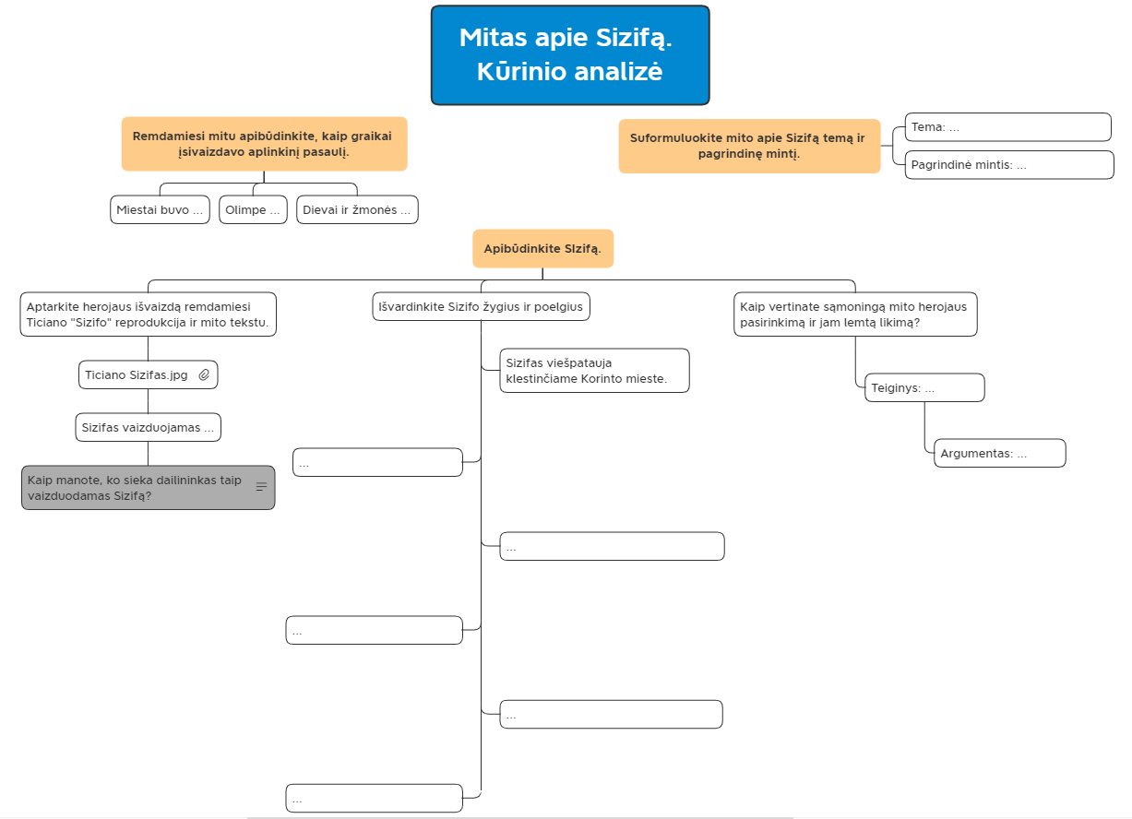
3. | Practice:  Compare Sizifas and Prometėjas. Fullfill Venas diagram.  https://www.storyboardthat.com/portal/storyboards/ingasalavei/class-storyboard/sizifo-ir-promet-jo-palyginimas  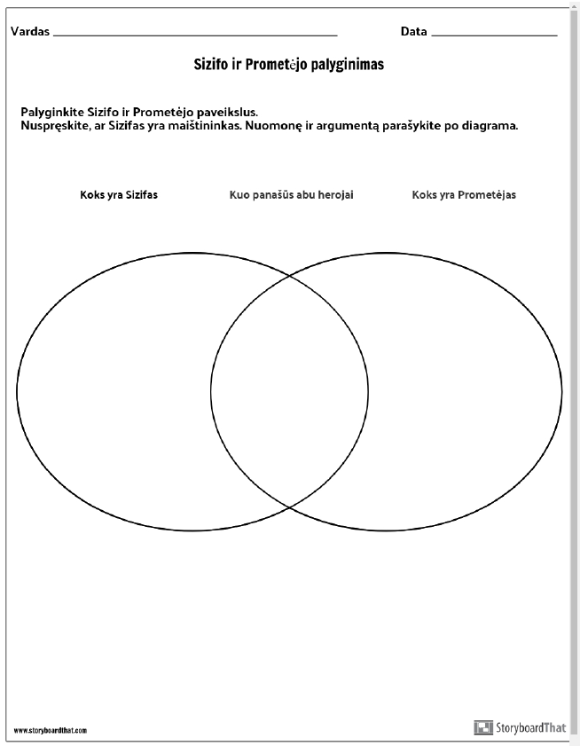
4. | Practice:  Apply your knowledge from the myth‘s analysis. Recognize the ideas hidden in myths.  https://ingasalavei.h5p.com/content/1291228590668110297  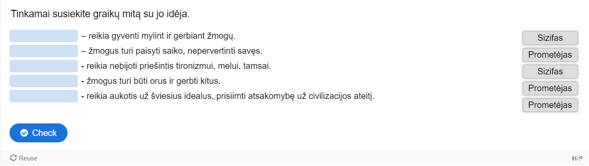

Smart School for Smart Age
3 lesson
Greek myth’s heroes Dedal and Icarus and their feats’ meanings.

1. | Learning content:  https://www.blendspace.com/lessons/KQJsLSHJZdfISA/dedalas-ir-ikaras-graiku-mitu-herojai-ir-ju-zygiu-prasme  http://ebiblioteka.mkp.emokykla.lt/kuriniai/graiku_mitai/  file:///C:/Users/t22/Downloads/Graiku_mitai%20(1).pdf
2. | Practice:  Myth‘s analysis. Fullfill the mind map.  http://www.xmind.net/m/GNMdYs  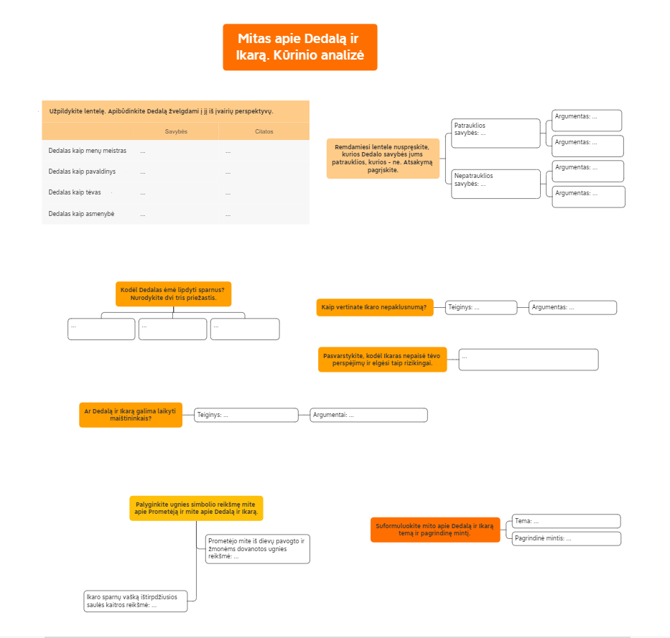
3. | Practice:  Recognize stylistic devises used in the writing piece.  https://ingasalavei.h5p.com/content/1291229290632417327  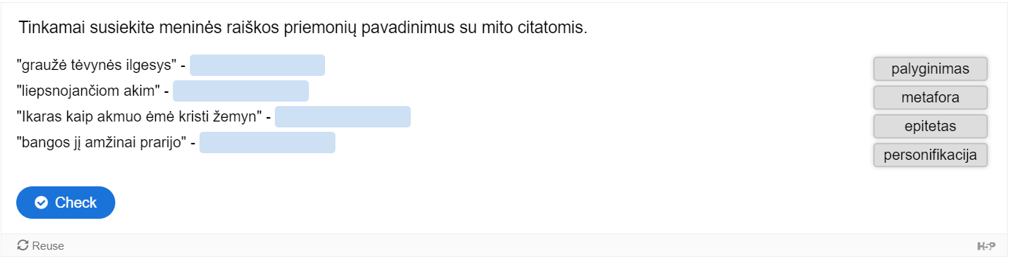
4. | Practice:  Connect the themes‘ formulations with the specific quotations of the writing piece.  https://ingasalavei.h5p.com/content/1291229279394576017  