Fable Writing
A fable is a short narrative that exemplifies a moral or principle of human behavior; that is usually stated in the conclusion of the story. The characters, setting and actions become a symbol of human nature.

Directions: Go online and research Aesop’s fables at http://aesopfables.com. Read some of the fables you find and gather some ideas for your own writing. After researching, you will write your own fable.

Criteria:
Entire fable less than 250 words (1 page) Title
Plots actions must lead to the moral Moral must be given in last line of the story Keep it simple and specific
Be original (not based on example fables) Uses appropriate language
Use correct grammar, punctuation, etc.

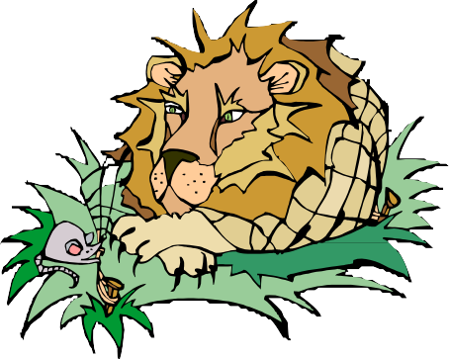

Fable Writing Rubric

 | 4 | 3 | 2 | 1
Title | Title is creative, sparks interest and is related to the story and topic | Title is related to the story and topic | Title is present, but does not appear to be related to the story and  topic | No title
Plot  (x2) | Actions in plot lead directly to the moral | Actions in plot lead to the moral | Actions in plot barely lead to moral | Actions in plot do not lead to the moral
Moral  (x2) | Successfully creates an effective moral that supports the  story | Creates a moral that supports the fable | Moral is present and somewhat supports the fable | Does not create a moral; moral does not support story
Originality  (x2) | Fable is original | ------------------- | ------------------- | Fable is not original
Use of Language | Demonstrates excellent sentence and vocabulary  variety | Demonstrates adequate sentence and vocabulary  variety | Demonstrates repetitive use of sentence structure and  vocabulary | Demonstrates poor use of language & generates  confusion
Grammar | Contains no errors in grammar, punctuation,  and spelling | Contains few errors in grammar, punctuation,  and spelling | Contains some errors in grammar, punctuation,  and spelling | Contains many errors in grammar, punctuation,  and spelling
Page Length | Meets required page length | ------------------- | ------------------- | Does not meet required page length

