Erasmus + Smart schools for smart age
 | Sports school G. S. Rakovski  Dobrich, Bulgaria  Lesson 5:  Religion - St. George's Day | 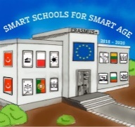

Lesson 5 Christian holidays - St. George's Day
Class 7
Topic: Тhe Christian holiday St. George's Day.
Objectives:
- Introduction to the Christian holiday St. George's Day
- Show St. George's Day customs
- Presenting how St. George's Day is celebrated in every home

Resources:
- computer with internet access
- multimedia projector

Lesson source:
https://1drv.ms/p/s!AmNGsB6QOHfRgSjZU_n2ZGZgQ4wQ?e=vVQuV9

