Erasmus + Smart schools for smart age
 | Sports school G. S. Rakovski  Dobrich, Bulgaria  Lesson 9:  Religion - St. Todor's Day | 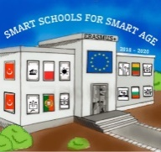

Lesson 9 Christian holidays - St. Todor's Day
Class 8
Topic: Тhe Christian holiday St. Todor's Day.
Objectives:
- Introduction to the Christian holiday St. Todor's Day
- Show St. Todor's Day customs
- Presenting how St. Todor's Day is celebrated in every home

Resources:
- computer with internet access
- multimedia projector

Lesson source:
https://1drv.ms/p/s!AmNGsB6QOHfRgTxEStj2lAX-a7S8?e=NrHXrU

