Erasmus + Smart schools for smart age
 | Sports school G. S. Rakovski  Dobrich, Bulgaria  Lesson 7:  Religion - Palm Sunday | 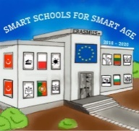

Lesson 7 Christian holidays - Yordanov-day
Class 7
Topic: Тhe Christian holiday Palm Sunday.
Objectives:
- Introduction to the Christian holiday Palm Sunday
- Show Palm Sunday customs
- Presenting how Palm Sunday is celebrated in every home

Resources:
- computer with internet access
- multimedia projector

Lesson source:
https://prezi.com/view/6dPlKHzUJuB82RkHDKVY/

