Erasmus + Smart schools for smart age
 | Sports school G. S. Rakovski  Dobrich, Bulgaria  Lesson 8:  Mathematics - Mathematical formulas | 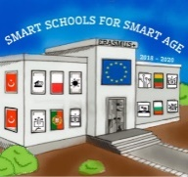

Lesson 8 Mathematical formulas
Class 7
Topic: Basic Mathematical formulas.
Objectives:
- Gaining basic knowledge of mathematics
- Learning the basic Mathematical formulas
- Applying knowledge to solve problems

Resources:
- computer with internet access
- multimedia projector

Lesson source:
https://drive.google.com/file/d/1LtfxBDsPUqg92G7TJMk4YlTdoVMKmDGx/view?usp=sharing

