Erasmus + Smart schools for smart age
 | Sports school G. S. Rakovski  Dobrich, Bulgaria  Lesson 2:  Religion - Christmas | 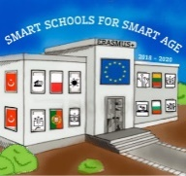

Lesson 2 Christian holidays - Christmas
Class 7
Topic: Тhe Christian holiday Christmas.
Objectives:
- Introduction to the Christian holiday Christmas
- Show Christmas customs
- Presenting how Christmas is celebrated in every home

Resources:
- computer with internet access
- multimedia projector

Lesson source:
https://1drv.ms/p/s!AmNGsB6QOHfRgSPgurwVFsPVuvjP?e=iN8y0f

