Erasmus + Smart schools for smart age
 | Sports school G. S. Rakovski  Dobrich, Bulgaria  Lesson 8:  Religion - Lazarus day | 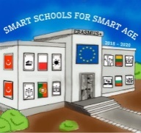

Lesson 8 Christian holidays - Lazarus day
Class 8
Topic: Тhe Christian holiday Lazarus day.
Objectives:
- Introduction to the Christian holiday Lazarus day
- Show Lazarus day customs
- Presenting how Lazarus day is celebrated in every home

Resources:
- computer with internet access
- multimedia projector

Lesson source:
https://docs.google.com/presentation/d/1VJ7JfEVHlvNnodyd0AifFi0G2-HhBrEUZxgqrUsrc3s/edit?usp=sharing

