Erasmus + Smart schools for smart age
 | Sports school G. S. Rakovski  Dobrich, Bulgaria  Lesson 4:  Religion - St. Nicholas Day | 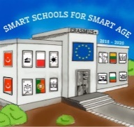

Lesson 4 Christian holidays - St. Nicholas Day
Class 7
Topic: Тhe Christian holiday St. Nicholas Day.
Objectives:
- Introduction to the Christian holiday St. Nicholas Day
- Show St. Nicholas Day customs
- Presenting how St. Nicholas Day is celebrated in every home

Resources:
- computer with internet access
- multimedia projector

Lesson source:
https://1drv.ms/p/s!AmNGsB6QOHfRgSZzZt-AT962Wgtw?e=cdFovf

