Erasmus + Smart schools for smart age
 | Sports school G. S. Rakovski  Dobrich, Bulgaria  Lesson 1- Religion | 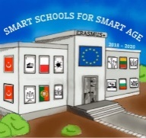

Lesson 1 RELIGION IN BULGARIA
Class 8
Topic: The main religion in Bulgaria.
Objectives:
- Introduction to the main religion of Bulgaria
- Showing the history of Christianity
- Explain the main characteristics and the main Christian holidays

Resources:
- computer with internet access
- multimedia projector

Lesson source:
https://prezi.com/view/VH8TSJLK0PhuhxFcSd7f/

