Smart School for Smart Age

Lesson plan - Erasmus +
Subject: Mathematics
Number of lessons: 1
Teachers: Murat AVANOĞLU
Topic: Cube Roots
Key words: cubes, cube roots , square roots
Lessons objectives:
Solve simple cube root equations.
Identify equations of both types with whole number solutions, irrational solutions, and no real solutions.
Resources
- Computers with internet access;
-Multimedia projects;
- Tablets with internet access;
- Mobile Phones with internet access
Lessons sequence/activity
Cube Roots with Khan Academy(1 Lesson)
Practice (1 Lesson)
Quiz (2 Lesson)
Web Tools
https://www.khanacademy.org/math/algebra/x2f8bb11595b61c86:rational-exponents-radicals/x2f8bb11595b61c86:radicals/v/introduction-to-cube-roots
https://study.com/academy/lesson/how-to-find-the-cube-root-of-a-number.html

Smart School for Smart Age

Lesson-Cube Roots

Sentences to Inequalities

1. | Learn-  Intro to cube roots: (Lesson 1)  https://www.khanacademy.org/math/algebra/x2f8bb11595b61c86:rational-exponents-radicals/x2f8bb11595b61c86:radicals/v/introduction-to-cube-roots  Cube and Square Roots Summary (1):  https://math.osu.edu/sites/math.osu.edu/files/SimplifyingSquareAndCubeRoots.pdf  Cube and Square Roots Summary (2):  http://www.germanna.edu/wp-content/uploads/tutoring/handouts/Square-Cubes-and-Their-Roots.pdf  Cube roots review :  https://www.khanacademy.org/math/cc-eighth-grade-math/cc-8th-numbers-operations/cc-8th-roots/a/cube-roots-review  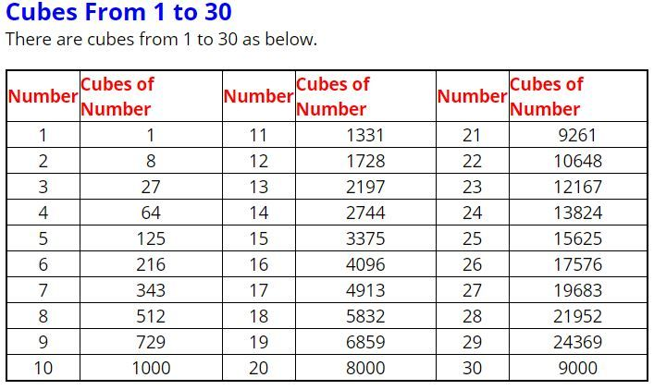
2. | Pratice  Cube roots:  https://www.khanacademy.org/math/algebra/x2f8bb11595b61c86:rational-exponents-radicals/x2f8bb11595b61c86:radicals/e/cube_roots
3. | Quiz  Square and Cube Roots:  https://www.cliffsnotes.com/study-guides/algebra/algebra-i/preliminaries-and-basic-operations/quiz-square-roots-and-cube-roots  https://www.proprofs.com/quiz-school/story.php?title=square-cube-roots-quiz  