Smart School for Smart Age

Lesson plan - Erasmus +
Subject: Mathematics
Number of lessons: 3
Teachers: Murat AVANOĞLU
Topic: Square Roots
Key words: square, square roots
Lessons objectives:
After this lesson, students will be able to:
-define 'square root'
- demonstrate an understanding of calculating square root

Resources
- Computers with internet access;
-Multimedia projects;
- Tablets with internet access;
- Mobile Phones with internet access
Lessons sequence/activity
Square roots with Khan Academy (3 Lesson)
Practice (2 Lesson)
Quiz (2 Lesson)
Web Tools
https://study.com/
http://www.khanacademy.org.tr/

Smart School for Smart Age

Lesson-Square Roots

Sentences to Inequalities

1. | Learn-  Square Roots Summary:  https://www.cabrini.edu/globalassets/pdfs-website/math-resource-center/square-roots.pdf  Intro to square roots: (Lesson 1)  https://www.khanacademy.org/math/algebra/x2f8bb11595b61c86:rational-exponents-radicals/x2f8bb11595b61c86:radicals/v/introduction-to-square-roots  Understanding square roots: Learn how square root means what number multiplied by itself will result in the given number. (Lesson 2)  https://www.khanacademy.org/math/algebra/x2f8bb11595b61c86:rational-exponents-radicals/x2f8bb11595b61c86:radicals/v/understanding-square-roots  Square root of decimal: (Lesson 3)  https://www.khanacademy.org/math/algebra/x2f8bb11595b61c86:rational-exponents-radicals/x2f8bb11595b61c86:radicals/v/finding-square-root-of-decimal  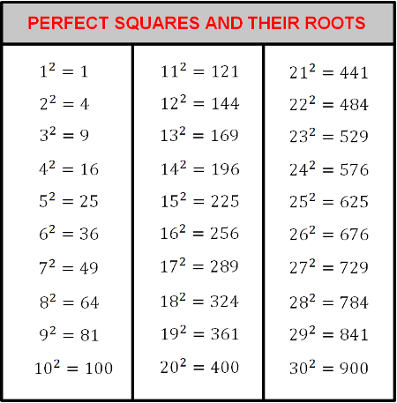
2. | Practice  Square roots:  https://www.khanacademy.org/math/algebra/x2f8bb11595b61c86:rational-exponents-radicals/x2f8bb11595b61c86:radicals/e/square_roots  Roots of decimals & fractions :  https://www.khanacademy.org/math/algebra/x2f8bb11595b61c86:rational-exponents-radicals/x2f8bb11595b61c86:radicals/e/roots-of-decimals-and-fractions
3. | Quiz  http://www.thegreatmartinicompany.com/negativenumbers/square-root-quiz.html  https://www.proprofs.com/quiz-school/story.php?title=ntq5mza4

