Rules for panel discussions 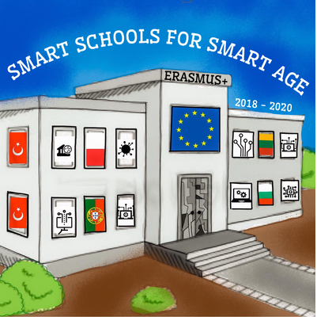
In order to make the panel discussion more efficient we recommend you to follow the following basic requirements.

Panelists:
- Panelists should make themselves known to their moderator at least 5 minutes prior to the session.
- Every panelist has to prepare a short account of his view on the debated problem. The list of questions for discussion will be sent to every panelist in good time.
- By invitation of the moderator each panelist makes a statement of point-of-view on the topic of the panel session.
- Discussion between panelists ensues in the form of questions and answers.
- Discussion between panelists is regulated by the moderator who invites one or another panelists to enter the discussion. The same concerns the interaction of a panelist and the audience. One may raise the hand to speak a word.

Moderators:
- You assume your duties when the chairperson of the relevant session announces the panel discussion and introduces you to the audience.
- After a brief introduction that states the topic(s) (they will be highlighted) and why it is being discussed, introduce each member of the panel (name, affiliation, characterizing features of her/his work).
- Ask questions to keep the debate/panel going and to clarify or ask for further explanation.
- Every panelist is treated on equal foot with another. The order of speaking is determined by moderator.
- Keep track of time. Normally a 45-minute discussion is envisaged which can be
– in exclusive cases - enlarged up to 60 minutes. 6.Control the debate.
- Monitor audience questions (it is recommended to get questions from the audience during the last third of the session except clarifying questions). Don’t admit more than 2 questions/comments from 1 person.
- Conclude the debate/discussion in a clear and concise way.

In general, you are expected to be impartial, which means you do not take sides and your personal opinion is not revealed. Your expertise is presenting the topic, leading the panel discussion, inviting and encouraging panelists to speak, being a liaison between the audience and the panelists and, finally, to summarize the discussion.
Let us emphasize the mandatory necessity for moderators:
- Not to consider themselves as panelists.Moderator is dispatcher.
- To give a comprehensive summary of the discussion.

