Erasmus + Smart schools for smart age
 | Sports school G. S. Rakovski  Dobrich, Bulgaria  Lesson 6:  Religion - Yordanov-day | 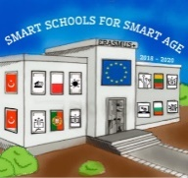

Lesson 6 Christian holidays - Yordanov-day
Class 7
Topic: Тhe Christian holiday Yordanov-day.
Objectives:
- Introduction to the Christian holiday Yordanov-day
- Show Yordanov-day customs
- Presenting how Yordanov-day is celebrated in every home

Resources:
- computer with internet access
- multimedia projector

Lesson source:
https://docs.google.com/presentation/d/1Q47CbfUjLY5D5xZVjKLKow7Nkm02jDQCLMWSuOYhhe4/edit?usp=sharing

