 | Smart schools for smart age  Events 2019-2021  Poland | 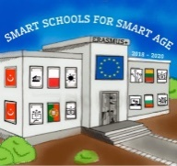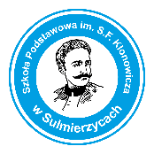
Computer workshops:
Computers workshop for teachers - 4.04.2019 – 4 hours
-„ Maths is not a cosmos”
- „School cooperation and between the schools under eTwinning and Edmodo”
- computers workshop for students – “How to use Powtoon and Edmodo platforms”
The very important element of the project is the training of how to use the Edmondo platform and eTwining for the teachers and then for the students. On the day 04.04.2019 the training took place which was of a great interest for the teachers.
Workshop – “for students -How to use Edmondo at school”Erasmus+
Students who participated in the Erasmus + project “Smart Schools for smart age” participated in computer workshops. During the class, the students got acquainted with the Powtoon and Edmodo platforms "

The School of small engineer”.
All the students used computers to participate in the Polish nationwide project –“The School of small engineer”. This project promoted science, robotics, automatics and the basics of programming,
https://drive.google.com/file/d/1XedLrjYfdvQ0wulCUKaHqz7gq6s93JP-/view?usp=sharing
https://drive.google.com/file/d/1Wz7GjnmmnFUB8uRrVyvUkW69ED4ODNyt/view?usp=sharing

https://drive.google.com/file/d/1yj1Jq6wSF3jNLk4y0WOw4vnc7cuQQfKS/view?usp=sharing

School Journalist Club
Type- Dissimination
http://zspsulm.szkolnastrona.pl/index.php?c=page&id=621
School Journalist Club activity takes place in our school . 18 students from class IV, VI and VII do work in the club. All of them willingly and regularly take part in the meetings which take place once a week . The school magazine is published for the students in our school, the parents and the local society of our town, Sulmierzyce. This magazine is one of the way to spread information concerning the realization of our project. Thanks to the magazine the students, parents and the whole local society can follow the events of our project. After each visit of the students in the partner country from the project, the students write reports and place them together with the pictures on the pages of the web site of our school magazine.

Erasmus Day 10 October 2019
Dissemination
https://photos.google.com/share/AF1QipOhTbeOxOQBErQU2gaTG16ItlO3eA8Bm-mpOOVyquOyntY4kwuzrFi5C-c7Hew7Kg?key=Z3M3WEZTM19nMnQ1Mndkd05QaFNxSjF6RzBWaXBR
On October 10, we celebrated School’s Erasmus + Day in our school in Sulmierzyce. Students of all classes could see exhibitions, posters, newsletters and presentations prepared by students belonging to the project group.
On this day, students who take part in the project familiarized younger colleagues about the implementation of our project. They showed them lots of photos from trips to partner countries

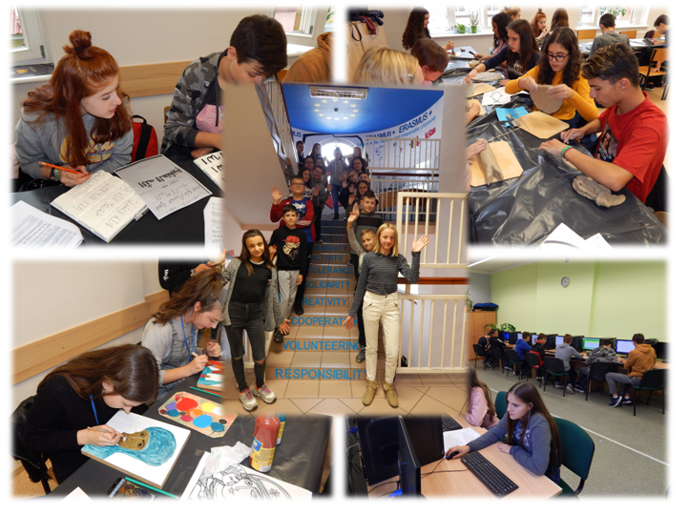
Selfe competition “ Be Smart and Creative”
October 2019
Dissemination
Our school took part in the selfe competition. By entering the competition, we sent the above photo with a description.

Corner Erasmus
Dissemination September 2019 – June 2021
http://zspsulm.szkolnastrona.pl/p,667,projekt-smart-schools-for-smart-age

Multiplication table day for school 2.10.2020
Maths
http://zspsulm.szkolnastrona.pl/index.php?c=article&id=974
This year, students of our school could present their skills by preparing a poster promoting the multiplication table. From among all the works, three were selected and we awarded them with wonderful gifts funded by the Parents' Council.

Magic Power of Fairy Tales - October 2020
Type- Reading Promotion Activite
http://zspsulm.szkolnastrona.pl/index.php?c=article&id=1001
Children made "sock readers", which will accompany them on a magical journey to the world of values, arranged "Design Corner" and learn the project song "Magic power of fairy tales".

European Coding Week 10-25 October
Maths
http://zspsulm.szkolnastrona.pl/index.php?c=article&id=987
As part of CodeWeek, the European Coding Week (October 10-25, 2020), European countries compete against each other in the number of organized programming events. It is based on the fact that schools in different countries in Europe organize various activities, games, games, competitions related to coding and programming. Poland is taking part in it and now our country is in place.
Students in class 1a and 2b started celebrating together with their tutors two weeks ago by taking part in the challenge "All of Poland is programming" with the program "Teaching Children to Program" (09/28/09/2020).

The challenge was to implement selected activities, which additionally fit into the international codeweek week. Both classes reported and completed all 10 tasks suggested by the EduSense organizers during a lesson or extra-curricular programming activity for two weeks.
The students programmed, among others, health, decoded board games, looked for repetitions in everyday life, played with dance and organized a coded class orchestra.

European Day of Foreign Languages 29.09 2020
English
http://zspsulm.szkolnastrona.pl/a,980,europejski-dzien-jezykow-obcych
On this occasion, students watched a presentation on interesting facts about the world's languages, and debated why it is worth learning foreign languages. The most fun was the competition in interactive language quizzes on the Kahoot platform.

THE DIGITAL SCHOOL OF WIELKOPOLSKA@ 2020”

Maths and Information Technology
http://zspsulm.szkolnastrona.pl/index.php?c=article&id=1000
The main objective of the Project is to improve the quality at each level of general education, through the development of digital competences of teachers and students, as part of the implementation of extracurricular activities using the project method and the method of advance education, using information and communication technologies (ICT).
As part of the project, activities related to equipping / equipping schools with ICT will also be implemented.
The school is implementing the sub-project: Student IT Laboratories for grades 4-8 entitled

REMOTE LEARNING WITH THE BOOK IN THE BACKGROUND
Literature
Type- Reading Promotion Activite
http://zspsulm.szkolnastrona.pl/index.php?c=article&id=1013
http://zspsulm.szkolnastrona.pl/index.php?c=article&id=1031
Students of class IV b in Polish language lessons as part of distance learning implemented the project "Remote learning with a book in the background". The task of the students, while discussing the compulsory reading of "The Chronicles of Narnia", was to make the main characters from the book from any artistic materials: Piotr, Susanna, Lucia and Edmund.

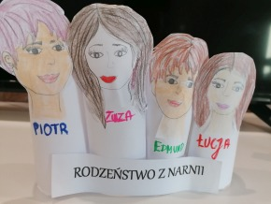

INVITATION TO THE THEATER March 2021

Literature
http://zspsulm.szkolnastrona.pl/index.php?c=article&id=1021
Second graders also got acquainted with the basic concepts related to theater, professions related to theater, improved the technique of reading and recitation, worked on diction, correct breathing and voice emission, facial expressions, gestures and other means of artistic expression.
The summary of these classes was staging short dialogue scenes with the use of puppets for the class.

WORLD BOOK DAY 23 April 2021
Literature Type- Reading Promotion Activite

http://zspsulm.szkolnastrona.pl/index.php?c=article&id=1030
On April 23, the World Book and Copyright Day is celebrated around the world. It is a holiday for all readers and people associated with the book and writing.
The Book and Copyright Day was established by UNESCO in 1995 to promote reading, and since 2007 it has been celebrated in Poland.
The students of class 2b were convincing that books are a treasury of knowledge and that they can contain many interesting facts by telling stories, presenting and writing notes about their favorite books.
As part of the celebration of this holiday, students learned the history of the creation of books and paper, the secrets of printing, the professions of people working on the creation of books, solved rebuses, created a family of the expression book, tried their hand at designing their bookplates.
We encourage everyone to reach for a good book! It will allow you to forget about difficult reality, deal with the problems of book characters, develop our mind and imagination, and most of all have a good time.

VALENTINE’S DAY – SHORT COMIC

14 February 2021

English, Religious Education, Art

http://zspsulm.szkolnastrona.pl/index.php?c=article&id=1029
On Monday - April 19 this year. the results of the school English competition "Valentine's Day- short comic" have been announced.

During the religion lessons, the students got acquainted with the history of Saint Valentine's life. They found out who he was and how he lived. Then, willing students made a short comic book about Saint Valentine.

MATHEMATIC AND PLASTIC COMPETITION "INFECT WITH MATHEMATICS" April 2021 Maths, Art
http://zspsulm.szkolnastrona.pl/index.php?c=article&id=1027

LAST MEETING WITH ERASMUS

14-18 June 2021

Dissemination
http://zspsulm.szkolnastrona.pl/index.php?c=article&id=1046

