Erasmus + Smart schools for smart age
 | Sports school G. S. Rakovski  Dobrich, Bulgaria  Lesson 10:  Religion - St. Petre's Day | 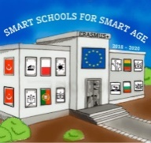

Lesson 10 Christian holidays - St. Petre's Day
Class 8
Topic: Тhe Christian holiday St. Petre's Day.
Objectives:
- Introduction to the Christian holiday St. Petre's Day
- Show St. Petre's Day customs
- Presenting how St. Petre's Day is celebrated in every home

Resources:
- computer with internet access
- multimedia projector

Lesson source:
https://docs.google.com/presentation/d/1hWz5A1BM8EjqEn05QqlYWxHbdpAZry0i6SJ5hBIXUj8/edit?usp=sharing

