Erasmus + Smart schools for smart age
 | Sports school G. S. Rakovski  Dobrich, Bulgaria  Lesson 10:  Mathematics - BASIC PROPERTY OF PROPORTIONS | 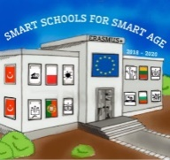

Lesson 10 BASIC PROPERTY OF PROPORTIONS
Class 6
Topic: PROPERTY OF PROPORTIONS.
Objectives:
- Introduction to proportions
- Learning the basic property and formulas of proportions
- Applying knowledge to solve problems

Resources:
- computer with internet access
- multimedia projector

Lesson source:
https://drive.google.com/file/d/1PwfWlIm5ApqZJoZ6CWaXjazG_Vbp8Tjn/view?usp=sharing

