Smart School for Smart Age

Lesson plan - Erasmus +
Subject: Mathematics
Number of lessons:2
Teachers: Murat AVANOĞLU
Topic: Types of Triangles
Key words: triangles, sides, angles
Lessons objectives:
After this lesson, students will be able to:
-Understand the basic properties of triangles
-Recognize and understand the three basic types of triangles
Resources
- Computers with internet access;
-Multimedia projects;
- Tablets with internet access;
- Mobile Phones with internet access
Lessons sequence/activity
Types of Triangles with Khan Academy (2 Lesson)
Types of Triangles Summary
Types of Triangles Quiz and Practice
Web Tools
http://www.khanacademy.org.tr/
https://study.com/

Smart School for Smart Age

Lesson-Types of Triangles

Sentences to Inequalities

1. | Learn- Classifying triangles: Learn to categorize triangles as scalene, isosceles, equilateral, acute, right, or obtuse. (Lesson1)  https://www.khanacademy.org/math/cc-fifth-grade-math/properties-of-shapes/5th-triangles/v/scalene-isosceles-equilateral-acute-right-obtuse#:~:text=Learn%20to%20categorize%20triangles%20as,Created%20by%20Sal%20Khan  Classifying triangles by angles : (Lesson 2)  https://www.khanacademy.org/math/cc-fifth-grade-math/properties-of-shapes/5th-triangles/v/scalene-isosceles-equilateral-from-angle  Types of Triangles Summary :  http://www.mpsaz.org/rmre/grades/grade5/homework_help/files/types_of_triangles.pdf  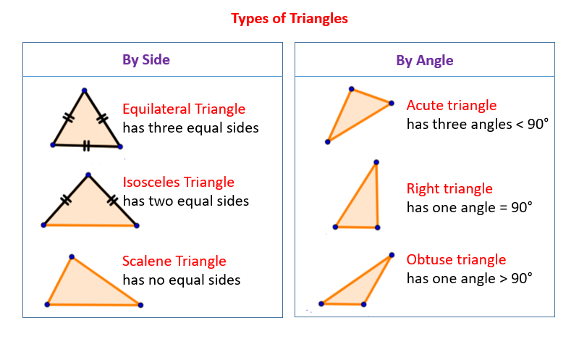
2. | Practice  Classify triangles by both sides and angles:  https://www.khanacademy.org/math/cc-fifth-grade-math/properties-of-shapes/5th-triangles/e/classify-triangles-by-both-sides-and-angles
3. | Quiz  https://www.proprofs.com/quiz-school/story.php?title=triangles-quiz-1  https://study.com/academy/practice/quiz-worksheet-types-of-triangles-their-properties.html

