Erasmus + Smart schools for smart age
 | Sports school G. S. Rakovski  Dobrich, Bulgaria  Lesson 2:  Mathematics - Common fractions | 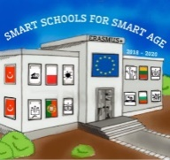

Lesson 2 Common fractions
Class 7
Topic: Actions with common fractions.
Objectives:
- Introduction to common fractions
- Learning the Actions with common fractions
- Applying knowledge to solve problems

Resources:
- computer with internet access
- multimedia projector

Lesson source:
https://drive.google.com/file/d/1As-xNAWwidWgsUaO1jH_vWSZ56J7Lejr/view?usp=sharing

