Erasmus + Smart schools for smart age
 | Sports school G. S. Rakovski  Dobrich, Bulgaria  Lesson 5:  Mathematics - Pyramid | 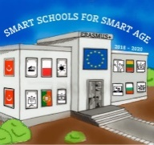

Lesson 5 Pyramid
Class 7
Topic: Properties of Pyramid.
Objectives:
- Introduction to Pyramid
- Learning the formulas for Pyramid
- Applying knowledge to solve problems

Resources:
- computer with internet access
- multimedia projector

Lesson source:
https://drive.google.com/file/d/1gmo9SRSFbOc92DOHCurMguuUurfo0faS/view?usp=sharing

