Erasmus + Smart schools for smart age
 | Sports school G. S. Rakovski  Dobrich, Bulgaria  Lesson 4:  Mathematics - Prism | 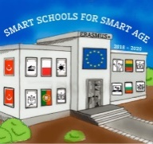

Lesson 4 Prism
Class 7
Topic: Properties of the prism.
Objectives:
- Introduction to prism
- Learning the formulas for prism
- Applying knowledge to solve problems

Resources:
- computer with internet access
- multimedia projector

Lesson source:
https://drive.google.com/file/d/1PW77_pI4Fu4emOYo6YIK3v0LYoYodlym/view?usp=sharing

