MEPs’ attitudes in the 2014-19 European Parliament: Key Findings from the European Parliament Research Group’s Survey
22/02/2017

Immigration

Immigration has been a salient topic in Europe for a long time, but its relevance to EU policy-making has been further underscored by recent events such as the refugee crisis and Brexit. This section presents some comparisons of MEPs’ positions on several policy questions related to immigration and also looks at changes in these attitudes over time. The last part of this section examines what determines MEPs’ attitudes to immigration-related policy questions. The findings are summarised in Figure 13.
Figure 10 shows MEPs’ responses to questions about, first, whether individual member states should be allowed to place restrictions on the free movement of people into their country and, second, whether EU migrants should be granted the same rights and access to public services as citizens of the recipient member state. Support for restricting freedom of movement is highest in Denmark, Croatia and the UK, and it is lowest in Italy, Spain, Poland and Germany. MEPs from Greece, Spain and Croatia are the strongest supporters of granting EU migrants the same rights and access to public services as citizens of the recipient member state, whereas MEPs from other EU countries have relatively neutral opinions on the issue. Opposition to granting EU migrants equal rights and access to benefits is strongest in the UK. Eurosceptic political groups, such as the ENF and ECR, as well as non-attached MEPs are strongly in favour of restricting free movement and opposed to granting migrants equal rights and access to benefits. In contrast, the S&D, Greens-EFA, ALDE and the EPP resist the idea of allowing individual member states to restrict free movement of people. In addition, the S&D, GUE-NGL and Greens-EFA are also supportive of granting EU migrants equal rights and access to benefits.

Figure 10: MEPs’ views on restricting freedom of movement and migrant access to equal rights and benefits, by country and political group
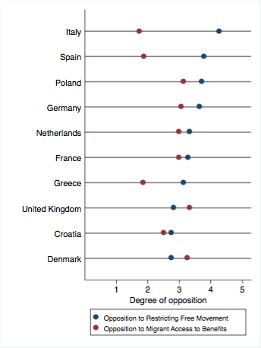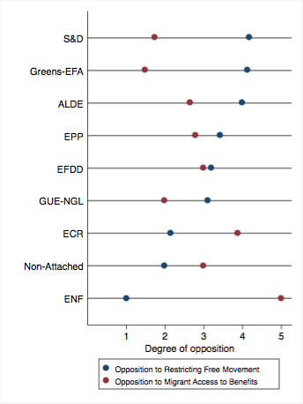

Note: Questions asked: To what extent do you agree or disagree with the following statements about EU Justice and Home Affairs policies? (a) Individual member states should be allowed to place restrictions on the free movement of people into their country; (b) EU migrants should be granted the same rights and access to public services as citizens of the recipient member state. Answers: 1=Agree Strongly, 2=Agree, 2=Neither Agree nor Disagree, 4=Disagree, 5=Disagree Strongly.

Figure 11 shows MEPs’ positions, first, on establishing a common EU policy on economic migrants from third countries and, second, on enabling the police in each member state to issue arrest warrants across the EU for serious crimes. Responses to both questions tend to be very strongly correlated. A striking exception is the ENF, which strongly opposes a common EU economic migration policy but backs EU-wide arrest warrants. Other Eurosceptic political groups, such as the ECR and EFDD are relatively opposed to a common economic migration policy, but they display more neutral views on EU-wide arrest warrants. Support for a common economic migration policy is strongest among the S&D, EPP, Greens and ALDE. Looking at the country-level, MEPs from Italy, Spain, Greece and Germany are most supportive of establishing a common economic migration policy and of allowing EU-wide arrest warrants for serious crimes. Opposition to a common economic migration policy is strongest in Denmark and the UK.

Figure 11: MEPs’ views on establishing a common EU economic migrant policy and EU-wide arrest warrants, by country and political group
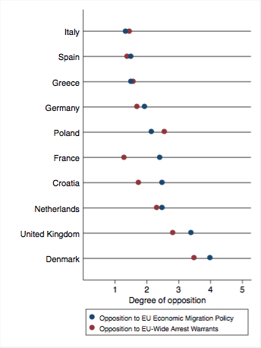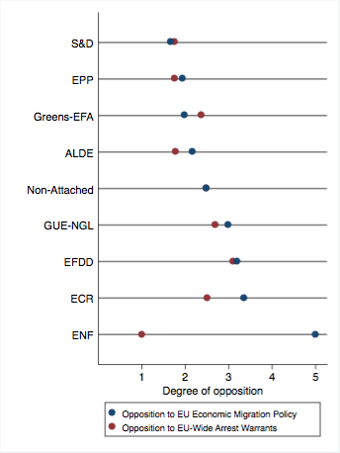

Note: Questions asked: To what extent do you agree or disagree with the following statements about EU Justice and Home Affairs policies? (a) There should be a common EU policy on economic migrants from third countries; (b) For serious crimes, the police in each member state should be able to issue arrest warrants across EU. Answers: 1=Agree Strongly, 2=Agree, 2=Neither Agree nor Disagree, 4=Disagree, 5=Disagree Strongly.

What determines MEPs’ level of opposition to restrictions on the free movement of people? To answer this question, we carried out a multiple regression analysis that allows us to isolate the effects of particular factors, while taking other things into account. Factors included, among others, are regional divisions, the left-right position of MEPs, the perceived left-right position of party supporters, MEPs’ level of support for further European integration, the frequency of contact with home interest groups and the degree to which MEPs aim to represent the interests of all EU citizens rather than only those of their home country. Figure 13 indicates whether and how strongly each variable influences MEPs’ positions on restricting free movement in the EU. First, MEPs from Eastern Europe tend to take a more anti-free movement position than MEPs from Northern Europe. Opposition to restricting freedom of movement in Western and Southern Europe is not significantly different from Northern Europe. Second, the ideological left-right position of MEPs does not have a significant effect on MEPs’ attitudes to restricting free movement. However, the perceived left-right position of MEPs’ own party supporters is significant in this regard. As MEPs perceive their party supporters to be more left-leaning, the more supportive they are of allowing member states to restrict free movement. Third, MEPs that back further European integration are also more likely to take a pro-free movement position. Fourth, MEPs also become more pro-free movement the more they emphasise the importance of representing the interests of all EU citizens. Finally, MEPs become more in favour of free movement the more frequently they are in contact with interest groups from their home countries.

Figure 13: Determinants of Opposition to Restricting Free Movement (2015)
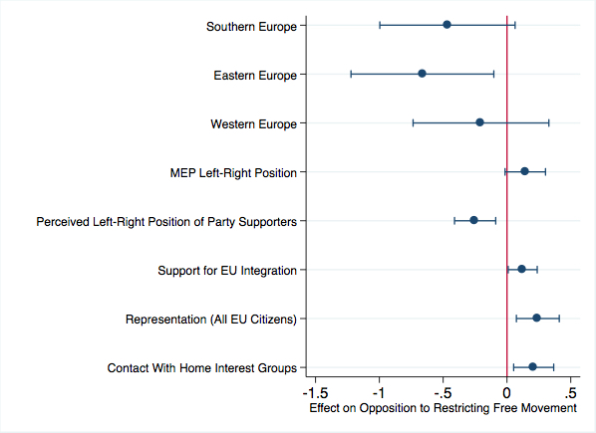

Note: These are average marginal effects, with 95% confidence intervals shown.

