Custom Pasta
- All of the pastas are handmade and healthy
- Respectful to Italian tradition
- Size depends on your request
- Softness depends on your desire
- Starts from 15€
- Can be tasted(optional)
Sauces
- Fettuccine Alfredo

- Pesto Sauce
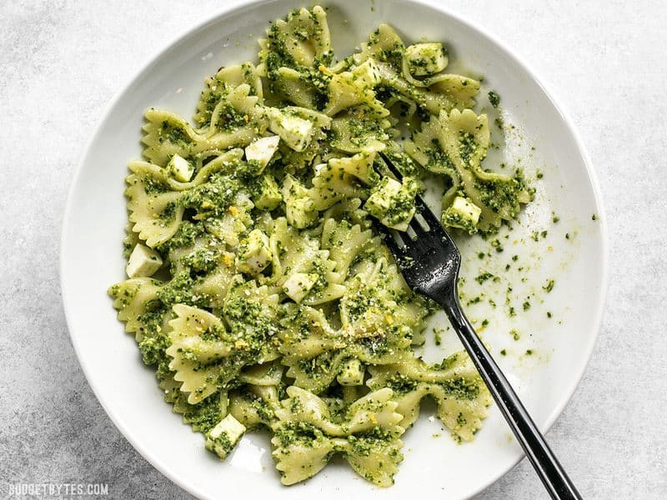

- Marinara Sauce
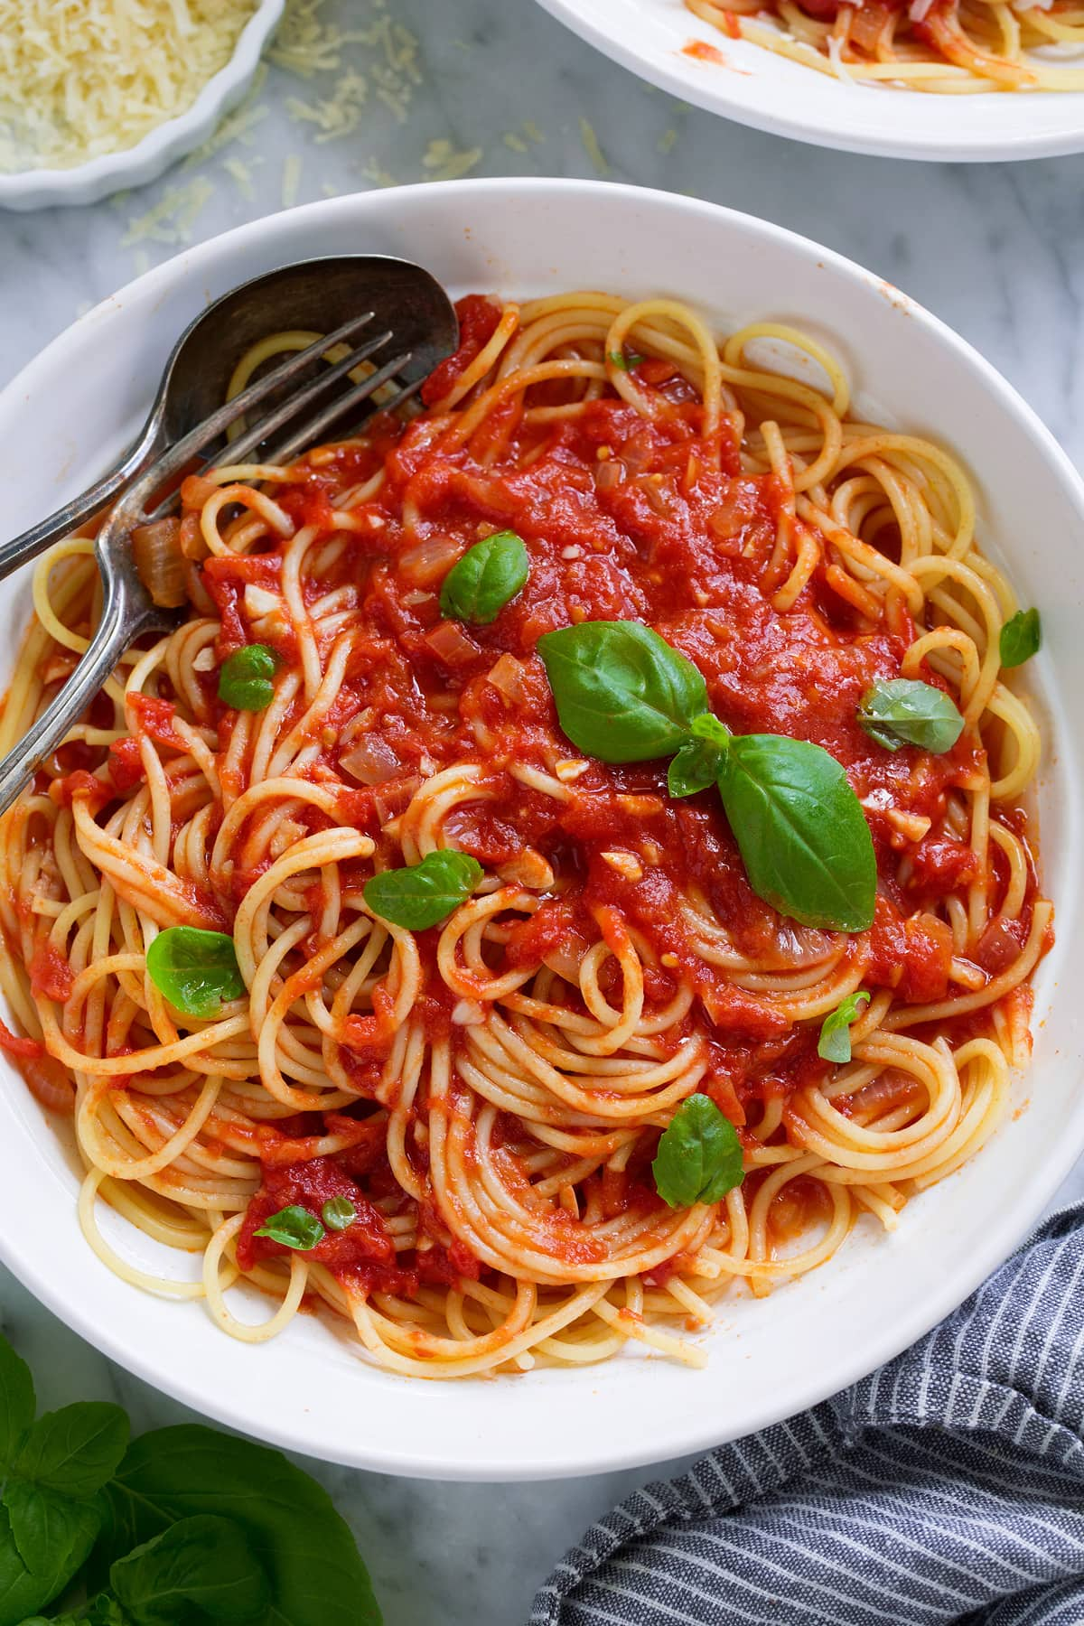

- Bolognese Sauce
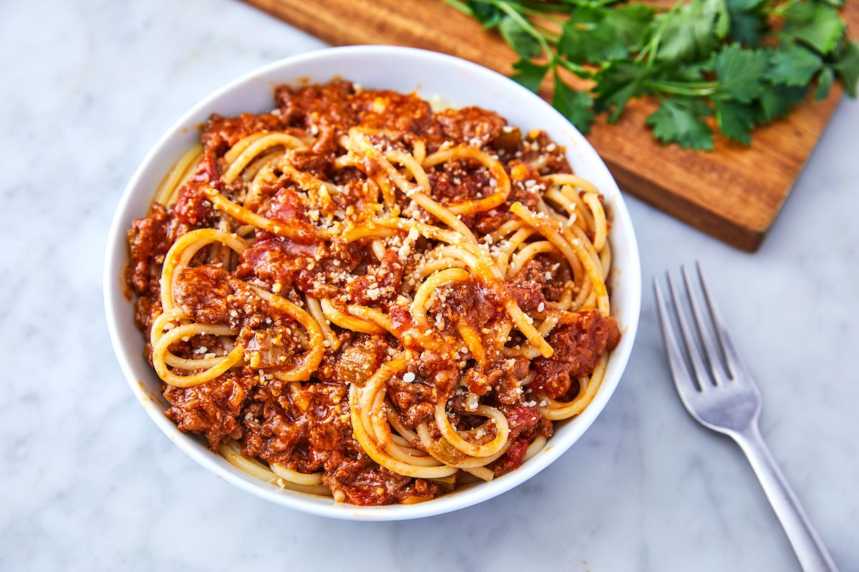

- Carbonara Sauce
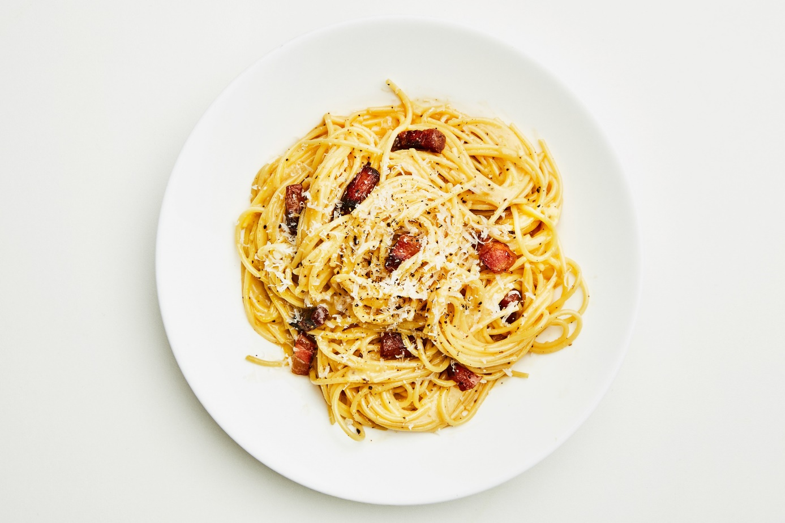

- Neapolitan Sauce
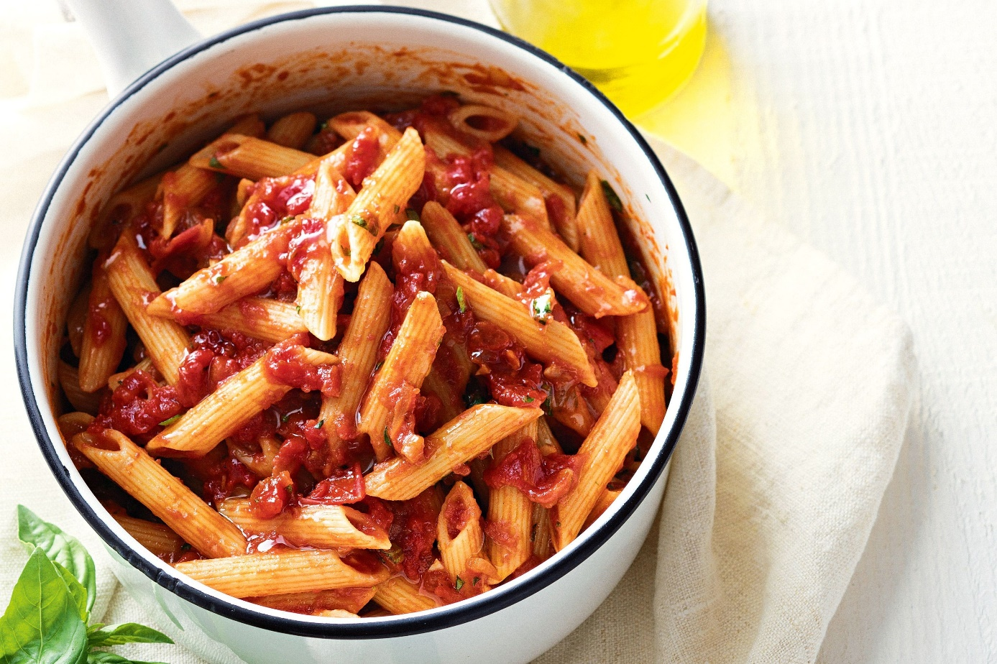

- Sauces are handmade and healthy like all of Cooking Class in Bari products.
- The amount of sauce depends on your choice.

