Masks
- Due to their composition, the masks have the capacity to preventthe passage of liquids, however they allow the passage of air, filtering it well and allowing the user to breath perfectly.
- They are disposable, that is, after their use, they must be placed in one of the machines or in the trash.
- It tightens on the nose and on the sides.
- Bacterial filtrationefficiency:>98%.
- Without latex orfiberglass.
- Hypoallergic.
- Size:17,5 x 9,5 cm.
- Light and odorless.
- Elastic and round ear loop.
- Made of spun polypropylene, not fabric.
The masks are PPE(personal protective equipment) and CPE (collective protective equipment).They should be used properly for maximum protection.
Recycling Machines
- Sensor based on artificial intelligence.
- LCD display counter.
- ID card and card reader device.
- SUltrasonc, whichchecks if the chamber is closed.
- UV-C lamp used to clean the masks.
Curiosities
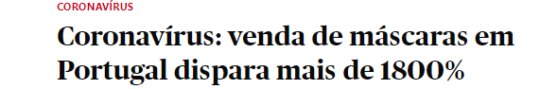
In this news says that the Portuguese people increased the use of masks for 1800% and that more and more the Portuguese increase the use of the mask due to the covid.

