Report of September 2019, Mickūnai, Lithuania
- Creation of eTwinning corner
WE‘ve got new materials from our friends, and puted it on our project corner in the preschool.
https://twinspace.etwinning.net/92479/pages/page/748491

- Introduction of our countries
Our coordinator created the new partners map, with marks on the countries, that now we have new online map with our introductions.

https://www.zeemaps.com/view?group=3548087&x=19.778553&y=54.719988&z=14

- Teachers introduction via twinboard
The teachers – coordinators introduced themselves on the page, created on twinspace, so we know better whom we work to.

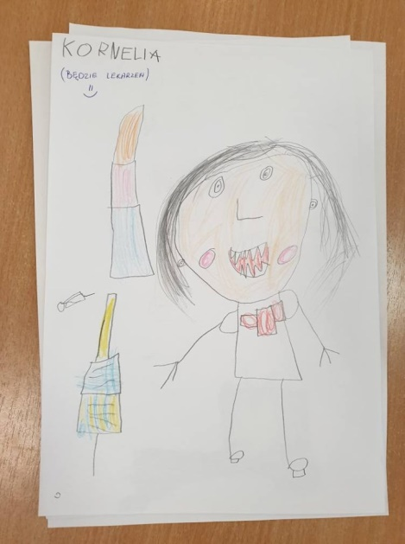
https://twinspace.etwinning.net/92479/pages/page/671820

- Children introduction
Our children painted the portraits of themselves, so we could put the paintings on the padlet wall, where other children, from other preschools, could know our children better.

https://twinspace.etwinning.net/92479/pages/page/671821
https://padlet.com/annmagiosi/8oj3uukksj9w
- „My self“ Children paintings
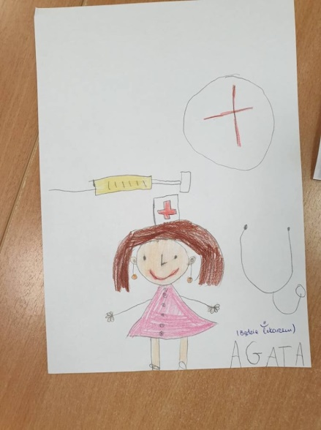
Children from different groups draw portraits of themselves, take a look what was the result:

https://www.youtube.com/watch?v=JHkVnoy3eig&feature=emb_title

- Children draw their generation tree
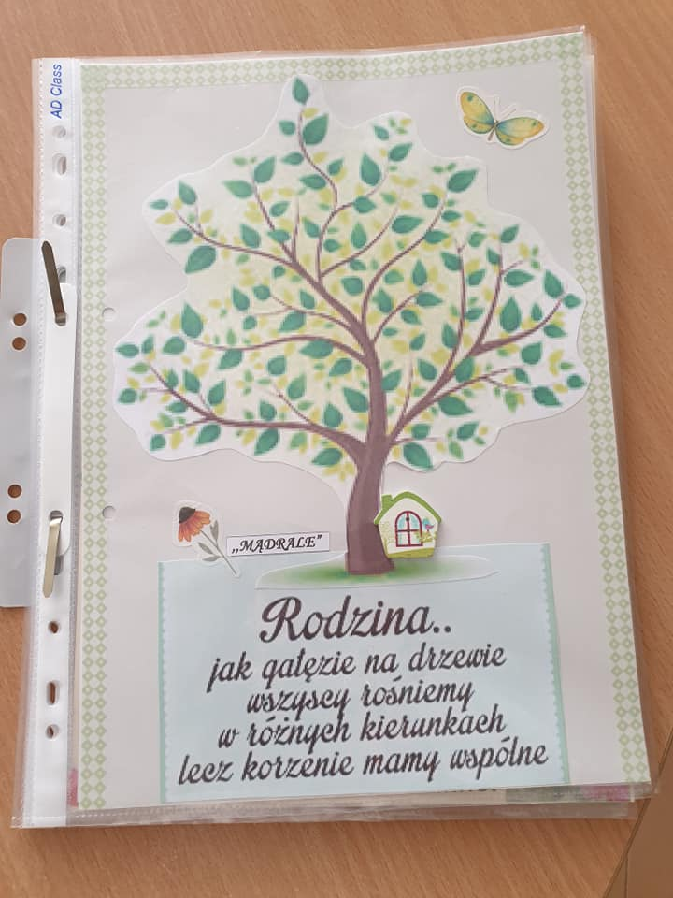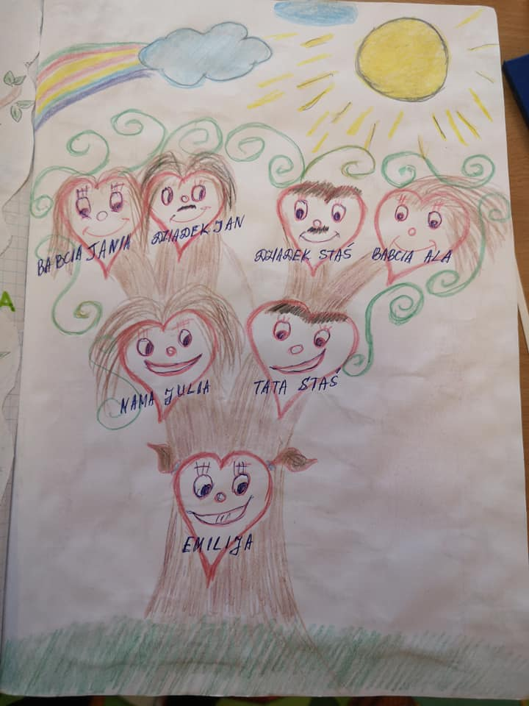
This activity was implemented together with the parents, because parents painted or created the generation trees at home, all together, with grandparents and children, after that teachers created the albums.

https://twinspace.etwinning.net/92479/pages/page/694784

- Say „Hello“ to our friends!
Children sang „Hello“ song to their friends

https://www.youtube.com/watch?v=PSldr-XZyZo&feature=emb_title

- Tolerance and diversity games
We shared few games about the diversity and tolerance, that we tried to play with our children and that are great to play also for others.

https://twinspace.etwinning.net/92479/pages/page/760961

- Traditional dances of my region
Our traditional dances are really fast and funny to dance, so we shared the easy steps and movies with our friends.

https://twinspace.etwinning.net/92479/pages/page/682609
https://www.youtube.com/watch?v=RFMqcq4J3uA&feature=emb_title

- Creation of children family albums
Parents together with children created one page for our group family album, on this page they puted the information about the child, and the family members and also they choosed one picture to share this picture with us.
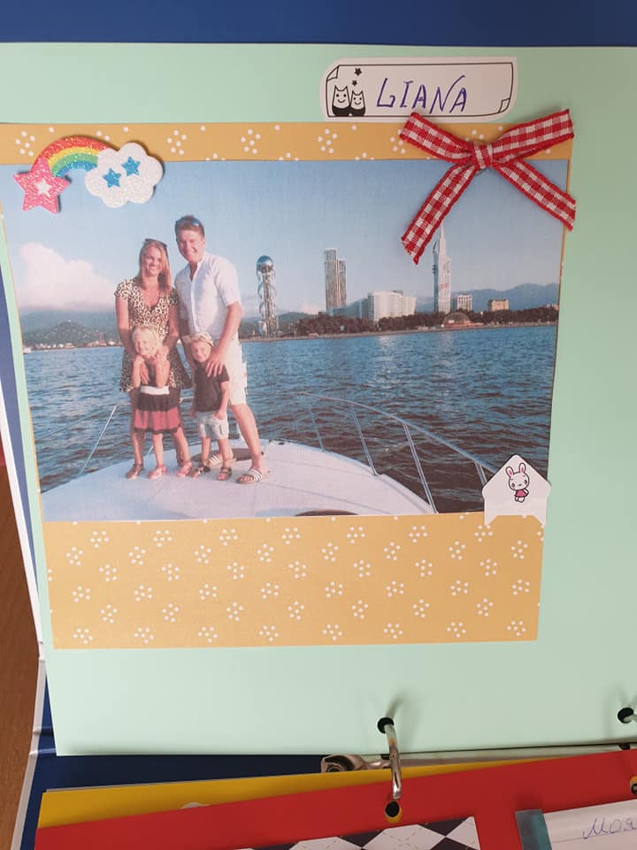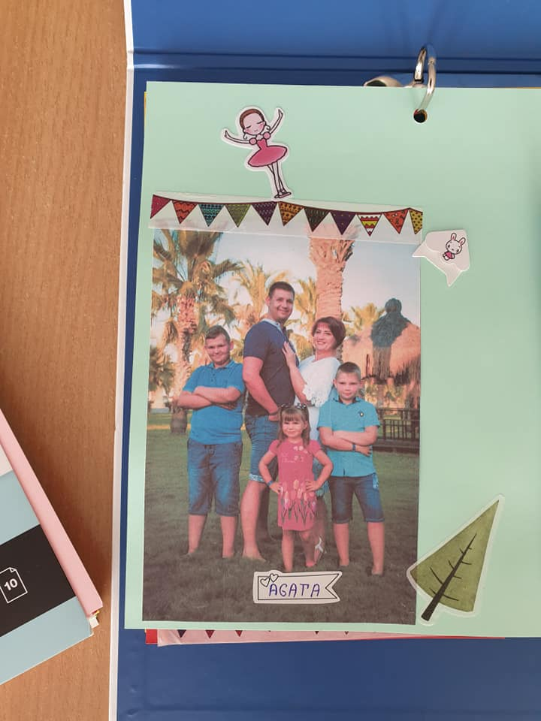
https://twinspace.etwinning.net/92479/pages/page/694804
MANAGMENT ACTIVITIES
At the end of September we sent the monthly report of September to our project coordinator. We have done all project activities for this month. We answered to the questionnaire about September partial evaluation of project implementation.
We received on time the list of October activities from our coordinator.

