Activity tittle: Reel Press, by Semra Kahveci, from Turkey

Theme: Reels Month: February

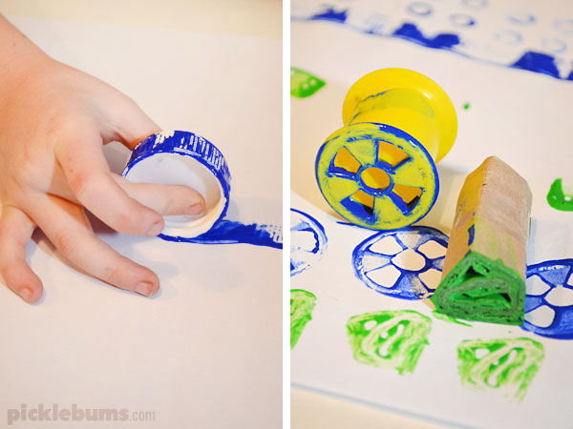

Aim: Promote creativity using cotton reels and develop motor fine skills .

Resources/materials needed:
Colors, cotton reels( different sizes), A4 papers

Introdution: What is cotton reel printing? Discussion on this issue with children. This is an art event, different printing techniques can be discovered. (Leaf, brush, finger ect.)

How to made?
Additional information is available:
https://picklebums.com/ten-crazy-things-to-print-with/

Similar activities
https://tr.pinterest.com/handsonaswegrow/simple-diy-painting-for-kids/
https://www.youtube.com/watch?v=xSsdnC896pU&ab_channel=5-MinuteCraftsPLAY
https://www.youtube.com/watch?v=SJq9XfbPXwE&ab_channel=HurstCreations

