Nurten ÖZEL- TURKEY
Water Art Plan

Let's make a liquid rainbow
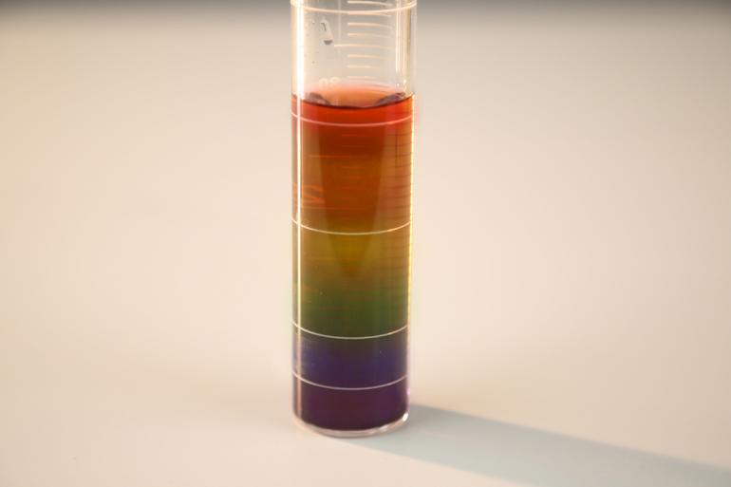

Theme: Water
Subject: Arts
Activity Title: Let’s Make a Liquid Rainbow
Resources:
- 6 cups
- 1 liter of water
- Food color (red, orange, blue, purple, green and yellow)
- Syringe (needle of syringe will not be used)
- A thin, long glass container
- Dessert Spoon
- Wooden stick
Aim: To understand that different colored waters will not mix with each other due to the difference in density.
Activity:
We put an equal amount of water in all glasses. We add a different color of food color to the water in each container. Then we add different amounts of sugar to the cups. Thus, we obtain water mixtures of different densities. We distinguish sugary water mixtures of different densities by coloring them with food colors of different colors. (the density of food dyes is approximately the same).

Since the amounts of water in the cups are equal, the concentration of the sugary water mixture in the cup to which we add the most sugar is highest and the concentration of red water without sugar is lowest. Other densities of sugary water mixtures increase with the amount of sugar in them.
In this activity, we put different densities that we prepared in the colors that make up the rainbow into the same container. The highest density color was at the bottom. Sugary water mixtures of other colors are ordered from bottom to top having a higher density than the following. So we have a rainbow of liquids of different colors.
Resources Link: https://www.youtube.com/watch?v=pkD1siJ1F7c

