3o Nipiagogeio Kilkis, Greece

Maria Kleidara
  - Cylinders December 2019

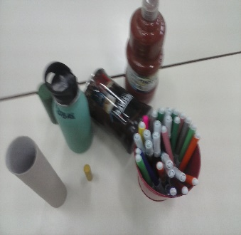
Students that participate in the project: 18 boys and girls
Student’s evaluation:
(which activity was their favorite?)
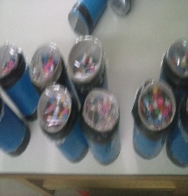
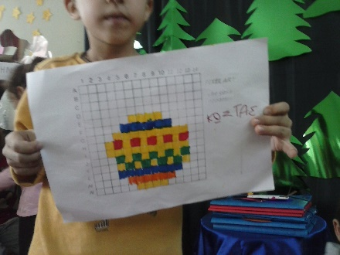
My students’s favorite activity was the “treasure hunt”. They also loved playing with pixels to make Christmas jewels. They also found very interesting to make a car from useless materials. They worked in pairs and in co –operation. They used their imagination and they cultivated their abilities in solving problems and exacting outcomes of their efforts.
The kaleidoscope was also a very funny creative activity and very new for them to explore colors. Some of them are still using it.
Teacher’s evaluation:
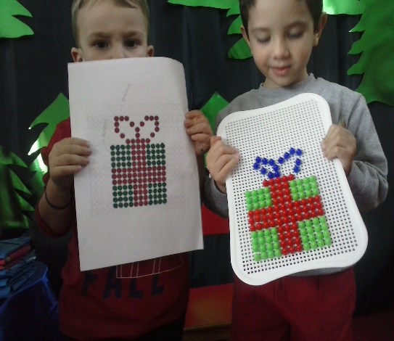
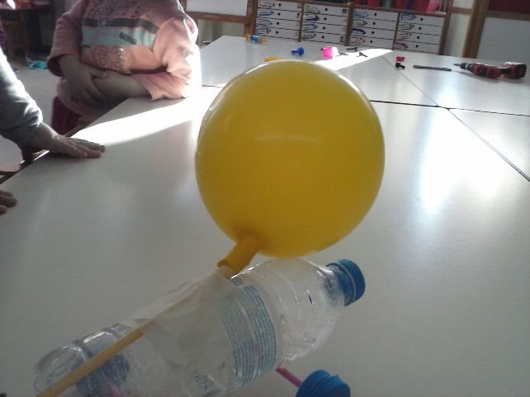
For me the best activity was pixel art as it gave the chance to my students to think and to complete their task using abilities like measuring. In general I think through STEAM activities students learnt to use freely their imagination and they had no fear if something was wrong. They had enough time to try an activity again and again. They also learnt to work in pairs to discuss and exchange ideas of how to find a solution in a problem. The use new technologies and they came closer to technology and innovation. As for parents they have informed about our project and they encourage us to keep working in this way.

