MAKE A RAIN CLOUD IN A JAR
Making a rain cloud in a jar is a great way to help kids visualize how rain drops form. It’s an easy science activity you probably already have the supplies for in your kitchen.

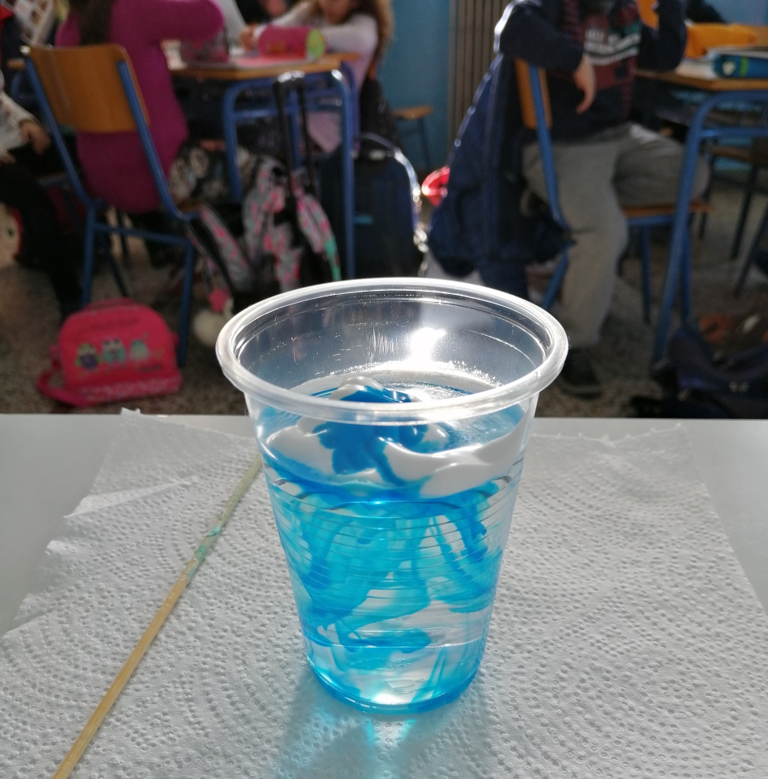

How to Make a Rain Cloud in a Jar
- water
- shaving cream
- food coloring or liquid watercolor
- dropper or pipette for liquid watercolors
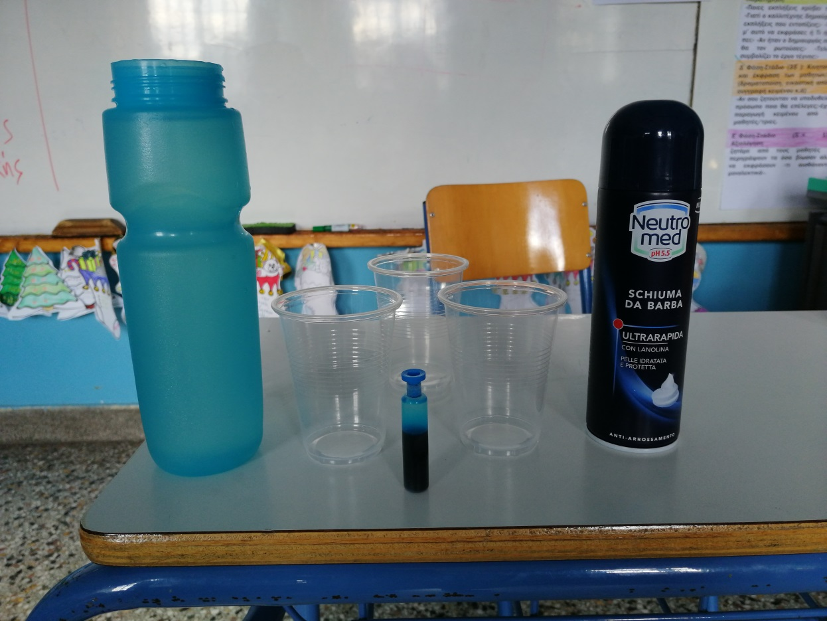

Start by putting a large dollop of shaving cream on top of a jar of water. Talk to the kids how about how the water droplets rise in the air and condense on dust particles. A huge group of them together is a cloud. Explain that in this demo the shaving cream is the cloud.
Add drops of liquid watercolor or food coloring. Once it gets saturated enough it will start to rain. Just like in a real cloud, once the
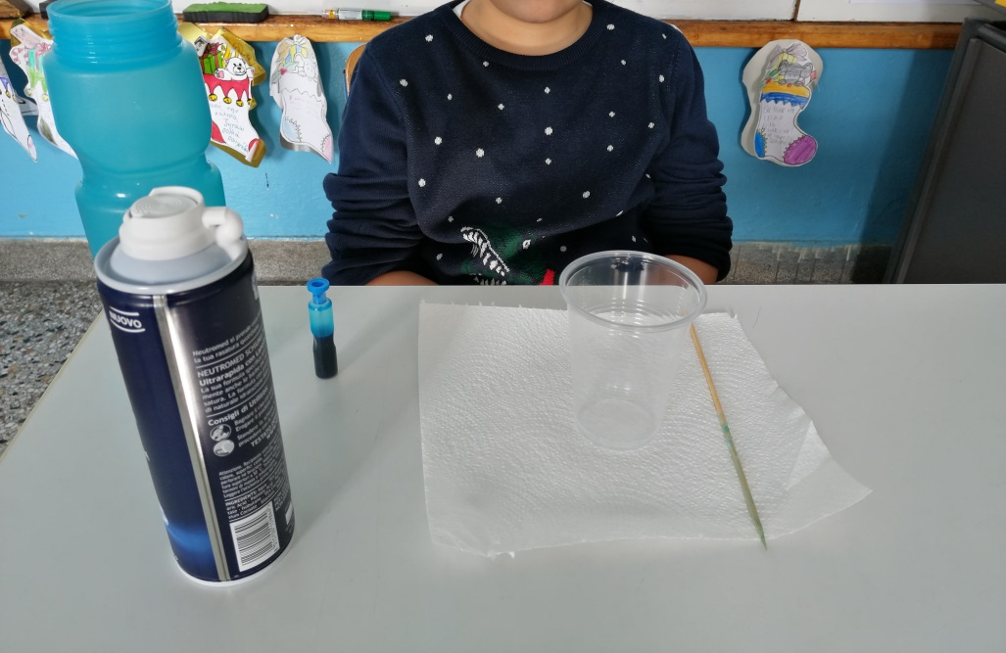
We ended up trying this one both liquid watercolors and food coloring. Each had a different thickness so had a little bit of a different effect. The food coloring ran through quicker and the liquid watercolors had more of a rain effect.
Both give kids the cloud cloud visual so use whatever you have on hand, but if you have both it’s fun to experiment to see the difference!
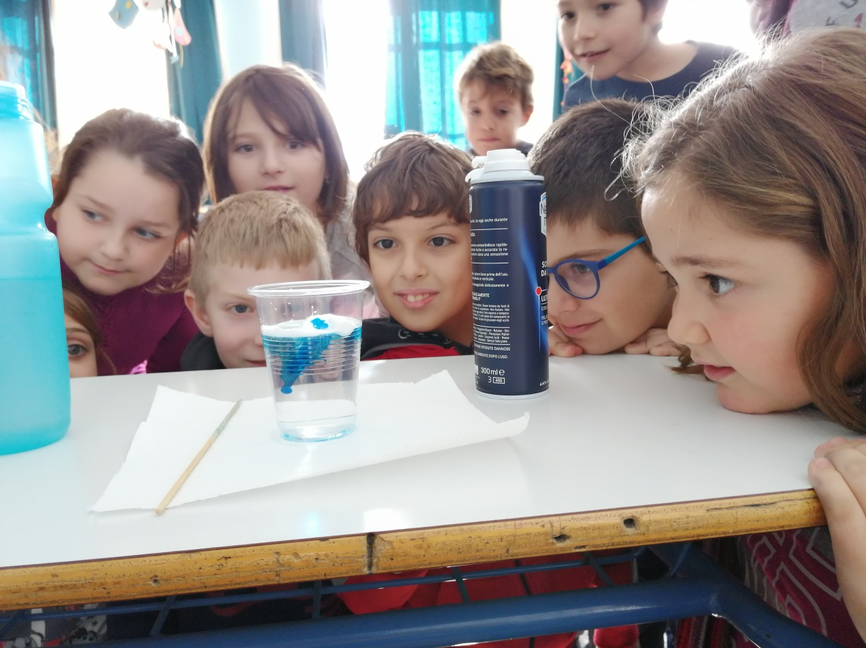

We follow every step by writing and drawing the experient!!!!!
