3o Nipiagogeio Kilkis, Greece

Maria Kleidara
  - Robots November 2019

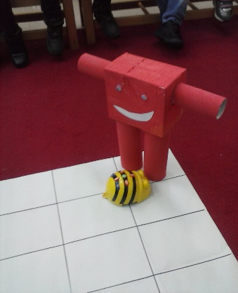
Students that participate in the project: 23 boys and girls
Student’s evaluation:
(which activity was their favorite?)
My students’s favorite activity was the “ moving robot”. They also loved playing with blocks to make a robot. They found very interesting the coding part of the activity.
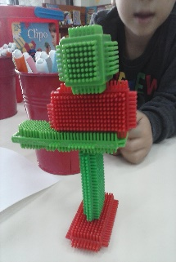
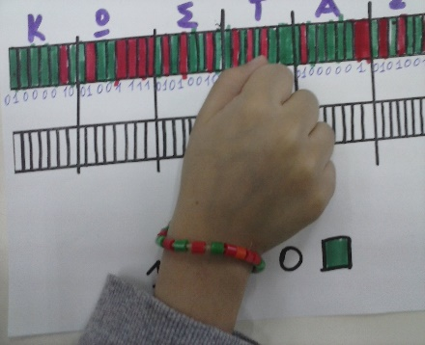
They worked in pairs and in co –operation. They used their imagination and they cultivated their abilities in solving problems and exacting outcomes of their efforts.
The binary bracelets were also a very funny creative activity and some of them are still wearing them. They also liked the drawing robot. They had fun and they connected it with a game they had.
Teacher’s evaluation:
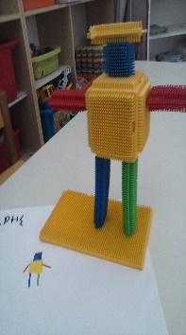
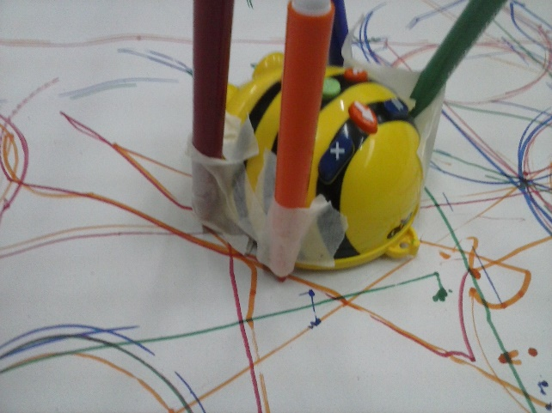
I think through these activities students learnt to use freely their imagination and they had no fear if something was wrong. They had enough time to try an activity again and again. They also learnt to work in pairs to discuss and exchange ideas of how to find a solution in a problem. The use new technologies and they came closer to technology and innovation. As for parents they have informed about our project and they encourage us to keep working in this way.

