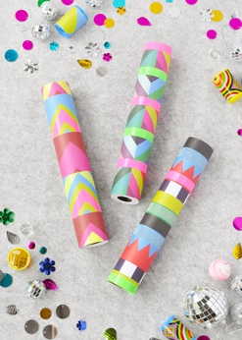
Activity tittle: Kaleidoscope, by Margarida Barbieri

from Portugal

Theme: Cylinders Month: December

Aim: Promote creativity using paper towel tube or toilet paper tube and develop motor fine skills as cut.

Resources/materials needed:
- Paper towel tube or toilet paper tube
- card stock or scrapbook paper
- Thin clear plastic (can be scrap from packaging)
- Colorful translucent beads or shinning stars
- Cardboard
- Aluminum foil
- Marker
- Washi tape, colorful pens or paints
- Glue
- Scissors

Introdution: What is a Kaleidoscope? Discussion with children about this topic. Although it is an art activity, it can be explored as a science one as an optical instrument.

Additional information is available:

https://kids.kiddle.co/Kaleidoscope

https://www.youtube.com/watch?v=yShrIOj34r0

https://www.youtube.com/watch?v=uvPFJpwuzFM

How to do it:
  - Children can colored the paper towel tube using different technics or use paper use scrapbook paper!
  - Squeeze glue all over the scrapbook paper and roll the paper towel tube up in it.
  - Trace the end of the paper towel tube on the scrap plastic three times and cut out all three circles.
  - Hot glue one circle on the bottom end of the paper towel tube.
  - Drop your beads or little colorful stars, into the tube. Put enough to almost cover the plastic. Then place the second plastic circle inside the tube (you will need to use a pencil or marker to push it down to the bottom and loosely cover the beads/stars, but do not push it snug up against them! If it is too tight, then the beads won't move around between the plastic discs).
  - Cut three strips of cardboard that are 1 inch wide and almost as long as the tube you are using.
  - Cover each strip with foil.
  - Glue them into a triangle shape and place inside the tube.
  - This will create the kaleidoscope effect when the kids look inside!
  - Now, glue the last plastic circle on the open end of the paper towel tube. This will be the end they look through.
  - Let the kids decorate with Washi tape, stickers, or color on it if they didn't already. Once they are done, hold your homemade kaleidoscope up to the light and turn to view!

