November activities

Vibrobots— Tiny Robots from Scratch

Overview
- So, whether you’re looking for a little cure for school boredom or are already storing up some activities for this school year (in which case, you are far more organized than I am!), I think you’ll find this is a great printable activity to have some fun with. I mean, it’s a robot that transforms…how cool is that?
- your students will work as physicists and engineers, carrying out experiments to investigate phenomena, principles, and concepts involved in physical science and technology. Working in pairs, they’ll go through a series of lessons that use hands-on experiments to explore gear ratios, friction, and gravity. The unit concludes with an open-ended challenge, which provides an opportunity for students to apply their newly acquired skills and knowledge in creative ways.
- This lesson focuses on these aspects of NGSS Three Dimensional Learning:
Science & Engineering Practices | Disciplinary Core Ideas | Crosscutting Concepts
Constructing Explanations and Designing Solutions. Generate and compare multiple solutions to a problem based on how well they meet the criteria and constraints of the design problem. | ETS1.B: Developing Possible Solutions. At whatever stage, communicating with peers about proposed solutions is an important part of the design process, and shared ideas can lead to improved designs. | Systems and System Models. A system is a group of related parts that make up a whole and can carry out functions its individual parts cannot.
Instructions

Print it out – either regular paper or cardstock works fine for this project.
Cut out around the outside edge of the robot – and don’t forget to trim the dark lines in the middle, between the two sections of the robot.
Fold the robot in half,right down the middle on the dotted line.
Then fold down on all the other dotted lines. Make sure to fold down the tabs, too.
Next you’re going to glue the tabs to form the robot. Think of it as two boxes held together by the first middle line you folded.
Now the little puppet car is ready! Just have it lay flat to be a car…
Or fold it in half and stick your hand inside…and it becomes a fun little robot hand puppet.
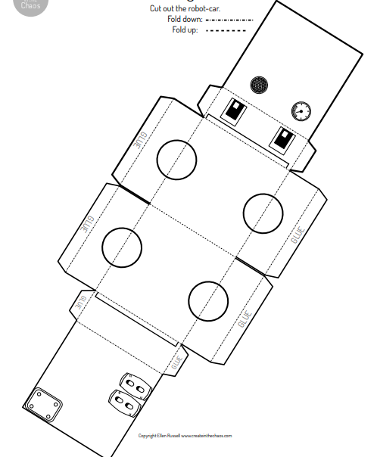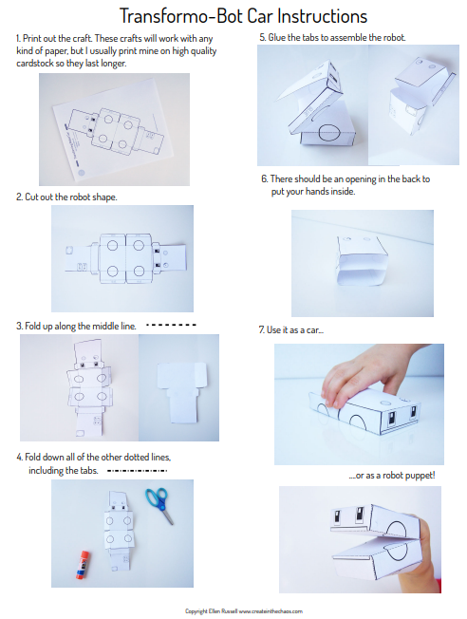

- In this lesson plan, your students will learn about engineering design as they build their own vibrobots from craft materials. No previous experience with robots is required
