Nurten ÖZEL – TURKEY
Let's Make a Clock with Stones
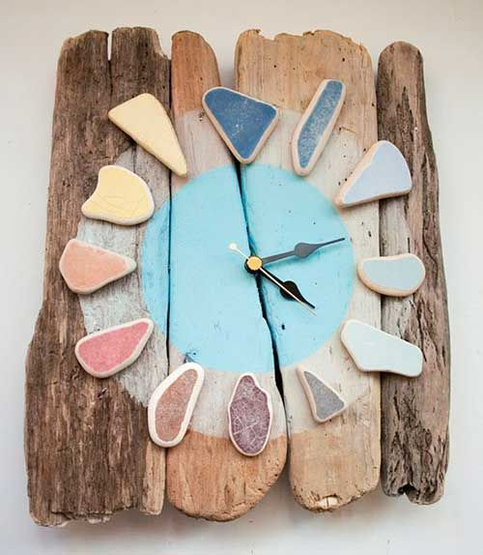
Theme: Rocks, Stones and Minerals
Subject: Technology
Activity Title: Let’s Make a Clock with Stone
Resources:
- Clock Mechanism
- Wooden parts for clock floor
- Adhesive for bonding Stones
- Battery for clock
Aim: Using stones in technology
Activity:
Pieces of wood are glued together. (A whole piece of wood can also be used.
The clock mechanism is attached to the middle of the wooden piece. The stones are glued to form the racks of the clock. We can insert and run batteries on our watch. Now our watch is ready :)

