Nurten ÖZEL – TURKEY
Stone Painting
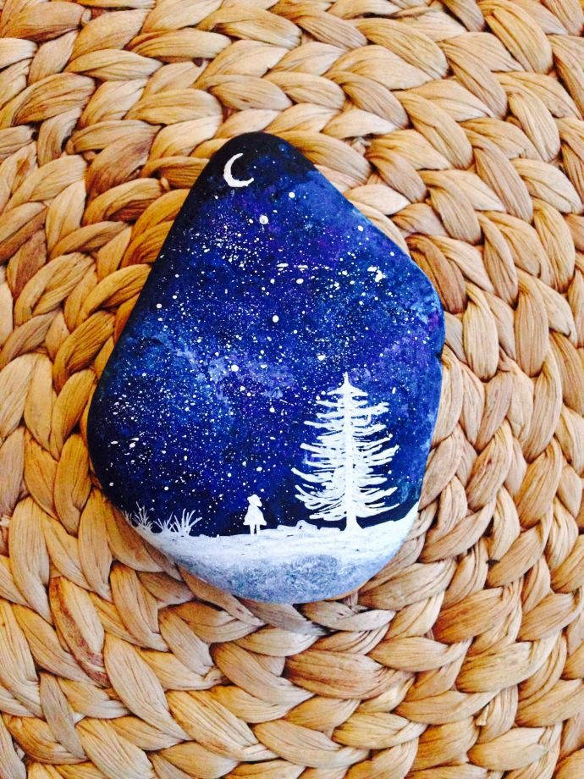
Theme: Rocks, Stones and Minerals
Subject: Arts
Activity Title: Stone Painting
Resources:
- Collect stones of various sizes from the seaside. When choosing stones, make sure that their surfaces are smooth. You will get better results when painting matte and lighter colored stones, especially white.
- Stone paint or acrylic paint; If you can not find stone paint, you can use acrylic paint. Acrylic paints are water-based paints. They do not dry late like oil paints. It has fast drying properties. It is also possible to find silvery bright and metallic colors in acrylic paints.
- Picture brushes; round and flat-tipped brushes used for painting in various thicknesses.
- Acetate pens; It helps you easily define and clarify or perform the application called contours in the picture.
- Shine nail polish or water based varnish; you will use the drawing on the stone to make it bright and lively and fixed. You can also use a toothbrush or divit for painting.
Aim: The biggest feature of stone painting art is painting on stones by combining your imagination, creativity and handcraft.
Activity:
You should first clean the stones you collect from the seaside so that the paint is easily dispersed and free from dirt. To do this, add some detergent or liquid soap to a water basin. Put the stones in it and let it sit for 15-20 minutes. If you are obsessive about this, you can add some bleach to it. Then, under the tap, brush the toothbrush and clean the individual stones. Get rid of dirt and moss residues on it. Place them on a towel or paper towel and allow them to dry thoroughly.
Now your stones are ready to be painted. The stones need a primer to show the paint color without changing it. You can use white color or any color you like for primer paint. With a thick brush, paint one surface of the stones first and then the other surface after drying. If you double your liner, you can create clearer pictures or patterns.
To paint a stone on a stone whose primer painting process is finished and dried out, draw the object you want to paint without pressing too hard. Prepare a composition. You can draw a landscape picture, any object, butterfly, bee, fruit figures, human or angel figures, mandala pictures on the stones. This part is entirely up to your creativity. You can even write. Then texture and paint your composition with the help of brushes. You can pass over the parts you want to identify with transparencies. After finishing your painting, apply a thin coat with varnish or transparent colored nail polish. Let it dry and use your stone object wherever you want.
Resources Link:
- https://www.youtube.com/watch?v=aOWHy2DrEk8&list=PLa4lgeHI11WYxwUlSHP3o0ccB2TSV9vJ4
- https://www.youtube.com/watch?v=1wIWmdMvAbc&list=PLa4lgeHI11WYxwUlSHP3o0ccB2TSV9vJ4&index=3
- https://www.youtube.com/watch?v=LtkbfvI9zFY&list=PLa4lgeHI11WYxwUlSHP3o0ccB2TSV9vJ4&index=2

