Activity Title
ENGINEERING-ROBOT WORK
by Neriman Temizel - Turkey

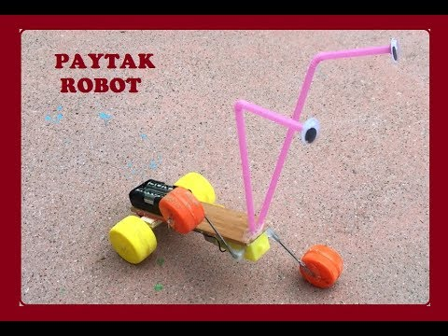
Theme: Robots Month:Nowember

Aim:
Objective: to enable them to communicate their ideas and thoughts,to put forth a product using their cooperation and communication skills,to make a presentation of the product, etc.

Resources/Materials needed:
battery, battery compartment, motor, bottle caps, toothpick, wire, silicone gun, piece of wood

Activity:
Step 1: Introduction:
All materials are placed in front of the children. 'what can we do with these?'he told reporters. Questions and Answers continue until the Robot finds the answer.

Step 2: bottle caps are distributed to children, with teacher support and silicone gun , bottle caps are attached. Children are given instructions to assemble the pieces.

Step 3: the materials are correctly combined under the guidance of the children and the teacher, as in the video.
Video Link: https://www.youtube.com/watch?v=gsPuc3fyjII

Step 4: Children are asked the following questions::
1-How many cylinder materials were used in this robot?
2-What is the power source that enables the robot to progress?
3-What else can we use instead of bottle caps?

Step 5: the teacher uploads a video of the children to the Twinspace.

