Activity Title: Let's build a car by Ayşe Beyza Ünlü - Turkey

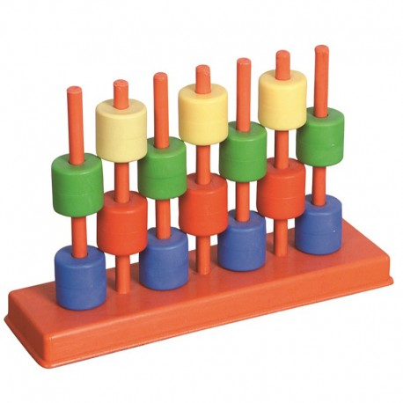
Theme: Cylinder systems Month: December

Aim: Think like an engineer with what he has learned in cylinder systems. use materials correctly. Be able to cooperate with an adult. Uncover product with residual materials

Resources/Materials needed: 2 pcs big pet bottle cap, 2 pcs small pet bottle cap, one pcs small pet bottle, 2 pcs wooden rods, scissors, adhesive, tape, 1 pcs balloon

Activity:
Step 1: Introduction: All materials are placed in front of children. 'what can we do with these?' he/she is asked. The questions and answers are continued until you find the answer to the car.

Step 2: The bottles are distributed to children, cut off, bottle caps punctured. Children are given instructions to assemble the pieces.

Step 3: The materials are combined by children in the right way as in the video.
Video Link: https://www.youtube.com/watch?v=VrAsQxGuy1E

Step 4: Children are asked the following questions:
1- How many roller materials have been used in this car?
2- What is the power supply that enables the car to advance?
3- What else could we use instead of a balloon?

Step 5: The teacher shoots a video of the children's uploads it to the twinspace.

