Suzana Mičević-Marušić (mother)
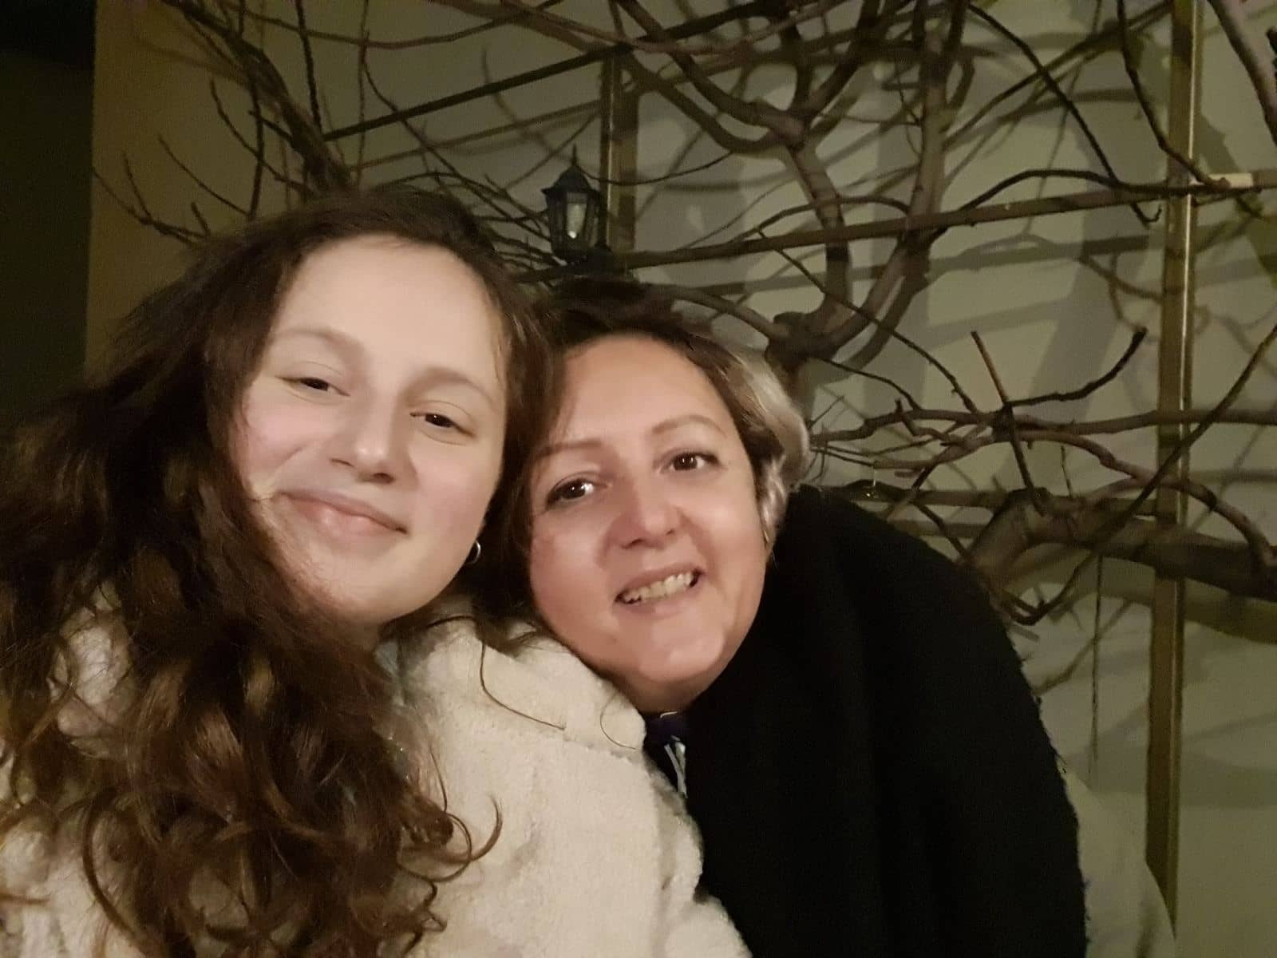
1. What is a healthy life?
Suzana: As a smoker, first of all, it would be a life without smoking. Secondly, it would be a life without consuming alcohol and drugs and most importantly, uniform food intake.
2. A lot of people try to live a healthy life. Do you think you are one of them?
Suzana: No, because, as I said, I am a smoker, but also I don’t eat very healthy. And I think I should exercise more.
3. Our school is a part of the Erasmus+ project Health to Meet You. It is an international project and the main theme is health and how to live healthier. Do you think these projects will help students, teachers and parents to learn?
Suzana: I don’t think so. That is something that everybody should already know. That is like having a project “How to behave culturally?”
4. What is your opinion about life habits of teenagers?
Suzana: If I look at my children, my opinion is very positive, but how it is in other families, I don’t know.
5. What is the biggest problem in life habits of teenagers (not enough exercise, too much media influence, screen usage, unhealthy diets, smoking, alcohol…)?
Suzana: I will attach to the last question. In the generation of my daughter, I don’t see any problems. They are on their phones non-stop, but by their grades I can see they use it for good purpose.
6. A survey conducted by a school project of 300 students showed that 90% percent of students check notifications on their cell phones as soon as they wake up. What is your view on this? Do you think that young people are overusing cell phone screens and that this can have negative health effects?
Suzana: I check my cell phone notifications when I wake up too and I don’t think that can have any negative health effects
7. What should schools do to help youth to live healthier?
Suzana: They should unload them of so many responsibilities
8. What should local community do to help youth live healthier?
Suzana: They can change the food in canteens.

