MRs Lenkienė Lesson plan

Title
“Welcome to Lithuania. The Ultimate Staycation”
Author(s)
Irma Lenkienė
Licenses
Please indicate below which license you attribute your work with by picking one of the options below. If you include images in the lesson plan, please make sure to add the source and licenses under the picture itself.
- Attribution CC BY. This license lets others distribute, remix, tweak, and build upon your work, even commercially, as long as they credit you for the original creation. This is the most accommodating of licenses offered. Recommended for maximum dissemination and use of licensed materials.
- Attribution ShareAlike CC BY-SA. This license lets others remix, tweak, and build upon your work even for commercial purposes, as long as they credit you and license their new creations under the identical terms. This is the license used by Wikipedia, and is recommended for materials that would benefit from incorporating content from Wikipedia and similarly licensed projects.
- Attribution-NoDerivs CC BY-ND. This license allows for redistribution, commercial and non-commercial, as long as it is passed along unchanged and in whole, with credit to you.
- Attribution-NonCommercial CC BY-NC. This license lets others remix, tweak, and build upon your work non-commercially, and although their new works must also acknowledge you and be non-commercial, they don’t have to license their derivative works on the same terms.
- Attribution-NonCommercial-ShareAlike CC BY-NC-SA. This license lets others remix, tweak, and build upon your work non-commercially, as long as they credit you and license their new creations under the identical terms.
√ Attribution-NonCommercial-NoDerivs CC BY-NC-ND. This license is the most restrictive of the six main licenses, only allowing others to download your works and share them with others as long as they credit you, but they can’t change them in any way or use them commercially.

Subject
List all the subjects that this lesson plan is intended for. If this is an interdisciplinary lesson, list multiple subjects.
English, ICT, Geography, History, Art.

Aim of the lesson
Describe in 1-2 sentences what you would like to achieve with your students by the end of the lesson.
By completing speaking, listening and role-play activities, the students will enrich their knowledge on Lithuania and its places of interest and expand their travelling related vocabulary. They will also develop the 21st century skills such as critical thinking, creativity, collaboration, communication, ICT literacy, global awareness and citizenship through social inclusion.

Age of students
Year 5 (age 11 -12)
Time
Preparation time: 180 min
Teaching time: 45 min

Teaching material
Online:
List here all the links of online tools and support documents that you will use during the lesson.
Computers and smartphones with the Internet access.
www. create.kahoot.it/details/welcome-to-lithuania
www.youtube.com/watch
Offline:
Paper, posters, flyers, brochures, postcards. writing and drawing implements, computer prints.

21st century skills
Add here how the lesson plan corresponds to 21st century skills. To find out more: http://www.p21.org/our-work/p21-framework .
Activities are designed to foster the learning of 21st century skills of students:
- critical thinking. Students analyze information objectively and make a reasoned judgment about which sightseeing places in Lithuania are worth visiting. They evaluate research findings. They draw reasonable conclusions from a set of information and discriminate between useful and less useful details to decide.
- creativity. Performing role-play activities students turn new and imaginative ideas into reality. They transform the classroom area into a travel agency and perform their roles as travel agents giving well-informed, appropriate advice to clients about where and when to travel in Lithuania based on their needs.
- communication. Students impart and exchange information by speaking and writing.
- collaboration. Students work together to run their travel agency successfully.
- ICT literacy. Students create Powerpoint presentations that meet the latest design trends. They present their ideas with beautiful design, rich animation, cinematic motion. For their assessment students use an online platform Kahoot!

Lesson Plan
Describe here in detail all the activities during the lesson and the time they require.

Name of activity | Procedure | Time
Brainstorming | It provides a free and open environment that encourages everyone to participate in the discussion based on the pictures presented. After naming the types of holidays students draw the conclusion that the theme of the lesson will be related to travelling.  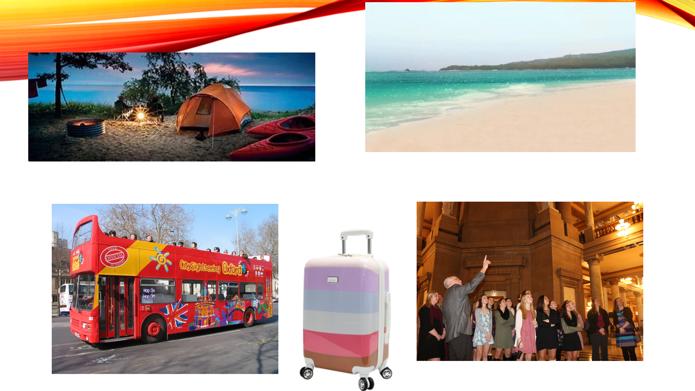  Students discuss the reasons for travelling, their expectations and priorities while travelling, they also express their preferences for local or foreign destinations. | 5 min
Students’ presentations. | The definitions of staycation and social inclusion are presented. Students name their expectations for having their ultimate staycation in Lithuania and define the acts of making all groups of people feel valued while organizing a trip and travelling. Reasons for applying to a travel agency for some information on sightseeing places are provided. Four students play roles of tour guides in a local travel agency. They provide information about history, geography, culture, travel tips, activities, restaurants, nightlife, etc. Tour guides show Powerpoint presentations that meet the latest design trends and students focus on communicating their ideas in their presentations:  • General information about Lithuania  • Top 3 places in Lithuania  • The Baltic Coast  •Lithuanian cuisine  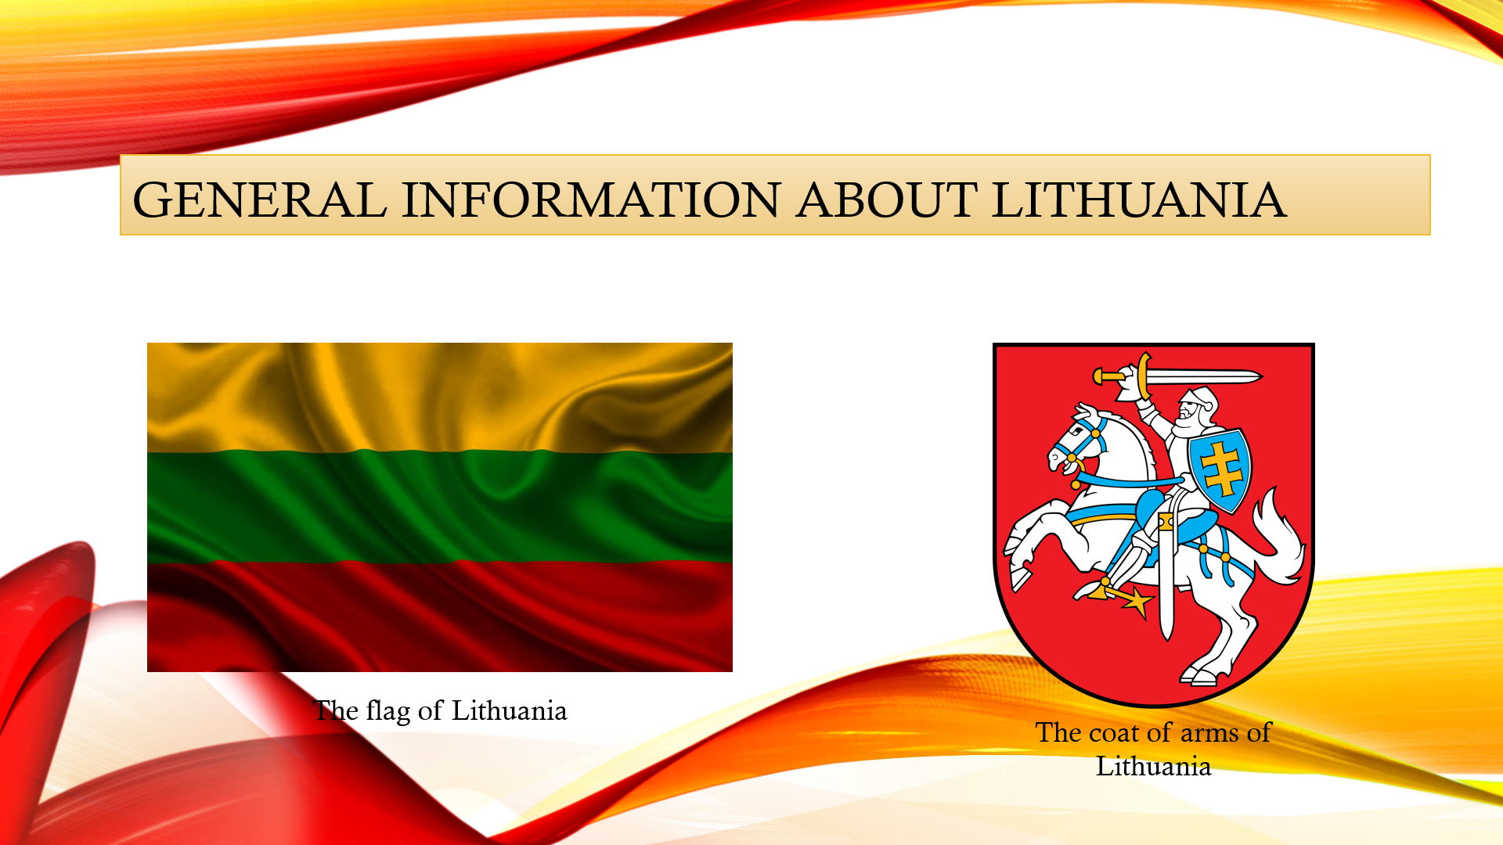  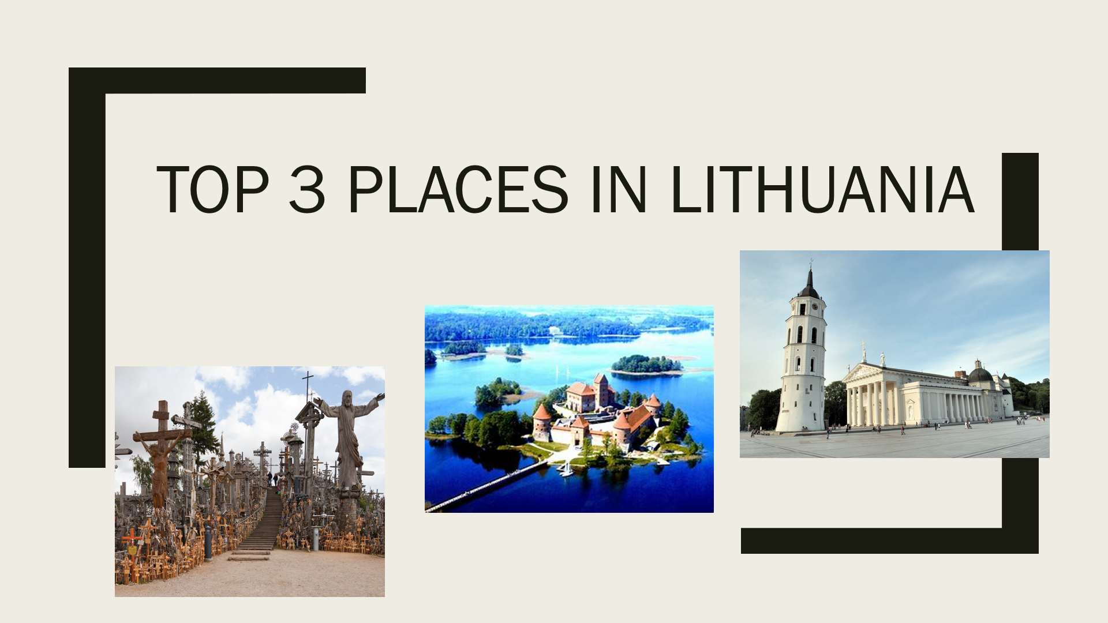  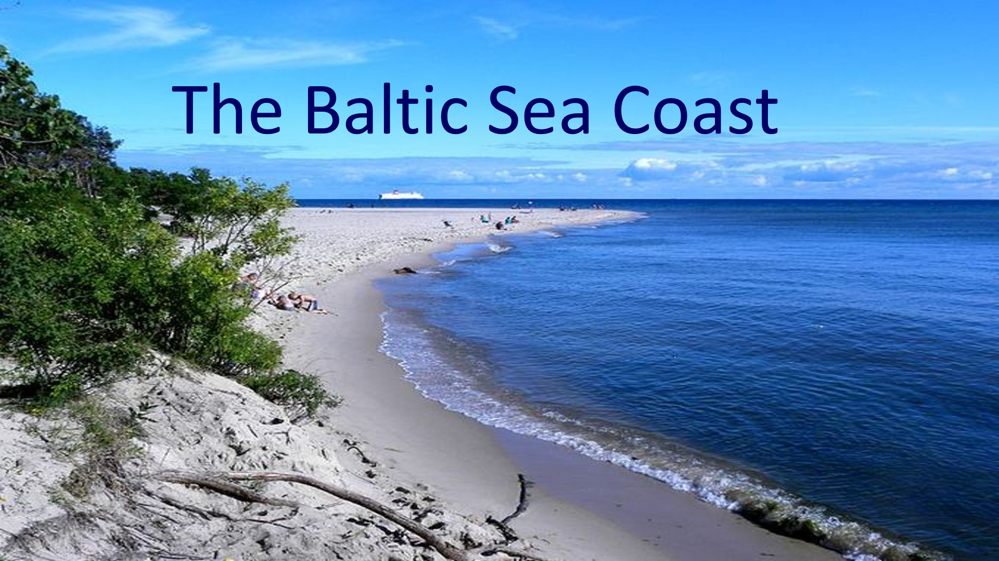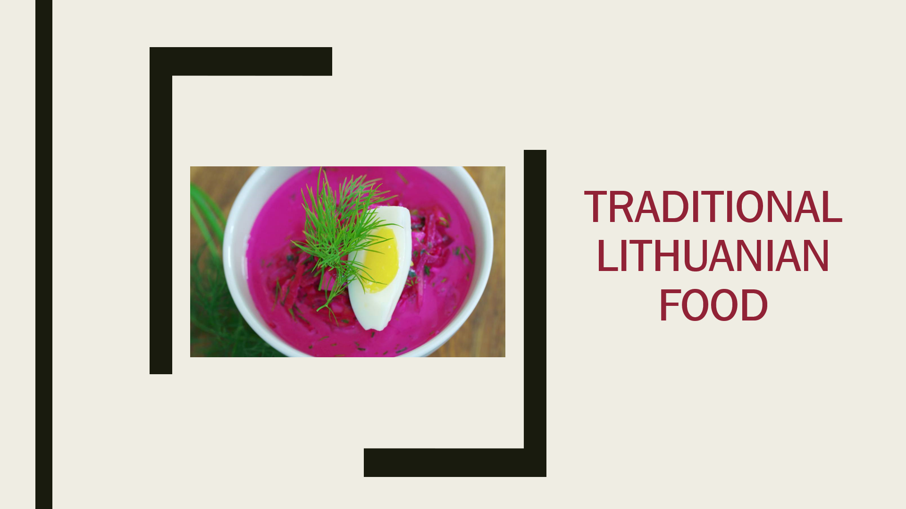 | 20 min
Gap filling | 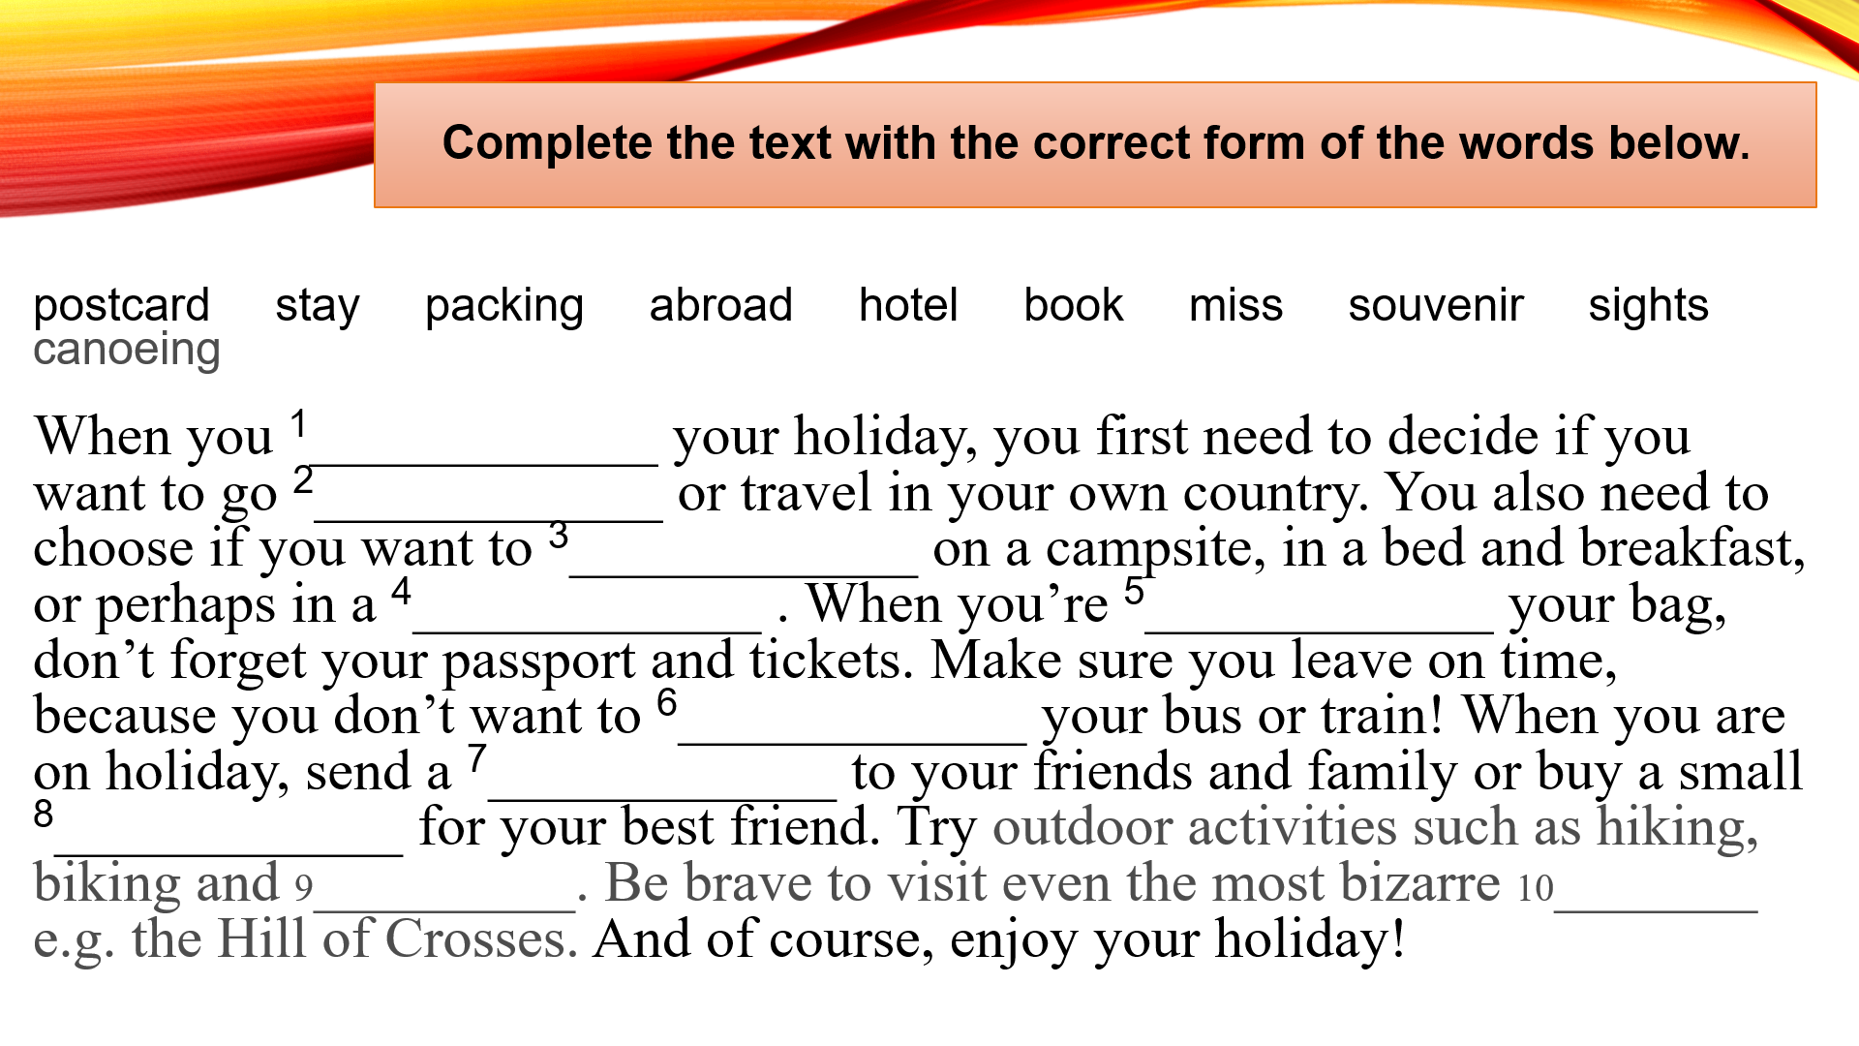  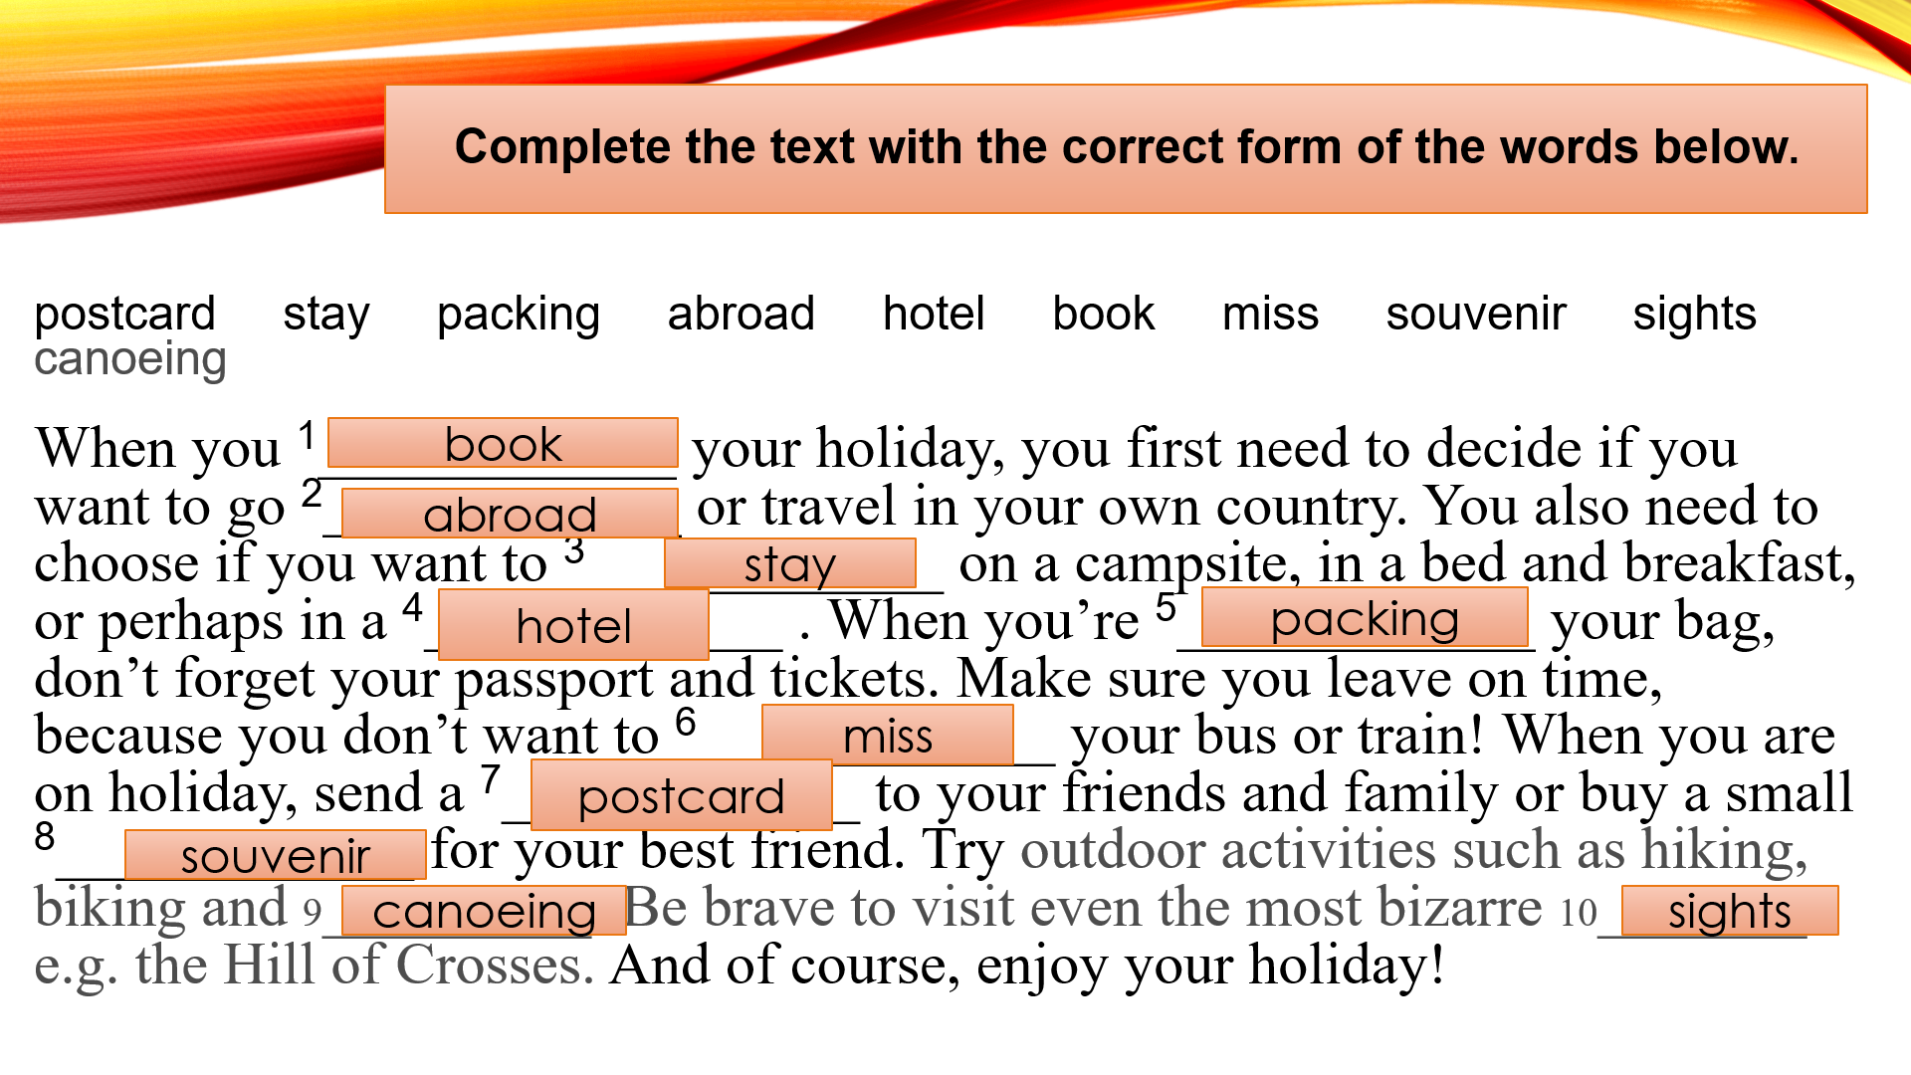 | 5 min
Self-assessment. | An online platform Kahoot! is used to assess the students. Questions, along with answer choices, appear on a classroom screen while students submit responses using a smartphone. | 10 min
Student feedback | Students watch a video Unseen Lithuania on Youtube. After that the class is gathered in a casual circle and some questioning strategies are used to hear what the students truly feel about the lesson. | 5 min

Assessment
Describe here the assessment method of the lesson, if any. For example, if you plan on assessing your students with a quiz, include here questions and answer options with color-coding the correct answers.
An online platform Kahoot! was used to assess the students. Questions, along with answer choices, appeared on a classroom screen while students submitted responses using a personal mobile device.

https://create.kahoot.it/details/welcome-to-lithuania

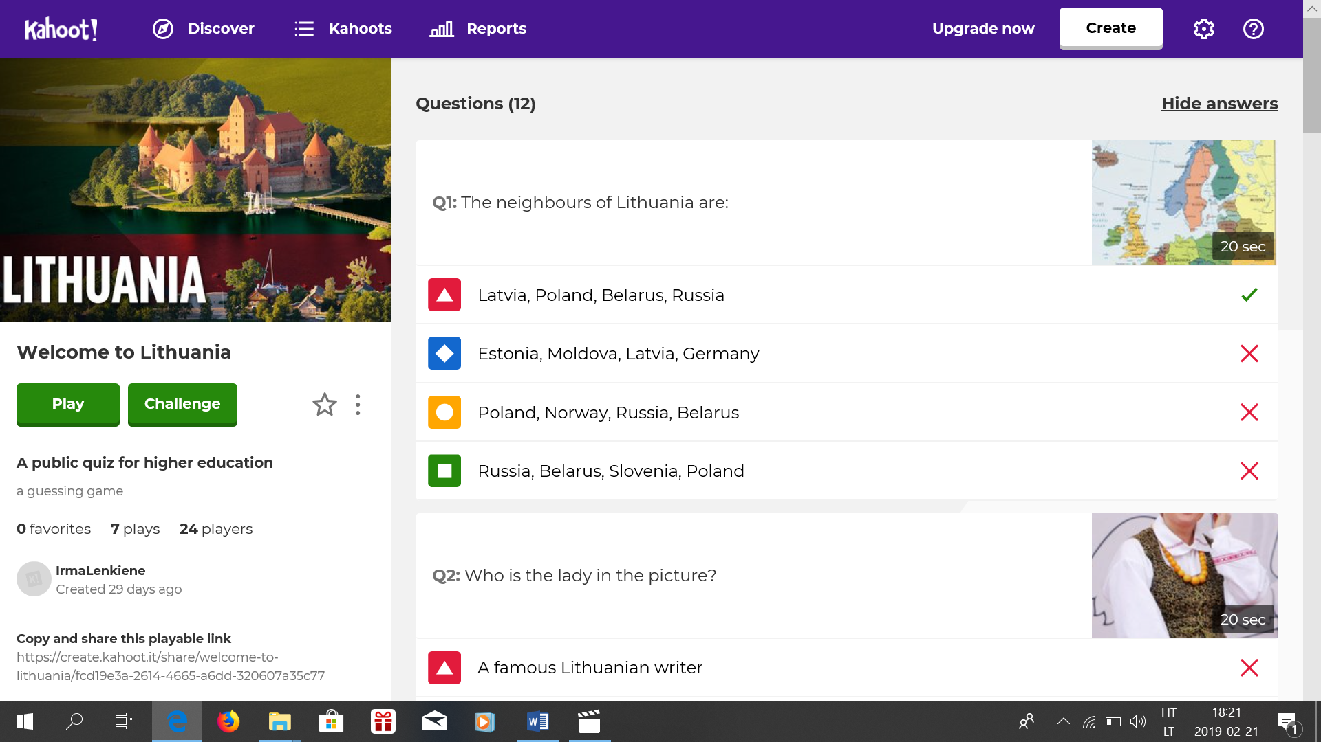

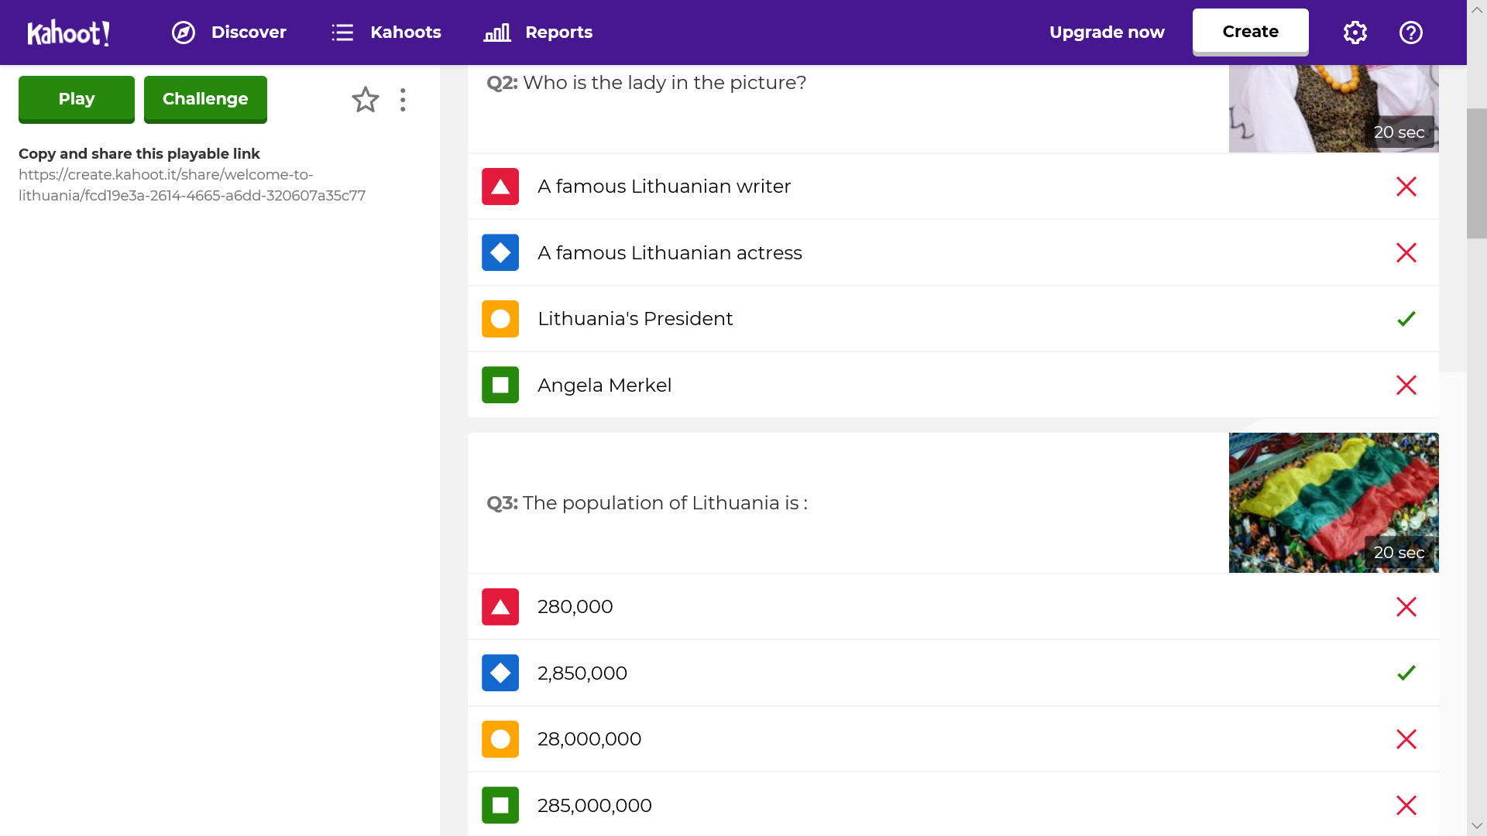

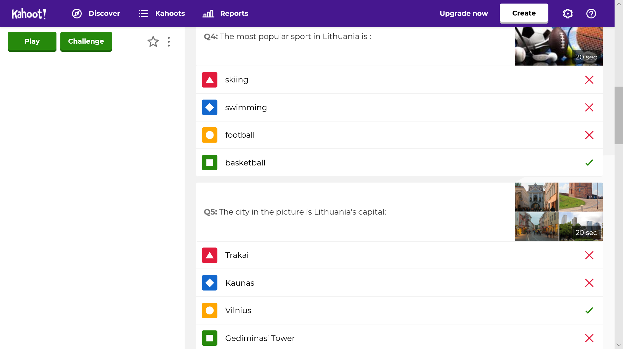

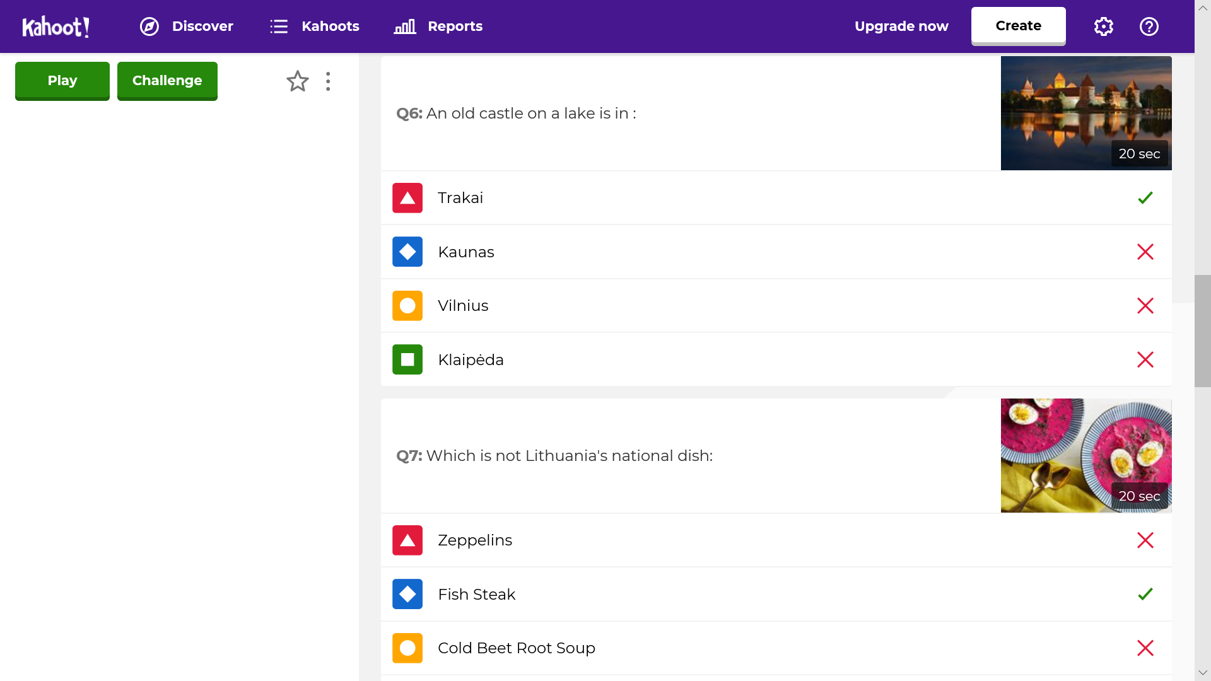

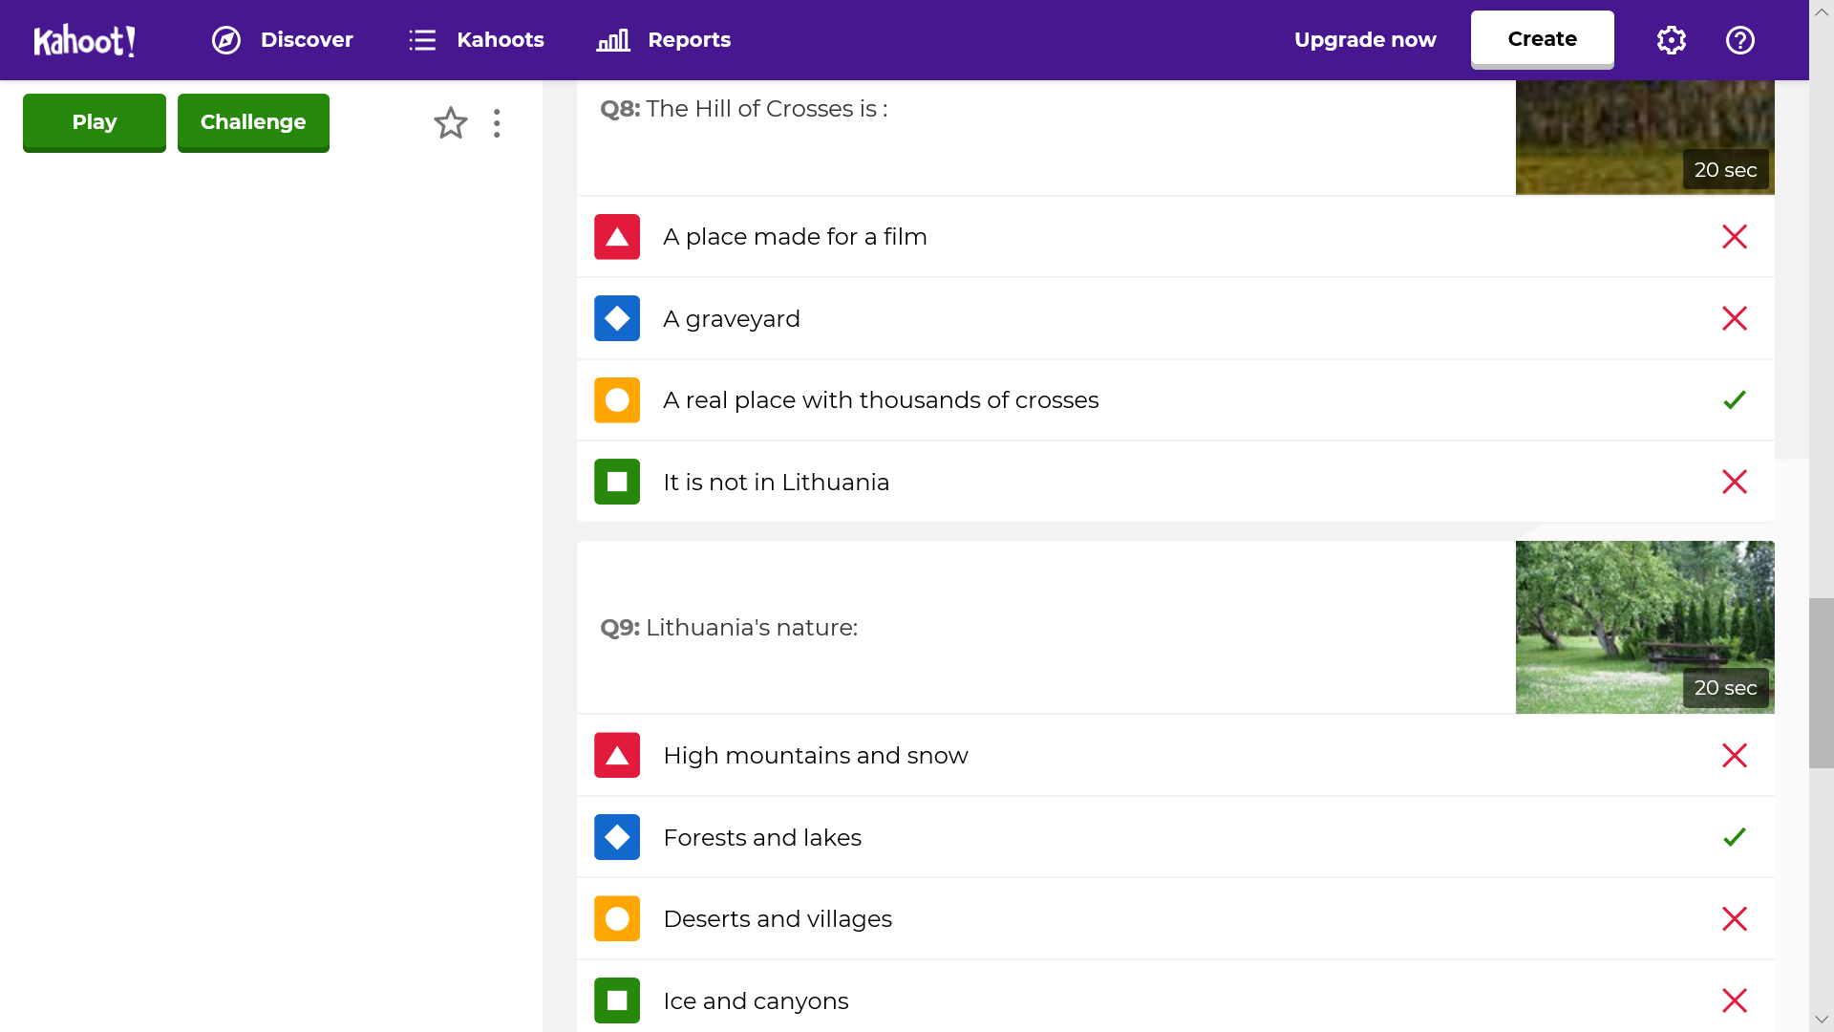
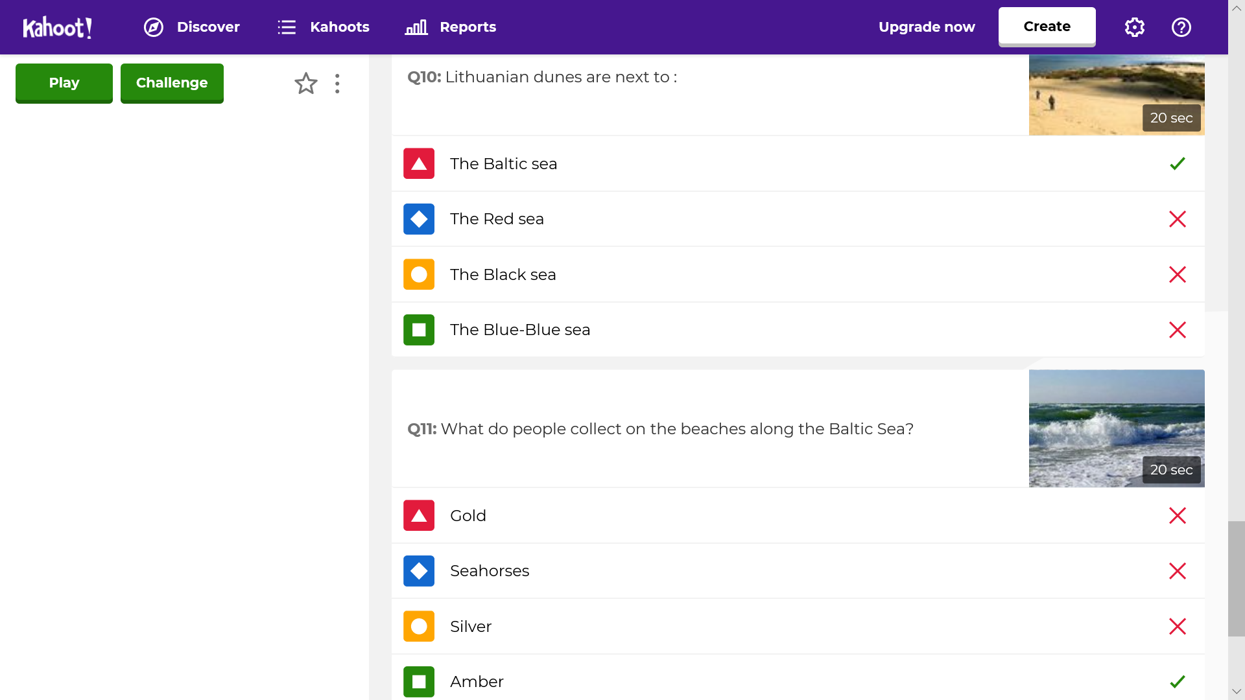
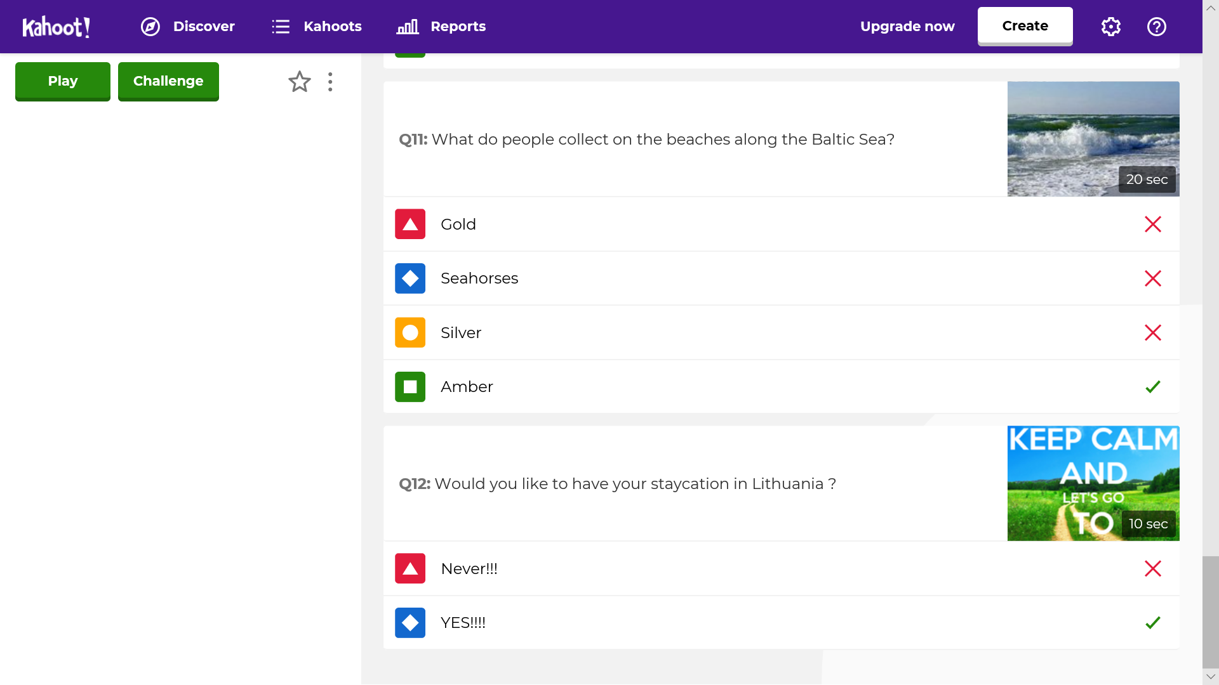

Student feedback

Add here the method with which your students will be able to give you feedback and discuss the lesson.
The class was gathered in a casual circle and some questioning strategies were used to hear what the students truly felt about the lesson.
• What are three things you learned today?
• What were the things you really liked about this lesson? And the things you really didn’t like?
• What do you wish we had more time for?
• On a scale from 1-10, how challenged were you in this lesson?
• Today we did a new activity [role-plays]. What did you like about this activity? If we do a similar activity in the future should I consider any modifications?

Teacher feedback
Different learning approaches proved a real success and achieved significant learning in personal, learning and thinking skills. Role-playing (agency guides) common social situations have given students the skills they need to successfully interact with one another, so they can build friendships and a sense of community. Their knowledge of travelling related vocabulary, the choice of places for having the ultimate staycation in Lithuania, the interaction, collaboration and critical thinking, the sense of identity made the activities both playful and meaningful. The activities helped to develop students’ strengths and see that kids with special needs have strengths too. The focus has been on progress, no matter how small it has been.

