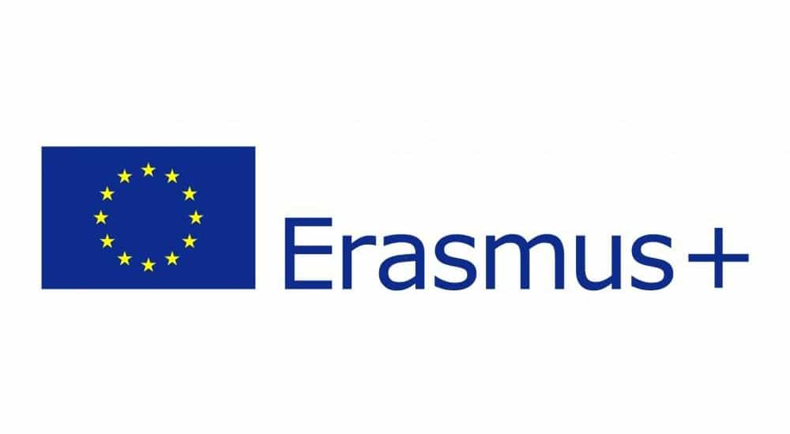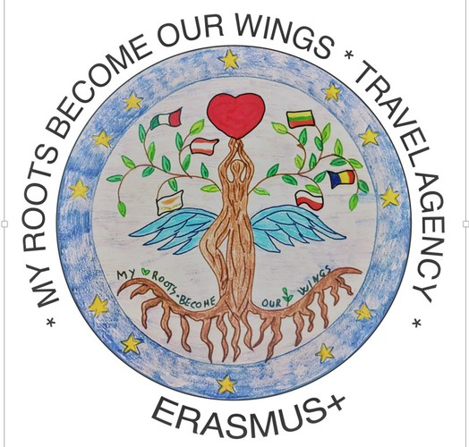

**ERASMUS+ Meeting in Poland**

*Must-haves for the Teacher and the Learner - Tablets, Web and ICT tools as new ways of Teaching and Learning in Schools in an Inclusive Way*

**26 - 31 05. 2019.**

**26/05/2019 SUNDAY**

arrival of partners

accomodation of students in hosting families

accomodation of teachers in Hotel Kur ([www.hotelkur.pl](http://www.hotelkur.pl)) in Olsztyn

7:00 dinner for teachers in Tatarak restaurant in Hotel Kur

**27/05/2019 MONDAY**

9:00 - 10:00 Welcoming ceremony at school

10:00 - 10:30 School tour

10:45 - 12:35 Classes for students in two groups

* *Calculate Your Travel* - with Ms Ewa Przybysz, IT and Maths teacher and a Coding Masters program trainer.
* *Be Creative - creative use of technology* - with Mr Maciej Gołębiowski, IT and Music teacher and a Coding Masters program trainer.

11:30 Teachers - meeting with Olsztyn’s Vice President

13:00 - 14:30 Lunch in the Old Town (Greco Restaurant)

15:00 - 15:45 *Olsztyn - our town* - screening at the Planetarium.

16:00 - 17:00 Visiting Olsztyn’s castle

17:00 - 18:00 Sightseeing tour: Old Town, Copernicus statue, St. Jacob Cathedral and Evangelical Church.

18:00 - students are picked up by the hosting families

19:00 - dinner for teachers at Pierogarnia Bruner restaurant.

**28/05/2019 TUESDAY**

8:00 meeting at school and a trip to Gdańsk

* European Solidarity Centre
* Old Town in Gdańsk
* Lunch in Gdańsk
* ORP Błyskawica and the harbour in Gdynia

18:00 students are picked up by the hosting families at school

19:00 dinner for teachers at Prosta 38 restaurant

**29/05/2019 WEDNESDAY**

8:00 meeting at school and a trip to the Ethnographic Park in Olsztynek - Polish folk architecture and tradition

11:00-12:00 Lunch in Olsztynek

13:00-14:00 Come back to school. Classes for students and teachers:

* STUDENTS *Poland in My Eyes*  - IT lesson with Ms Ewa Przybysz and Mr Maciej Gołębiowski
* TEACHERS *Tablet Applications for Students and Teachers* - with Ms Jolanta Okuniewska, Coding Masters program trainer and Global Teacher Prize finalist.

15:00 - 17:00 Erasmus Cooking - food from our countries.

18:00 students picked up by the hosting families

19:00 dinner for teachers at Słoneczna Polana restaurant

**30/05/2019 THURSDAY**

8:00-8:45 Presenting the effects of the students’ work and summary session for teachers

8:55-9:40 Official closing ceremony

11:00-13:00 Copernicus City Game (students)

11:50 - 12:35 *ICT tools for teachers* with Mr Michał Siwkowski, English language teacher and eTwinning Ambassador.

13:00-16:00 School Festivity - Sports Day Competition, Time Capsule burial and planting a MR BOW tree

16:00 students are picked up by the hosting families

19:00 Culture night: traditional food and dances workshop at Ataman for the students, teachers and hosting families.

**FRIDAY 31/05/2019**

Departure day